The Ocean Health Index Assessment Manual

# The Ocean Health Index Assessment Manual

**Summary:**

This guide provides an overview of conducting an OHI+ assessment to produce Index scores. An assessment involves discovering the data and developing the models for Index goals and using the information within the Toolbox and WebApp software. This process is explained in this guide.

## Where you are in the process

At this stage, you should have **Learned** and **Planned** for your assessment, and are now ready to **Conduct** it.

**Here you will learn how to conduct an independent Ocean Health Index+ (OHI+) assessment.** The OHI+ process consists of four phases. In the first phase, you **learned** about the OHI to understand the philosophy behind the goals and the motivation for conducting a study. In the second phase, you actively **planned** to conduct your OHI+ assessment. Now you will actively **conduct** the assessment by engaging with the work of finding the data, preparing the goal models, and taking the necessary steps to learn how to use the **OHI Toolbox** and related software to produce the final results. This is where the science of data discovery and goal model development comes in. In the final phase, you will **communicate** the findings and results of your assessment with others.

* **Phase 1:** **Learn** about the OHI
* **Phase 2:** **Plan** an OHI+ assessment
* **Phase 3:** **Conduct** the OHI+ assessment
* **Phase 4:** **Communicate** and inform

## Why you are conducting an assessment

Remember that the process of conducting an OHI+ assessment is as valuable as the final results. Documenting decisions made, as well as the challenges and successes encountered along the way, can lead to better understanding of the system and help guide future assessments.

**The Ocean Health Index (OHI) framework** allows you to synthesize the information and priorities relevant to your local context. Because the methods of the framework are repeatable, transparent, quantitative, and goal-driven, the process of a carrying out an OHI+ assessment is as valuable as the final results. The first completed assessment for a study area is valuable because it establishes a baseline and highlights the state of information quality and availability in an area. Any subsequent assessments carried out through time are also valuable because they can be used to track and monitor changes in ocean health. With this in mind, the **Conduct** phase will require careful thought and consideration along the way, and we encourage documentation and scripting to be done within the OHI Toolbox to facilitate the transparency and reproducibility of future assessments.

Each OHI assessment should have a purpose. One of the typical reasons for carrying out an independent assessment is to have an impact on policy and management decisions, and for this reason it is very important to have explicitly defined spatial boundaries. Assessments can be more relevant to policy and management when they are conducted at the spatial scales in which policy decisions are made. These spatial scales could include political subdivisions like countries, states, provinces, or they could even include ecological regions such as bays. The **regions** and the overall **study area** are definitions that will be used throughout the data collecting and preparation phases, and these definitions will guide the output of the final results. In the OHI framework, goal scores are calculated for regions separately and then combined to produce an overall OHI score for each study area. The number of regions varies with each assessment's study area; completed assessments have had between one and 221 regions.

## What to expect when conducting an assessment

It is important to make science-driven decisions and modifications that are most important for your study area, and to clearly document what was done and why. Your team should as creative and insightful as you can be while working within the bounds of informational and technical limitations.

There are **key processes and considerations** that will be a part of every assessment. Every assessment should build from the lessons learned of completed assessments and identify what local characteristics need to be included in a study. This is done partly by comparing the local situation to the example situations in the literature; it is also done by comparing the default information provided in the WebApp to what is known about local realities. After you have outlined and identified local characteristics and priorities, you should prepare to use the Toolbox software and fit the data you have found to be formatted correctly for that software. Finally, once working with the information within the Toolbox, your team will constantly udpate and improve the methods of the assessment before being able to calculate the final results. The last thing you will do is visualize the outputs once more in the WebApp and in the charts and displays that can be shared with other partners and collaborators. Above all, you should be prepared to **know that this process takes time and is an iterative approach**.

The time required to conduct an assessment is not set in stone. On average, assessments have taken between one and a half and three years, but that will vary depending on the a number of factors such as the size and composition of your team and the challenges encountered in discovering and gathering information. The scale of data processing and goal model modifications needed before you will be able to actively use the information available also affects the amount of time it takes to conduct the assessment. The skill sets of the team members and the amount of technical resources available if another factor. You should think about which team members are needed at what stage of the process, including an R user, a spatial analyst, and those who will be familiar with GitHub.

#### Understanding completed OHI assessments

It is important to **understand completed OHI assessments** before you can begin tailoring the approach to your needs. By looking at specific uses of the OHI, you can identify how information was found and how it is presented in the results. You can also get a sense of what kinds of research questions are useful to ask. In many cases, studying completed OHI assessments will inform your approaches for discovering data and developing goal models later on in the process, and it is good to keep the literature readily available since you will likely be returning to it throughout this process.

The OHI framework was developed through collaboration and iteration too. Your assessment can leverage the collective knowledge and insight used in the methods of the Global Assessment by Halpern *et al*. in *Nature* (2012) as well as the subsequent assessments conducted annually (in 2013, 2014, and ongoing). Each annual Global Assessment has improved upon some of the goal models based on better data availability or a better understanding of the systems involved. Several smaller-scale assessments have been completed that are highly informative as well, and particularly for regional scale assessments. The following studies been published with supplemental online materials, and are available at <http://ohi-science.org>:

* **Global**
* Halpern et al. (2012) An index to assess the health and benefits of the global ocean. *Nature*.
* Halpern et al. (2015) Patterns and emerging trends in global ocean health. *PLoS ONE*.
* **Brazil**
* Elfes et al. (2014) A regional-scale Ocean Health Index for Brazil. *PLoS ONE*.
* **United States West Coast**
* Halpern et al. (2014) Assessing the health of the U.S. West Coast with a regional-scale application of the Ocean Health Index. *PLoS ONE*.
* **Fiji**
* Selig et al. (2015) Measuring indicators of ocean health for an island nation: The Ocean Health Index for Fiji. *Ecosystem Services*

TIP: The OHI+ development team is prepared to provide guidance for assessments. Please be familiar with past approaches and documentation before requesting guidance from the OHI team.

#### Identifying local characteristics and priorities

The initial actions of an assessment involve **identifying local characteristics and priorities**. This means considering all of the elements unique to your local context. What are the key issues that should be included for your assessment to be credible, useful, and meaningful at the same time? What are the types of coastal habitats in your area that should be included in order to more accurately represent your ecology? How do people typically relate to the ocean in your area in terms of social and cultural patterns? These are the kinds of questions you should consider prior to discovering the data and gathering the indicators that will be needed to fulfill the goal models.

This idea means that the ability to find information should not be the only guiding force as you develop your approach. You should always try to keep in mind the social and ecological characteristics and priorities that are the most relevant for your area, even though data gaps and information limitations will influence your approach along the way. This is important because knowing these issues beforehand will make all of the other parts of conducting the process easier; not only will you have to decide which goals are relevant in the first places, but you will also have to decide later on which social and ecological stressors are relevant, and how much of a relative impact they have on each of the moving parts of the Index. Knowing what you want to include beforehand will help drive your search for data and indicators and make it go more smoothly, yet keep in mind that what is available will ultimately determine how goal models can be developed for your area.

#### Determining goals to be assessed

Once you have identified local characteristics important to your study area, consider whether all goals included in the Global Assessment are applicable to your assessment. Should new goals or sub-goals be added? Should a goal that is not relevant to your study area be removed completely? Should a goal or sub-goal be given more or less weighting compared to other goals or sub-goals in the final Index score? These decisions should happen while beginning your assessment and before you become more constrained with what kinds of information are available. At the point where you have determined the goals to be assessed, you will likely modify existing goal models or develop a new ones based on the accessible information as you prepare to use the Toolbox and associated software. Sometimes encountering difficulties in data availability will send you back to these questions.

#### Discovering data and developing goal models

The actual approach to conducting your assessment will depend on data availability and it will require an iterative process of improvement. It will also require creative thinking and problem-solving abilities among your team. There are many decisions to be made when gathering data. This is because your data will come from disparate sources, and you will have to engage experts to help identifying good proxies and indicators, deciding reference points, and developing goal models. OHI+ assessments should incorporate higher-resolution information where possible, and always be guided by local priorities preferences to develop tailored goal models and reference points that produce scores that best reflect local realities. Similarly, pressures and resilience measures can be refined using local data and indicators.

There are many data inputs included in the OHI framework. The process of discovering and gathering so many different kinds of data and indicators is an important step that you will return to as you continue to conduct the assessment. This is where having a collaborative team that can work across issue-areas will be useful. The goal models you develop will also be an important process that occurs with data discovery and it is important to document the decisions being made along the way. Documenting the decisions is important because the deliberations involved are a key part of goal model development. Keep in mind that both of these broad steps are part of the same overall process of conducting the methods of the assessment. It is an iterative process that will not necessary be linear, which is why your team should be prepared for all of the moving parts and the length of time required in conducting an assessment. At the same time, documenting these decisions is important for the communication of the methods in the ultimate sharing of the results.

#### Using the Toolbox software

The **OHI Toolbox** is the main software used for organizing and processing information, documenting decisions made, calculating scores, and visualizing results. It was created to facilitate the goal score and Index calculation as well as the organization of information and transparency of the approach. The Toolbox is built with open-source software, meaning that it is freely available for you to use able to be modified to meet your needs. You will access the software from online and will use several free software tools to conduct your assessment in a collaborative, transparent, and reproducible manner.

Accompanying the OHI Toolbox is the **OHI+ WebApp**, which is a visualization tool that displays input information and calculated scores in several ways, including an interactive map. Most coastal countries have a WebApp that was created to facilitate planning and communication during your assessment. The WebApp visually presents inputs, goal models and calculated scores for each defined region through maps, histograms, and tables. All inputs presented in a country's WebApps were extracted for each country from the global analysis, and scores were calculated using Global Goal models.

The software should be used when your team is ready to apply to your prepared informational inputs. The steps of carefully preparing and gathering data layers, indicators, and developing goal models can be done independently of the actual software use; however, learning how to use the software when you are ready to organize your files and information can be very useful. Not all members of your team will need to use all of the different platforms, and different members may have expertise in one or more of the tools. They each have their own particular uses and strenghts; for instance, RStudio is useful for engaging directly with the files that run the calculations, and GitHub is useful for tracking the changes in goal model development through time.

The WebApp is a widely useful communication tool and that is why it is presented first in this guide. Not all team collaborators may be involved with Toolbox calculations or goal model development, but they will all certainly want to see the final results. The WebApp will help you convey the findings and it will orient the component parts that go into building the Index.

#### Outcomes of conducting an assessment

**The process of conducting an OHI assessment is as valuable as the final results.** This is because while conducting an OHI assessment you will bring together all of the meaningful information for ocean health together to the same place. In doing so, you will have a census of existing information and also will identify gaps in knowledge and data that in itself can help identify priorities for management or monitoring. With your team and advisors, you could also create an ocean alliance that combines both knowledge and cultural values across issue-areas and disciplines. Conducting an OHI+ assessment can engage many different groups, including research institutions, government agencies, policy groups, non-governmental organizations, and both the civil and private sectors.

Your completed assessment will have OHI scores for each region in your study area that can be compared with each other. These scores will not be quantitatively comparable to those of other OHI assessments because they differ in the underlying inputs, goal models, and reference points. The only *quantitative* comparisons between territories or countries across that can be made occur in the Global Assessment when the same data and methods are being applied to all countries. A quantitative comparison is also possible for the same region through time when the same methods are applied. However, all OHI assessments can be *qualitatively* compared because the scores are an indication of how far a region is to achieving its own targets. That is why the process of preparing the data and setting the right targets is so important. For instance, a score of seventy in one country should mean that that country is seventy percent of the way to achieving its perceived ideal state of ocean health.

The final scores can be visualized using the WebApp. This is valuable for interpreting calculated scores and communicating results with collaborators and stakeholders. The information can be visualized in a number of ways, including through data tables, maps, and through the flower plots of used in goal score communication in the literature. Once you have the scores and outputs, you must then use it appropriately to achieve the stated aims of your OHI study. The output created from running the calculations will usually be analyzed to answer research questions about the state of ocean health. This can include questions on the state of the environment or on considering management scenarios and policy options; usually it can consist of both. In any case, your team should already be thinking about the expected outcomes and what to do with the final results even before beginning to prepare all of the input information. This is where previous studies are a useful reference in understanding how to interpret goal scores, which will change according to the local context.

The resulting scores should be understood in the context of repeated assessments. The scores you produce will be the scores that describe that particular starting scenario, including all of its available data, its reference points, and its underlying assumptions. This is where storing the information and cataloguing that particular scenario will be useful. You can conduct an assessment for the following year by following the same methods and using updated data. Once you do this, you can compare and track how scores have changed over time in your area. These repeated assessments are the most valuable for tracking the better and worse changes that have occurred in your area in terms of ocean health.

## How to use the OHI Manual to start your assessment

Conducting an assessment requires both an understanding of how past assessments have been completed and innovation to capture important characteristics of your study area using the information available. You can start by understanding the structure of completed assessments at global and smaller scales and the models that were created with the information available. Understanding the approaches in different contexts will help you think about what should be done similarly and differently in your local context. Identifying local characteristics and priorities in your study area will help you determine the relevant goals to be assessed.

Navigating through the WebApp can help frame your thinking and introduce you to the structure of inputs that will be required for the Toolbox software.

This Manual will guide you through the process with the following information:

1. Using the OHI+ WebApp to define regions and develop the approach
2. Defining spatial regions, discovering data, and developing goal models

* Defining spatial regions within the assessment area
* Discovering and gathering data and indicators for goal models, pressures, resilience
* Developing goal models and setting reference points for goals, pressures, resilience

1. Learning how to install and use the OHI Toolbox and supporting software

* Understanding the file system for the Toolbox and assessment repositories
* Formatting data for the Toolbox
* Installing the Toolbox and supporting software
* Learning how to use the Toolbox by modifying data layers and goal models
* Refining goal models and data inputs within the Toolbox

1. Guidance for frequently asked questions and troubleshooting

# Overview of the OHI WebApp

**Section Summary:**

Your team should keep the WebApp in mind throughout the **Conduct** phase. The information in the WebApp can guide your team as you define spatial regions, discover and gather data and indicators, develop goal models, and set reference points. At the end of the process, the data you feed into the WebApp will be used share your assessment's scores and results.

**OHI+ WebApps** are websites created to facilitate independent assessments. The WebApp is a good starting point when preparing to conduct an assessment. It is also meant to be used in the final steps of the conducting phases for communicating and visualizing results. For this reason, it is good to think about how your work can feed into the WebApp throughout the course of this phase.

The WebApp displays information about the underlying data as well as the results of the final Index scores. The underlying data are raw data known as **data layers** that are used in all of the OHI calculations. These data layers exist for all components of the goal models, including the pressures and resilience. They are the common format used by the software and will be where your team spends time in preparation. By default, the WebApp only displays data layers and score information that has been extracted from the latest Global Assessment. This information has been simplified to a smaller scale geographically. The default display therefore does not provide fine resolution nor does it guarantee accurate data for each nation or territory. You will have to work to improve this default information. These data can be used as inputs into your assessment only in the cases where no better information for a region exists; however, it is always encouraged to improve the given information wherever possible. **Having the best data that are tailored to the local context will ensure that you get the best results for your assessment.**

The WebApp is powered by the **OHI Toolbox**, which organizes all of the data inputs and uses the appropriate software to calculate Index scores. The Toolbox is where you will actively work to format data layers and develop and modify goal models later on in the conducting process. The Toolbox then links your input data and the OHI software within the WebApp to produce the displays that can be used for orientation throughout the process.

A default WebApp is available for every coastal nation and territory that was in the Global Assessment. The WebApps are available through <http://ohi-science.org> by adding a three-letter identifier to the ohi-science URL. For example, Ecuador’s WebApp (ECU) is found at: <http://ohi-science.org/ecu>

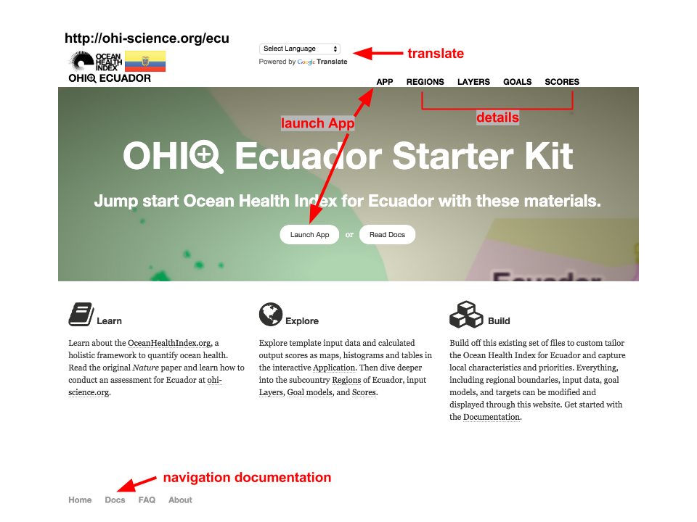

The WebApp start page. Note that it's possible to translate the page into your language of choice.

*Remember that this information is public by default, and you must choose to sign up for a premium option to make it private.*

The WebApp homepage provides tabs for you to explore your data, regions, and calculated scores. The main pages are **Apps**, **Regions**, **Layers**, **Goals**, and **Scores**. A quick reference on how to navigate the WebApp is available through the **Docs** link at the bottom of the page.

The interactive **App** page allows you to explore input and output variables. The inputs are data layers and the outputs are calculated scores for each part of the Index for each region in the study area. This page is where you should spend your initial exploration. By choosing input data layers you can see the range of values for a given variable and you can also see information about data sources. More detailed information about the default goal models and the calculation methods is found in the other pages on the site.

The information displayed on the website is stored online in a **GitHub repository.** GitHub is an open-source development platform that allows multiple users to collaborate, track changes, and share their work to prepare data files and write code. Some members of your team will use GitHub to track data layer preparation and view the history of changes made in this process. It also a a way for your team to document the decisions made in the course of this conducting phase. Any changes made to files contained within the GitHub repository will be automatically displayed on the WebApp for other team members and collaborators to view. The history of these changes is also stored on this platform as an archive, and it can be used to display changes made over time (See the section on **GitHub** for how to modify files using this platform).

When your team has finalized preparing both the data layers and modifying the goal models, these data and scores will be visualized through the WebApp.

## Using the WebApp to help define regions

The WebApp displays a list of default sub-country regions. These sub-country regions are usually defined as states, provinces, or territories. The regions are extended offshore by default in order to divide the Exclusive Economic Zones (EEZs) of coastal study areas into offshore regions. The offshore regions are an important part of the Index calculations, and so you should think about whether their definitions are appropriate for your area. These sub-country regions have been provided as a starting point mainly because they are consistent with the scale at which policy decisions are made. However, it is possible to change these boundaries to fit your on local characteristics. The boundaries can be defined as administrative or geographical unit as required by your assessment. This is possible because you can customize the inputs to the WebApp's spatial files. You will most likely need a spatial analyst to help do this when beginning to conduct the assessment.

It is important to note that the provided WebApps do not claim to take a stance on disputed territories. The boundaries for all EEZs were identified by MarineRegions.org (<http://www.marineregions.org>). The largest sub-country regions were identified by the Global Administrative Regions database (<http://gadm.org>).

## Using the WebApp to discover data, develop goal models, and set reference points

### The App Page

The App page allows you to explore the input data layers and calculated output scores for each region in the study area. The page presents data and scores from the Global Assessment that are applied to each sub-country region in the study area by default. In order to explore data and scores, you can select them on the left to view their attributes and you can also visualize them in a number of ways on this page.

The App page allows you to view displays through the **Data** and **Compare** tabs. The **Data tab** provides summary information on each data layer and metadata descriptions that accompany them. The **Compare tab** is mainly used for comparing output scores when modifications are made to the underlying data or models.

### The App's Data tab

#### Overview of display options

The Data tab displays input data layer or calculated scores for each goal parameter. It presents the information through a *Map*, *Histogram*, or *Table*. These options are available as sub-tabs on the Data tab page. The *Map* sub-tab is the default display option for the Data tab, and all data presented are drawn from the Global Assessments by default. This means they are either directly duplicated across regions, or the raw values are down-scaled using area- or population-weightings. The *Histogram* sub-tab likewise draws from the same data source, but it displays a histogram of observed values with a smoothed line added. The *Table* sub-tab also draws from the same data but offers information in a tabular form.

**Data displayed in the Map sub-tab:**

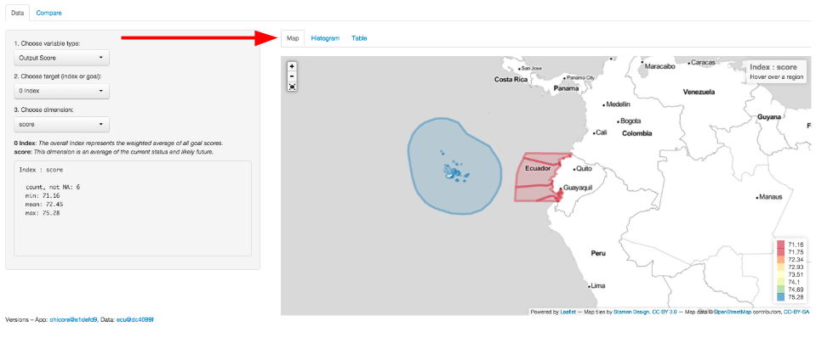

The Map subtab. Click on 'Map' to see a geographic view of your assessment region. Colors indicate scores or values for your input layers or output scores.

The *Map* displays data for every region as defined in the assessment scenario. A legend is displayed in the lower right-hand corner of the map to explain the meaning of the colors presented. The range of values will change when variables are selected, and the colors will automatically change to create a visual scale of reference.

**Data displayed in the Histogram sub-tab:**

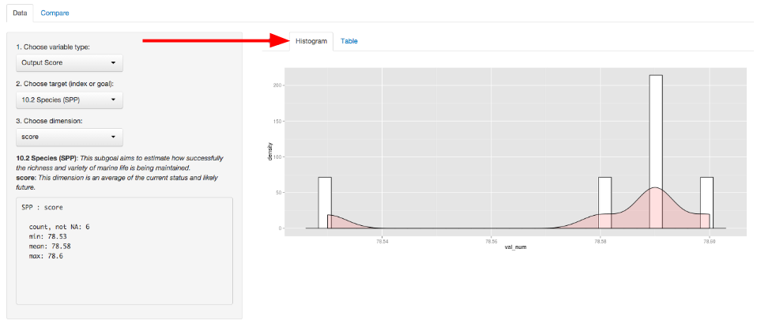

Click on *Histogram* to see the distribution of your data or scores, after selecting a variable layer on the left. This example shows the Species sub-goal scores for the study regions of Ecuador.

The *Histogram* shows the distribution of values of the selected variable as the number of observations for each value bin (shown as white bars) and it also automatically creates a smoothed density function (shown as pink shading).

**Data displayed in the Table subtab:**

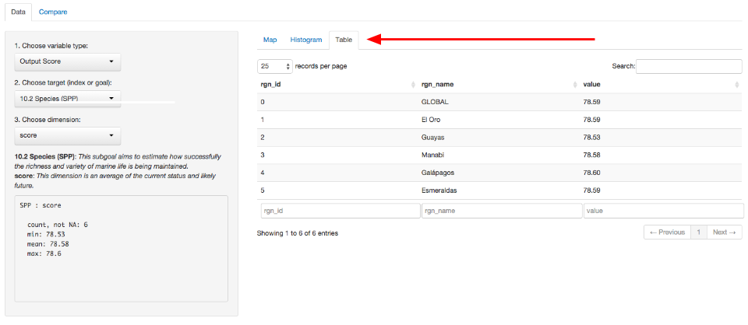

Click on 'Table' to see a table of your data or scores, after selecting a variable layer on the left. This example shows the Species sub-goal scores for the study regions of Ecuador.

The *Table* displays the variable's value for each region in the study area. It provides an identifying code (*rgn_id*), name (*rgn_name*), and value (*value*) for each observation. The variables are also searchable since you can use the textbox at the bottom of the page to filter the results displayed.

#### Overview of variable options

When you choose the variables to be displayed, you will also see summary descriptions for the data layer. These descriptions, statistics, and metadata for the chosen fields are displayed below the drop-down menus on the left side of the page.

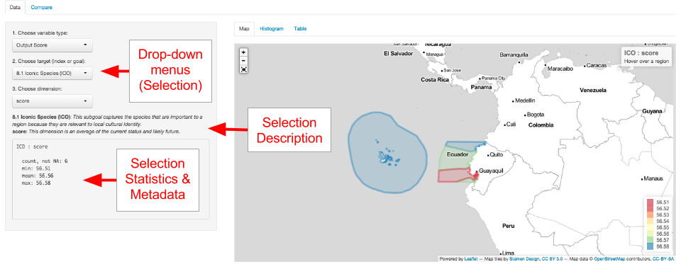

Overview of the Data tab. Choose the variable you would like to explore through the drop-down menus on the left-hand side of the page. Once you select either input data or an output score, you can view a description and summary of values below.

TIP: The data layer descriptions that you will produce later in the conducting phase will appear here.

The first selection you should make from the drop-down menus is the variable type. This means you can choose either **Input Layer** or **Output Score**. The **Input Layer** will show the data layer used for a particular target you select. The targets in this case are either goals, pressures, resilience, or spatial information. The **Output Score** will show calculated scores for the alternative target selections you will make. In this case, the targets are Index or goal scores. In either case, you then have the option to further refine your variable search by either going into a specific layer or a specific dimension, respectively, that's used in the overall Index calculations. If you do not make a selection, the **Output Score** is displayed by default.

For example, if you select **Output Score** as the variable type, you will then be able to choose a target goal or sub-goal, and then you will be able to choose the OHI dimension to be displayed. Remember that the dimensions are status, trend, pressures, resilience, future state, and score. In this way you can understand the calculation of the goal scores.

As another example, if you select **Input Layer** as the variable type, you will be able to choose a target such as a goal and a specific data layer associated with that goal. If that input layer has multiple categories of input types, or if it has multiple years of information available, you will be able to select more specific information. If you do not make a selection, the default setting is the first alphabetical category and the most recent year available.

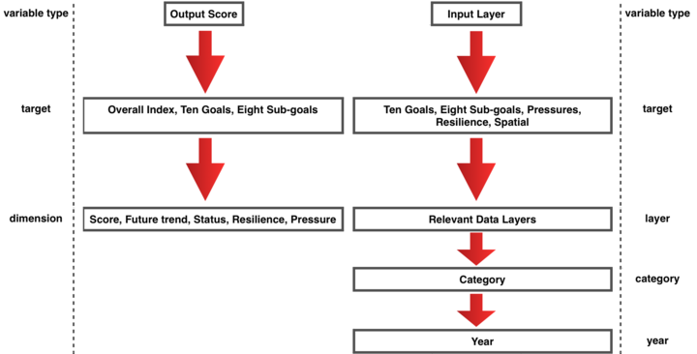

Overview of the variable options. You can choose to select and view either input layers or output scores.

### The App’s Compare tab

The **Compare** tab allows you to compare differences in calculated scores based on changes you have made to the underlying data layers. These changes can be made to the values of the data layers themselves, or they can be changes made by changing the goal models. Any component you change is tracked through the archiving system of **GitHub** (See the section on **GitHub**) and each version of the changes be visualized here. You can take advantage of this ability to compare one saved version of your calculated Index output to another version of your calculated output. This is done to compare the how changes made to your data or indicators for goals, pressures, or resilience would affect the resulting scores.

You can use this in two ways. One way is use this as an experimentation to guide the process of conducting the assessment itself. This is because visualizing differences is extremely helpful for error checking and for sharing tests to the data among your technical team. Another way to use the **Compare** tab is to compare different management scenario to how changes in your assumptions would impact score results. These changes could occur in the goal models themselves, such as through changes to targets or reference points, or they could be changes made to the values of pressures and resilience layers, for example. Once you have created the outputs, you can visualize theme on this page.

More context on the use of this function can be found in the section, **Using the Toolbox**.

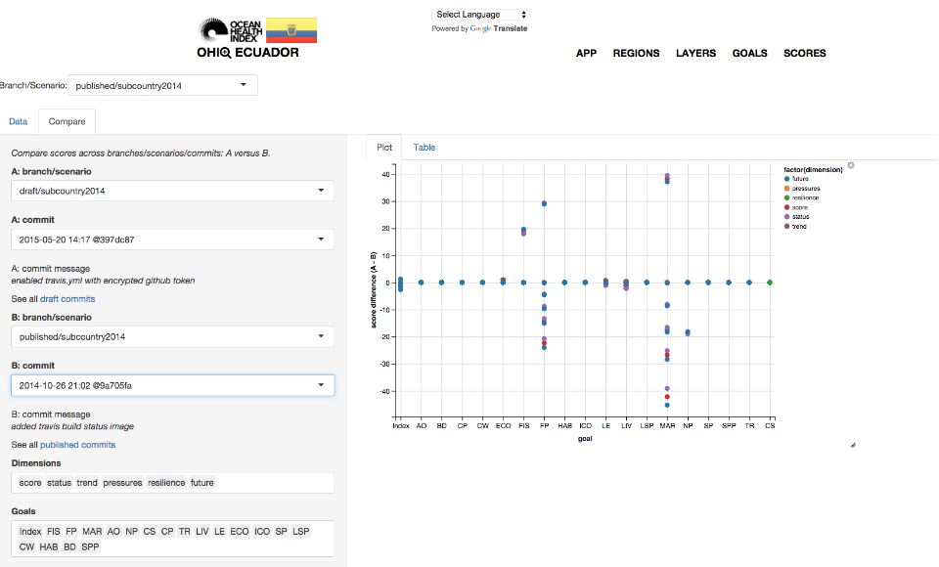

You can use the OHI+ WebApp's 'Compare' tab to error check, and check the outcomes of alternate scenarios of your assessment.

The App page also offers the ability to view different **branches** or **scenarios** in the upper left-hand corner of the page. This is an option that you will take advantage of later on in the **Conduct** phase, and it is good to think about so you can plan the assessment appropriately. The **branches** refer to unique copies of a GitHub repository where information is stored. Each branch is a copy of a repository that is meant to be modified independently of other branches. This is done to ensure that changes made to one branch will not affect the information in another branch. This allows for active collaboration and offers a way to archive different outputs to Index calculations. For example, the *published* branch shows information that has been vetted for sharing, while the *draft* branch can be used for experimentation. These branches can be merged together at any time, and that is typically done when important milestones in the conducting process are reached. The *subcountry* folders displayed also offer another way to compartmentalize outcomes by allowing you to compare different *scenarios* within the same branch of your repository.

The App displays a *published* branch by default. It is recommended work on the *draft* branch until your assessment is finalized. When it is finalized, you can then merge the *draft* branch with the *published* branch.

These options for displaying and comparing information will be useful for understanding the multiple objectives in your OHI+ assessment.

# Defining Spatial Regions Within the Assessment Area

It is important to think about which spatial regions to use when conducing your assessment. You should consider some of the questions from the planning phase before you begin to involve GIS or other spatial analysts. If managers or policy makers are going to be involved, at what scale do they work? Where are the political and administrative boundaries in your area? How will political boundaries affect your ability to gather and discover data and indicators? Will the regions change in the future? These questions are important for the future relevance of the assessment.

There are several spatial considerations you should have prepared before moving forward with the Toolbox later the process. One is your map definitions for use in the assessment itself and for display in the WebApps. You must check the definitions of your map regions and boundaries even when they have been pre-prepared for you the default OHI Toolbox setup. You should have your spatial analyst prepare the files that best suit your needs. If political boundaries are not appropriate in all areas, there might be other boundaries like biomes or biogeographic considerations you can use. These may be useful when there are disputed territories or undefined border regions in your area.

Note that the OHI+ tools do not intend to take a stance on disputed territories. The boundaries defer to the judgment of the original map data providers. It is up to you to decide on the quality of the maps.

You may need to prepare spatial data files for your assessment. Not all goals will require spatial data. When considering it, you should be conscientious of how it is presented: is it in square kilometers, or by a kind of region such as an EEZ or other identifier? Do you have better local data than global satellite or modeled data?

Once you have maps, you may also need to define buffer zones. Buffers are distances from shore, both inland and offshore, that can be used in the OHI Toolbox calculations to assess impacts more accurately. For example, mangrove forests were assessed at 1km inland and 1km offshore in the latest Global Assessment in order to approximate aspects of their importance for carbon storage. Buffer zones could also be defined by visual distance. The main thing to do is remember that you are trying to capture ocean health, so going too far inland may no longer relate to ocean health. Perhaps fixed buffer distance might not be appropriate, and it might better to follow the actual path of a habitat extent; this will be up to your team. You will also consider these questions further when you are changing and developing your goal models.

## Discovering and Gathering Appropriate Data and Indicators

The OHI+ approach spans disciplines and integrates diverse data to give a comprehensive assessment of ocean health. A hallmark of the OHI is that it uses freely-available data and indicators to create the models that capture the philosophies of individual goals. The quality of the data matter because the accuracy of Index scores is a reflection of input data quality and the amount of information available for the study area. **Including the best available data and indicators is very important throughout this process.**

The approach of your assessment will depend on the available data. Determining the appropriate scale and defining the study area and any regions within the study area will also depend on available data. The scale and resolution of available data can help inform the scale of the study area to be analyzed and how to divide it into regions.

Finding appropriate data requires creative thinking, particularly when ideal data are unavailable. It also requires problem-solving abilities. There are many decisions to make when gathering data. This is because your data will come from disparate sources, and you will have to engage in many steps of expert judgment such as identifying good proxies and indicators, deciding reference points, and developing goal models.

There are many data layers included in the OHI framework. There are about eighty individual data layers from the global assessment that should be replaced with higher-resolution data in your study area where possible. You will need to search for data used to calculate status models and trends as well as pressures and resilience layers.

### Thinking Creatively

Remember that you are trying to capture information that is meaningful for ocean health.

Humans interact with and depend upon the oceans in complex ways, some of which are easy to measure and others of which are harder to define. More familiar measurements include providing seafood, transporting goods, or disposing of waste. A less familiar measurement is finding out the way marine-related jobs indirectly affect coastal communities, how different people receive or perceive benefits simply from living near the ocean. Thinking creatively and exploring the data available can make the Index more representative of reality.

Data used in the Ocean Health Index spans a wide array of disciplines, both within and outside of oceanography and marine ecology. It is important to think creatively and beyond the interests of a specific institution or one particular field of study. Therefore, it is necessary to look beyond the most known or obvious data sources to find data relevant for the goals in the region. Discussions with colleagues, literature searches, emails to experts, and search engines are good ways to understand what kinds of data are collected and to hunt for appropriate data. Simply using a Google search is a great starting place to begin developing ideas for discovering data. Investigate what kinds of information are available from government and public records, scientific literature, academic studies, surveys and reports or other sources, too.

### Data sources

Existing data and indicators can be gathered from many sources across environmental, social, and economic disciplines. This includes government reports and project websites, peer-reviewed literature, masters and PhD theses, university websites, and information from non-profit organizations, among others.

All data must be rescaled to specific reference points (targets) before being combined with the Toolbox; therefore setting these reference points at the appropriate scale is a fundamental component of any OHI assessment. This requires your assessment team to interpret the philosophy of each Index goal and sub-goal using the best available data and indicators. Some indicators already are scaled (e.g., from 0-1 or 0-10), and can easily be incorporated into your assessment since the reference points have already been identified. If they are not scaled, you should think about ways to scale them and ways to determine the reference points while you are searching for the data. For instance, can you find historical time-series for the data?

Because the data and indicators you use will come from different sources and available from online databases, reports, spreadsheets and text files, they will also have different formatting. To include these data and indicators in your assessment, you will need to process these files into the format required by the Toolbox, which is explained in the section, **Formatting Data for the Toolbox**. When data have been prepared and formatted for the Toolbox, it's called a **data layer.** Because creating data layers can be quite time-intensive, data should only be prepared for the Toolbox after final decisions have been made to include the data or indicator in your assessment, and after the appropriate goal model and reference points have been finalized.

### Gathering responsibilities

Gathering appropriate data requires searching for and accessing existing data. You do not have to go collect the data itself, but you do need to discover and acquire existing data. It is important that team members responsible for data discovery make thoughtful decisions about whether data are appropriate for the assessment, and that they get feedback from the full team to discuss the merits of different data sources. Data discovery and acquisition are typically an iterative process, as there are both practical and philosophical reasons for including or excluding data.

When you begin exploring data possibilities, you can seek local data sources that could directly replace data from the global assessment provided in your repository. Such data would be better quality, i.e., higher accuracy and spatio-temporal resolution, than the data from the global assessment, and models may not need to change. However, we recommend first exploring other data possibilities that could capture specific characteristics to your study area. Assessments conducted at smaller scales are an opportunity to include characteristics specific to your study area that were not captured in the global assessment.

### Requirements for data and indicators

There are six requirements to remember when investigating (or ‘scoping’) potential data and indicators. It is important that data satisfy as many of these requirements as possible. To meet these requirements, you may have to do gap-filling. If requirements are not met and gap-filling solutions are not possible, you will likely need to exclude a dataset from the analyses. If data cannot be included, you may elect to use the global data layers or identify other data and a different modeling approach.

The requirements for good data are:

* Relevance to ocean health
* Accessibility
* Quality
* How to set the reference point
* Spatial scale
* Temporal scale

#### Relevance to ocean health

There must be a clear connection between the data and ocean health, and determining this will be closely linked to each goal model.

#### Accessibility

The two main points regarding accessibility are whether the source is open access and whether the data or indicators will be updated regularly.

The Index was created in the spirit of transparency and open-access, using open-source software and online platforms such as GitHub, is to ensure as much accessibility and open collaboration as possible. Data and indicators included should also follow these guidelines, so that anyone wishing to understand more about the Index may be able to see what data were used and how. For this reason we emphasize the importance of using data that may be made freely downloadable, as well as the importance of clearly documenting all decisions and reasons for the choices made in selecting data, indicators, and models.

Index scores can be recalculated annually as new data become available. This can establish a baseline of ocean health and serve as a monitoring mechanism to evaluate the effectiveness of actions and policies in improving the status of overall ocean health. This is good to keep in mind while looking for data: will it be available again in the future? It is also important to document the sources of all data so that it is both transparent where it came from and you will be able to find it in the future.

#### Quality

Understanding how the data or indicators were collected or created is important. Are they collected by a respected organization with quality control? Are there any protocol changes to be aware of? For instance, were there changes in the collection protocol to be aware of when interpreting temporal trends?

#### Reference point

Most data will need to be scaled to a reference point. As you consider different data sources it is important to think about or identify what a reasonable reference point may be. Ask the following types of questions as you explore data possibilities:

* Has past research identified potential targets for these data?
* For example, fisheries goal require a Maximum Sustainable Yield (MSY).
* Have policy targets been set regarding these data?
* For example, maximum levels of pollutants allowed in beaches.
* Would a historic reference point be an appropriate target?
* For xample, the percent of habitat coverage before coastal development took place.
* Could a region within the study area be set as a spatial reference point?
* For example, a certain region is regarded as the leader in creating protected areas.

#### Appropriate spatial scale

Data must be available for every region within the study area. It is not always possible to fully meet the spatial and temporal requirements with each source. In these cases, provided that the gaps are not extensive, it can still be possible to use these data if appropriate gap-filling techniques are used (See: 'Formatting Data for Toolbox' section).

#### Appropriate temporal scale

Data must be available for at least three to five years to calculate the trend. For some goals, where temporal reference points are desirable, longer time series are preferable.

### The process of discovery

The most important thing to remember when gathering data and indicators is that they must contribute to measuring ocean health. Not all information that enhances our knowledge of marine processes directly convey information about ocean health and may not be appropriate within the OHI framework. Because of this, compiled indicators can sometimes be more suitable than raw data measuring single marine attributes.

Whether you are working goal-by-goal, or data layer by data layer, it is important to consider where you can find synergies in data discovery. For example, while you are looking for data layers for fisheries goals, you may also find data layers for fishing pressures, such as metrics on bycatch or trawling intensity. This will save you time and allow you to start thinking about how to rank pressures and resilience weights on your goals as well. Conceptually, it will help your team build a picture of how your goals are interlocking in a way that is reflective of the actual linkages that exist in the connected systems you are studying. Some key examples are listed below, and are further explained in the following sections.

You should begin by understanding and comparing the best approaches used in assessments that have been completed, including the Global Assessments (Halpern *et al*, 2012; 2013), Brazil (Elfes *et al*. 2014), Fiji (Selig *et al*., 2014), and the U.S. West Coast Assessment (Halpern *et al*., 2014). For OHI+ assessments, if finer-resolution local data were available in the study area, these data were either incorporated into modified goal models that used locally appropriate and informed approaches or into the existing global goal model. When local data were not available, the global-scale data and global goal models were used, which is least desirable because it does not provide more information than the global study.

When looking for data, the following decision tree may be useful when going goal-by-goal for discovering data and developing models:

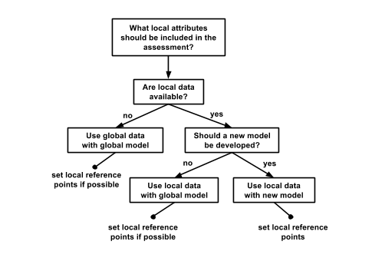

### Example: U.S. West Coast data discovery

Below are examples of some decisions made when exploring available data for the U.S .West Coast assessment. Determining whether certain data could be included began with a solid understanding of the data layers and models included in the global assessment. Since the US West Coast is a data-rich region, finer-resolution local data could be used in place of many of the global data layers. The U.S. West Coast assessment had five regions: Washington, Oregon, Northern California, Central California, and Southern California.

#### Reasons data were excluded

There are a lot of existing data that contribute to our scientific understanding of ocean processes and interactions but are not ideal for the OHI. Reasons to exclude data are both due to practical requirements (e.g., resolution, coverage, or other requirements that have been listed) and philosophical requirements (i.e., they do not help capture the attributes of interest for assessing ocean health). Some common reasons for excluding data are:

* **The data do not cover the entire area of the reporting region**. The state of California had excellent, long-term data on public attendance at state parks that would have been quite useful in the calculation of the tourism and recreation goal. However, data were only available for three of the five regions (the three California regions but not Oregon and Washington), so they could not be used.
* **There is not a clear and scientifically observed relationship between the data and ocean health**. Along the U.S. West Coast, kelp beds are a very important habitat because of their contribution to biodiversity and coastal protection. However, kelp coverage variation and is driven primarily by abiotic natural forcing (wave or storm disturbance and temperature) and thus it is not a good indicator of kelp forest health, particularly in the case of anthropogenic impacts. For these reasons kelp coverage was not included in the assessment.
* **The feature being measured may provide benefits to people, but this feature is not derived from marine or coastal ecosystems**. Sea walls and riprap provide coastal protection to many people along the U.S. West Coast. However, these structures are not a benefit that is derived from the marine ecosystems, so only coastal habitats were included in the calculation of this goal. These data can be included as a pressure due to habitat loss. They were not used as a resilience measure because they can often have negative side effects (e.g., by altering sedimentation dynamics), and because they have limited long-term sustainability (i.e., they need maintenance).
* **Data collection is biased and might misrepresent ocean health**. The U.S. Endangered Species Act identifies a species list focused on species of concern within the US. As such, these data are biased in the context of ocean health since they only assess species whose populations may be in danger. For the calculation of the biodiversity goal, using these data would be inappropriate because this goal represents the status of all species in the region, not just those that are currently of conservation concern. Using these data may have shown the status of biodiversity to be lower than it really is because the selection of species to assess was already biased towards species of concern.
* **Time series data are not long enough to calculate a trend or a reference point** (when a historical reference point is most appropriate). For the U.S. West Coast, the current extent of seagrass habitats was available, however, these do not exist for previous points in time in most areas, so could not be used to calculate the trend or set a historical reference point. Therefore, we estimated the trend in health of seagrass habitats using as a proxy the trend in the main stressor (i.e., turbidity). In other words, we assumed that the rate of seagrass loss was directly proportional to the rate of increase in turbidity. Similar solutions may be used to estimate trends in your own assessment, if there is scientific support for assuming that the trend of what we want to assess (or the relationship between the current state and the state in the reference year) has a strong relationship with the trend of the proxy data available.

## Developing Goal Models and Setting Reference Points

Once you have determined which goals are assessed and have begun searching for data and indicators, you can start to develop goal models and set reference points. The decision tree of the data discovery process also applies here: first consider how goals can be tailored to your local context before you consider replicating what was done in the Global Assessments. It is always better to use local goal model and reference point approaches where possible.

### Developing multiple goal models at the same time

You can develop some goal models simultaneously, for example, the habitat-based goals. **Carbon Storage**, **Coastal Protection**, and the **Habitats sub-goal of Biodiversity** all rely on the same underlying data, and their models can be developed together. This will be efficient and help streamline the data search. A spatial analyst can do the file manipulation to create the spatial layers that get used for these goals using the same source material. This will greatly expedite your data layer preparation. If you wish to further coordinate these activities on a higher level, you could have the same team member coordinate activities for the development of certain goals. That is a consideration when assembling your team and planning your workflow.

### Identifying linkages between goals and pressures

You should note the linkages between your goals and the pressures and resilience that affect them while you are developing your model approach. The team members who are developing goals should think about the pressures that act upon those goals at the time that they are data-gathering, and they should think about the data sources that could be used to provide pressures information. However, it may be most useful when someone specific gathers all of the data for pressures, since pressures affect multiple goals.

For example, when developing the **Wild-Caught Fisheries** goal model it is possible to prepare some of the pressures layers that affect multiple goals. This is because the goal model will require catch data, which may be the same data source for information on commercial high- and low-bycatch data. Bycatch data are used as pressures layers that affect multiple goals, including **Livelhoods and Economies** and **Biodiversity**. It is important to remember these linkages as you go through the data discovery process.

You may also start searching for pressures data rather than data for goals. An example would be how climate change impacts will appear in various places in your assessment. Climate change pressures layers can include UV radiation, sea surface temperature (SST), sea-level rise (SLR), and ocean acidification, and these impacts might affect such goals as **Natural Products**, **Carbon Storage**, **Coastal Protection**, **Sense of Place**, **Livelihoods and Economies**, and **Biodiversity**. In global assessments, the **Clean Waters** goal is very much linked to pressures layers because the same data layers for pressures are used as the input layers for the status. Trash pollution is a pressure that affects **Tourism and Reacreation**, **Lasting Special Places**, **Livelihoods and Economies,** and **Species**.

These linkages will become more clear as you go through the OHI+ assessment process.

### Keeping Reference Points in Mind

The decisions on choosing a reference point will be a theme in each of the goal models you develop. The choice of a reference point will affect how the final scores are calculated, and must be balanced between knowledge of the system, expert judgment, and limitations of the data and to assess the conditions of the various dimensions of ocean health.

Once you find data, always consider how you would set the reference point. How many years of data are available? Can you set a temporal reference point with these data, or do you have to find another dataset or other source of information? It is also possible to use spatial reference points. With spatial reference points, a region within the study area with the highest input values could be set as a perfect (score of 100), and all others are scaled to it. It's also possible to set a different reference point for each region of your study area, as was done in the U.S. West Coast study (2014). Using temporal reference points, a historical benchmark is used as a the "ideal" point in the past. A third type of reference point is a policy-set target, such as a sustainable catch yield by a certain year, or the number of people employed in a marine sector by a certain year. In any case, you must balance being realistic with being ambitious. We suggest following the S.M.A.R.T. criteria when choosing a reference point. S.M.A.R.T. criteria means they should be "Specific," "Measurable," "Ambitious," "Realistic," and "Time-bound."

You will learn more, and think more critically about reference points, as you develop the data layers for your assessment.

#### How to Use This Section

The Ocean Health Index team has a gained knowledge from working with groups conducting independent OHI+ assessments. Your OHI+ assessment will also be valuable for adding to the body of knowledge on how to develop better goal model and score calculations where appropriate. By presenting specific guidance in the following sections, we hope to encourage discussion on the best approaches to conducting your own assessment.

The following sections will guide you through searching for data sources and indicators for the goal models used in the Global Assessments. They will start off with a summary of what the goal is intending to measure with a reminder of the philosophies and key concepts to keep in mind in order to orient your process. The descriptions are then followed by questions to consider, and these are then followed by discussion on how to use gathered information in the practical considerations for each goal model approach.

We provide recommendations for how to approach data discovery and goal model development broadly for goals that have been conducted commonly across OHI+ assessments and the Global Assessment.

You should make sure you have prepared the first steps in starting an OHI+ assessment. The data discovery approaches are based on the philosophical framework of the Ocean Health Index (See the **Conceptual Guide**). If you haven't already read about the goal philosophies in the OHI **Conceptual Guide**, you should read it before actively developing goal models. You should already have an understanding now of the reason for doing an OHI+, and you should have a sense of your local characteristics and priorities that will determine which goals need to be assessed. You may also wish to read about **Assembling a Team** and **Strategy** because this is where you may wish bring your technical teams together for the **Conduct** process. You should also have checked out the WebApp and already be familiar with its capabilities to keep your end-goal in mind.

Below you will concrete examples from the main OHI studies to-date and you can use them as guides for how to go about your own goal model development. You can change these approaches. You should use the best judgment to capture their philosophies when changing them. Keep in mind that some goal models are intended to remain the same across most assessments, and other goals are recommended to be changed where you have better data or more information. These descriptions are not proscriptive in all cases, but they are meant to be illustrative. Use them as a menu of options from which to compare the status of your own data and indicators. Also keep in mind that this is a longer process than is presented here; your team should be prepared at this stage to do both the scoping and the thinking on the actual science behind conducting the assessment.

Throughout this section, you can use the **Examples of the Approach** to identify use-case scenarios that may be useful for your assessment. If you are lacking certain kinds of data, for example, you may be able to find a precedent from the examples in order to inform your own approach. These examples are both instructive and illustrative.

### Discovering Data and Developing Models for Habitat-based Goals

Habitat-based goals should be considered together during the data gathering process because the same data underly three goals: **Carbon Storage**, **Coastal Protection**, and **Biodiversity**. Goal models to date have depended on the area (square kilometers) of each habitat type in each region, the condition of each habitat, and a weighting to distinguish how different habitats contribute to each goal.

*Ideal Approach*

The goal models for Carbon Storage, Coastal Protection, and Habitats developed for global assessments will likely not change in OHI+ assessments.

Ideally, information on the area extent (square kilometers) and condition of every habitat type would be available. All habitats will be included in the Habitats sub-goal of Biodiversity, but only habitats contributing to storing carbon will be included in Carbon Storage and only habitats that provide protection to coastal shorelines will be included in Coastal Protection. The reference point for habitat-based goals will likely be temporal, meaning you will compare the current area of these habitats to some area in the past, and thus historic data are needed. Reference points could also be set by with a proportion increase (or decrease) of known conditions.

*Practical Guidance*

The first thing to consider with habitats is **what habitats are in your study area**, both in the coastal regions and offshore. In the global assessments, data were available for mangroves, coral reefs, seagrass beds, salt marshes, sea ice, or subtidal soft-bottom habitats, but there are likely other important habitats in your region.

Once you determine what habitats are in your area, you will need information about **the area extent of each habitat within each region of your study area**. You should consider whether and how far they go offshore and inland. Spatial data are preferred: you will be able to calculate the total square kilometers of each habitat within each region. You will need to determine how far offshore and inland certain habitats contribute to each goal. For example, in global assessments mangrove area within 1 kilometer of the coastline were included in Coastal Protection, Carbon Storage and Biodiversity, but this distance could change in OHI+ assessments or be different for each goal.

TIP: Do you have maps that show current habitat distributions and maps that show historical habitat distributions? If so, you could extract that data for each of your regions to get a current and reference area. You could also use summarized habitat data that exists in tables or are already compiled in another source.

The **condition** of the habitats can be measured in different ways, depending on the data available. The intent is to track not only how much of a habitat there is (the km2 area) but also how well each habitat is doing. Indicators of condition could include information about habitat density, susceptibility to pathogens, or other impacts such as change in species composition or growth rates from impacts such as overgrazing. Has there been a study assessing habitat integrity or condition specifically in your area? In global assessments, direct information about coral condition was not available so it was based on the percentage of "living cover" on a coral reef relative to the potential range of the reef. Mean predicted values for each region from 1985-1987 were set as reference points.

Habitats can be **weighted** to distinguish that they contribute unequally to the amount of protection they provide and the amount of carbon they sequester. The weights of the habitats in global assessments comes from the literature, and it is possible to use the same weighting scheme. However, if you include different habitats you will need to find information to support additional weights.

If possible, you will want to gather habitat area and condition data through time so that you can calculate the **trend**. Ideally, there will be enough years of data to directly calculate the recent change in habitat condition as the trend. This isn't always the case, and proxies or estimates might need to be used. For example, due to spotty salt marsh data we created trend categories of increasing (0.5), stable (0), and decreasing (-0.5) based on available data.

The **reference point** will likely be based on historic habitat area coverage and condition, with the assumption that habitat destruction has been and still is occurring and the target is to return to some point in the past. You will need historical data for this, from satellites, published papers, or even hand-drawn maps. The challenge is to find a reference point that is both *ambitious* and *realistic* (based on the S.M.A.R.T. principles: see **Conceptual Guide**), usind the data available. If data allow, it will be possible to set a reference point that is more ambitious than that used in global assessments.

Example: In the U.S. West Coast assessment (2014), researchers went to the local public library to find hand-drawn maps of historical salt marsh and sand dune extents in California.

You will need to include area and condition data specific to your study area and not rely on the global data provided. This is because the habitat data provided for your assessment are either over-representative by allocating the study area's data equally to each subcountry region, or can be misrepresentative by allocating a proportion of those data to each subcountry region (based on the offshore area of each region to the total area). Either case assumes that if a habitat was present in the country, it could be found anywhere (which is not the case with study areas that span many degrees of latitude), and the first case inflates the habitat coverage in the study area.

There are many potential **pressures and resilience** measures to consider as well. What pressures can reduce the area or condition of the different habitat types? Pressures and resilience measures will act on each habitat type separately, so it is important to think of what affects each individual habitat types. Are any of the habitats in your study area invasive, exerting pressure on other goals?

#### Additional considerations for the **Carbon Storage** goal

For the Carbon Storage goal it is possible to include weights based on the relative ability of different habitats to store carbon. Only habitats that store carbon are included.

TIP: Understanding habitat carbon storage rates is an area of ongoing research. The capacity for habitats to store carbon varies, and depends on the morphology of plants in the system.

*Practical Guidance*

In terms of **habitat types** for the Carbon Storage goal, it is recommended to search for mangroves, saltmarshes, and seagrasses because these are viewed as carbon-sequestering habitats that are both ecologically threatened and sensitive to policy responses. Are there other carbon-sequestering habitats present in your study area? You should remember that we recommend using habitats that can store carbon on the order of 100 years, thereby limiting the types of habitat types you will need.

TIP: If you look at your default data on the WebApp, you will see **Carbon Storage** information presented for **mangroves**, **salt marshes**, and **seagrass** even if there are no mangroves in your area: the area will be 0. You will not be scored on these if they are not in your area.

**Contribution** is how much each habitat stores relatively to the others--such as the rates of carbon uptake as measured by empirical data. For this you would have to search the literature and find ratios of organic nutrient uptake between habitats, and you would have to make sure these studies represent your study area. For example, were the studies done with a young mangrove forest, or an older one, which might have different growth rates?

The **goal status model** for Carbon Storage developed for global assessments will likely be appropriate for independent assessments. Knowing the area and the condition of of carbon-storing habitats are the two components that are most important.

Your **reference point** could be guided by a policy target instead of a historic reference point. For example, are there any climate change policies in your area, with defined targets and objectives? Are there any restoration or carbon storage projects in your area? Do any organizations offer guidance on the amount of carbon storage your management policies should be aiming for?

Example: In global assessments, the condition of mangroves was assessed as the current hectares of mangrove coverage divided by the reference hectares (calculated from 1980 to 2005). Seagrass condition was calculated as the current percent cover of habitat divided by the reference percentage cover from 1975 to 2010.

#### Additional considerations for the **Coastal Protection** goal

For the Coastal Protection goal, it is possible to include weights based on the relative ability of different habitats to protect the coastline. Only habitats that protect coastlines are included.

*Practical Guidance*

Coastal Protection aims to assess the amount of protection provided by marine and coastal habitats against flooding and erosion to coastal areas that people value. This definition does not include man-made structures such as sea-walls because they are not regarded as sustainable and likely destroyed habitat. However, there can be many **habitat types** included in Coastal Protection goal. In global assessments, coral, mangroves, saltmarshes, seagrasses, and seaice were included. Habitats were **weighted** based on their protective ability identified by www.naturalcapitalproject.org. Depending on the habitats you include, you will need to find additional weights.

The **goal status model** for Coastal Protection developed for global assessments will likely be appropriate for independent assessments. However, it could be possible to somehow incorporate the differences in vulnerability between subcountry regions. Vulnerability can be quantified as the ability to evacuate, economic ability to reconstruct in case of damage. Physical properties may be available in OHI+ assessments, allowing for more a detailed understanding of the protective ability, and likelihood of exposure for each habitat type in different portions of the coastline.

#### Additional considerations for the **Habitats** sub-goal of Biodiversity

The Habitats sub-goal includes all habitats in the study area.

*Practical Guidance*

**Habitats** is included in the Biodiversity goal to provide a more complete picture of diversity in the system. This is because in global assessments assessed species data were limited and the diversity of habitats can be included with the assumption that healthier habitats mean healthier species. Therefore if you have comprehensive species assessments in your area you may not need to include habitat information as a sub-goal, instead only including living habitats (algae, corals) along with species.

#### Examples of the Approach

*Carbon Storage Goal*

|  |  |  |  |
| --- | --- | --- | --- |
| Assessment | Developing the Model | Setting the Reference Point | Other Considerations |
| **Global 2012** | Seagrasses, tidal marshes and mangroves, were assessed. The whole extent of mangroves was included, including parts on land or in river deltas. The status was measured as a function of its current condition relative to a reference condition and a variable that weights the relative contribution of each habitat type to total carbon storage. | Reference conditions were set as the current condition or area of coastal plant habitat coverage relative to that in ~1980. Relative contribution was measured as the amount of area each habitat covers relative to the total area covered by all three habitats given available data. | This was not a very ambitious reference point. |
| **Global 2013** | The goal model was the same as in Global 2012. Mangrove data included 1km inland in addition to 1km offshore. | The reference point was the same as Global 2012. | There were improvements in data processing. |
| **Brazil (2014)** | The goal model was the same as in Global 2012. The greatest data gaps were for sea grasses. | Different reference points were set for each habitat. For salt marshes, the reference year was 1975; mangroves, 1980; salt marshes, 1979 - 1981. Estimations were used to retroactively determine the reference condition for mangroves and salt marshes. | The same approach was used as in Global 2012, with local data used as available. |
| **U.S. West Coast (2014)** | Salt marshes and seagrass beds were considered. Extent was used and habitat health was not used. | Temporal reference points were set for each habitat. For salt marshes, the percentage of pre-industrialized habitat coverage; for sand dunes, the habitat extent between the 1950s and 1960s. | The study required reconstructions of historic habitat extents in order to set more ambitious targets. |

*Coastal Protection Goal*

|  |  |  |  |
| --- | --- | --- | --- |
| Assessment | Model Description and Reference Point | Evolution of Approach | Other Considerations |
| **Global 2012** | The habitats included mangroves, coral reefs, seagrasses, salt marshes, and sea ice. The status was calculated as a function of the amount or condition of marine habitat relative to reference states and the ranked protective ability of each habitat type. | The reference point compares the current extent and condition to their condition in the early 1980s. | This focused on the EEZ scale and assumed that all coastal areas have equal value and equal vulnerability. |
| **Global 2013** | The goal model was the same as in Global 2012. | The reference was the same as Global 2012. | This approach followed the Global 2012 approach. |
| **Brazil (2014)** | The 12 nmi boundary was used for each habitat type for mangroves, seagrasses, coral reefs, and salt marshes. Only costal portions were used for mangroves. The total reported extent divided by the coastal area of each state was used for seagrasses. For coral reefs we calculated the extent per coastal waters of each state using maps of coral reef distribution. The salt marsh extents for some states were from national statistics. | The reference condition was the mean of the predicted values for 1985-1987 using regional estimations for coral reefs. The ‘current’ condition or health was the mean of the predicted values for 2008-2010. | Same goal model as Global 2012, while using local data. |
| **U.S. West Coast (2014)** | Salt marshes, seagrasses, and sand dunes were included. | Temporal reference points were set for each habitat. For salt marshes, the percentage of pre-industrialized habitat coverage; for sand dunes, the habitat extent between the 1950s and 1960s. | Same as Global 2012, with more ambitious reference points for target habitat coverage. |

*Biodiversity, Habitats sub-goal*

|  |  |  |  |
| --- | --- | --- | --- |
| Assessment | Developing the Model | Setting the Reference Point | Other Considerations |
| **Global 2012** | The status was assessed for all habitats for mangroves, coral reefs, seagrass beds, salt marshes, sea ice edge, and subtidal soft-bottom habitats. Status was assessed as the average of the condition estimates for each habitat present in a region. | The reference years were between 1980-1995 and the current years were between 2001-2010. The current condition was compared 1980 for salt marshes and sand dunes, and it varied by site for seagrasses. | Anomalous values occurred due to data availability issues. A significant amount of pre-processing of the habitat data was needed to fill data gaps and resolve data quality issue |
| **Global 2013** | The goal model was the same as 2012. | The reference was the same as Global 2013. | The same model as 2012 was used. |
| **Brazil (2014)** | The goal model was the same as as Global 2012 for mangroves, coral reefs, seagrass beds, salt marshes, and subtidal soft-bottom habitats. | The timeframes between current and reference condition varied across habitats using a 20-year gap. | Information from a few point estimates had to be used to infer the health of many habitats. |
| **U.S. West Coast (2014)** | Salt marshes and seagrass beds were considered. Extent was used and habitat health was not used. | Temporal reference points were set for each habitat. For salt marshes, the percentage of pre-industrialized habitat coverage; for sand dunes, the habitat extent between the 1950s and 1960s. | The study required reconstructions of historic habitat extents in order to set more ambitious targets. |

### Discovering Data and Developing Models for Species Goals

#### Comparing **Biodiversity, Species** and **Iconic Species**

In the Global Assessments, the **Species** sub-goal for **Biodiversity** and the **Iconic Species** sub-goal for **Lasting Places** make use of related data sources.

*Ideal Approach*

Ideally, you would find data for all species present in your region including information on their habitat ranges along with scientific studies that speak to the health of their populations. You would also ideally have a list of species that are valued as iconic by coastal communities as a subset of the list of species that are present in your area. Since different species are be iconic to different groups, defining which species are iconic can be challenging when it's a cultural question. You might have to find information from experts or local customs and tradition.

#### Where to start on species goals?

You should start by trying to **find spatial information for species that occur in your area and determine whether or not they have been scientifically assessed and given a conservation status**. For the **Biodiversity** goal, it is important to note that you can only use species for which there are both spatial data and an assessment. The International Union for the Conservation of Nature (IUCN) provides global species assessments that indicate the conservation status of species. These range from species of Least Concern to Critically Endangered to Extinct. You can turn values like as these into numbers and use them as weighting factors in your calculations. You should use unbiased scientific data sources where possible. [AquaMaps](http://aquamaps.org/) offers data for species ranges that have also been used in the Global Assessments. However, good marine species data are lacking at global scale and so wherever there are [spatial data from IUCN](http://www.iucnredlist.org/technical-documents/spatial-data), the Global Assessments prefer it over AquaMaps. For regional assessments, local studies of marine species status and local datasets are best here. The spatial information can be a range map with simple presence or absence information, or it can have more detailed data. You can complement the species list search with a scientific literature search to see if anyone has scored the species status in a way that you can use.

For example, the OHI Antarctic Seas Assessment (2014) assessed thirty-five iconic species. These included bowhead, minke, fin, gray, and humpback whales, and polar bears. Walruses were not included in the High Seas Assessment because they were determined to be data-deficient by the IUCN.

Once you have the full list of assessed species, you need to determine a subset for the **Iconic Species** sub-goal of **Sense of Place**. You may have to consider a few approaches. For instance, are there known "indicator species" in your area? Are there species that are culturally held as valuable? Do any species appear on the currency or postage stamps? In practice, **Iconic Species** are usually a subset of the broader list of species in an area, and so you should be able to find **Iconic Species** after having found assessed species data for the **Species** sub-goal of the **Biodiversity** goal first.

Alternatively, you can figure out which iconic species are present, and then use another kind of assessment approach to see if the populations are healthy, which could be indicated, for instance, by the stability of their populations.

Local experts are often consulted to determine what **Iconic Species** are in an area. In the Fiji Assessment (2014), experts identified thirty-three species. In the U.S. West Coast study (2014), local experts identified seventeen species.

The choice of inclusion of iconic species in your list can be subjective. You could also come up with specific inclusion criteria, for instance, that would filter a list of species or filter a subset of the gathered data for **Biodiversity**, and then you could use this new list in the **Sense of Place** goal. This would be a more rigorous approach because then it could be documented and you could replicate the study in future assessments.

#### Defining spatial regions and map considerations

Once you have gathered the data, the treatment of it will matter for the model and goal score calculation. Do you know how the data were collected? Do you have information on sampling effort? If you don't know, you may not be sure whether changes in condition are due to monitoring efforts or biodiversity change, and you therefore may want to consider the uncertainty of your model.

In any case, the original logic of the **Species** sub-goal of the **Biodiversity** goal is to represent the species present relative to the proportion of their range within a given region. The goal is to summarize extinction risk for an area across assessed species, and assign it appropriately so that the loss of species scores poorly. You should consider whether the impacts to local species status are linear or non-linear. Will drawing borders affect how your scores are assigned?

When considering how to change the model, you should think about the outcome of the score on your decisions. For instance, will weighting a "Critically Endangered" species higher on the scale result in the inclusion or exclusion of more rare species? Will the way you aggregate spatial data to summarize extinction risk for your area take into account the influence of species with smaller ranges size, or will that information be lost in the averaging process? An inherent disadvantage for conservation may occur when rare species get rarer in the future, and will therefore have a relatively small influence on the score while common species drive the results.

Range size has an impact on score results. For example, if you use the current model, none of the cone snail species listed below will have a big impact on the **Species** sub-goal score because to their small range size that covers one cell of map area. However, the 0.8 score for *Conus roeckeli* shows that it is a rare species as assessed by the IUCN. On the other hand, the coral *Acropora palmata* is also rare and yet covers a large range.

|  |  |  |  |
| --- | --- | --- | --- |
| Scientific name | IUCN Category | Trend | Map Cells |
| *Conus salreiensis* | Critically Endangered | Decreasing | 1 |
| *Conus trochulus* | NearThreatened | Unknown | 1 |
| *Conus roeckeli* | Least Concern | Unknown | 1 |
| *Acropora palmata* | Critically Endangered | Stable | 1158 |

You should also think about the reference point for scores that signal poor **Biodiversity** status. You can use the same threshold as the Global Assessments which say that places with extinction risk scores greater than seventy-five percent will get scores of zero. This is an estimation based on the literature of mass extinctions (e.g., Barnosky *et al*., 2011) and could be applied across scales. You don’t need all species extinct for there to be a zero, so you will have to choose how to rescale it, and whether the risk effects are linear or nonlinear.

#### Examples of the Approaches

*Species sub-goal of Biodiversity goal*

|  |  |  |  |
| --- | --- | --- | --- |
| Assessment | Developing the Model | Setting the Reference Point | Other Considerations |
| **Global 2012** | The status of assessed species was calculated as the area- and threat status-weighted average of the number of threatened species within each 0.5-degree global grid cell. Species distribution and threat category data came from the IUCN Global Marine Species Assessment. | The reference point was to have all species at a risk status of Least Concern. We scaled the lower end of the biodiversity goal to be 0 when 75% species are extinct. | There were no measures of integrity measures included. The species chosen represents a partial sample of overall species diversity. |
| **Global 2013** | The goal model was the same as Global 2012. There were data updates available for 15 out of 6080 species. | The reference point was the same as Global 2012. | Updates were available for data used for this sub-goal. |
| **Brazil (2014)** | The status of 504 assessed species was calculated as the threat status-weighted average of species occurring in the Brazilian EEZ. The sub-goal was calculated at the national level, giving equal weight to all species occurring in Brazilian waters. Threat weights were assigned based on the IUCN threat categories status of each species. | The reference point was the same was Global 2012. | This study substituted global assessment data for regional data whenever available. This study did not weight by area of occurrence as in Global 2012 because distribution maps were not available for all species. |
| **U.S. West Coast (2014)** | The model description and reference point were the same as Global 2012, with regional data available for threat categories. | The same reference point was used as the Global model | This followed the Global model, but used local data. |

*Iconic Species sub-goal of **Special Places**

|  |  |  |  |
| --- | --- | --- | --- |
| Assessment | Developing the Model | Setting the Reference Point | Other Considerations |
| **Global 2012** | The status was the average extinction risk of iconic species, calculated as the weighted sum of the number of species in each threat category. An increasing weight was assigned by level of extinction risk of the threat category. A list of region-specific iconic species was combined with a list of globally-recognized iconic species from the World Wildlife Fund’s global and regional lists for Priority Species and Flagship Species. | The reference point is to have the risk status as Least Concern. | The lists used were the only source that included cultural reasons for listing iconic species but they only cover a few regions and by no means capture the rich diversity of species that are iconic for local regions. |
| **Global 2013** | The method was the same as Global 2012. | The reference point was the same as Global 2012. | The approach was the same as Global 2012. |
| **Brazil (2014)** | The method was the same as Global 2012. | The reference point was the same as Global 2012. | The approach was the same as Global 2012. |
| **U.S. West Coast (2014)** | This study replaced the global IUCN risk assessments with regionally-specific species assessments provided by NatureServe. | The reference point was the same as Global 2012. | Same as Global 2012, with regional data for the threat categories. |

### Discovering Data and Developing Models for Sense of Place

#### Where to start on the **Lasting Special Places** sub-goal of the **Sense of Place** Goal?

*Ideal Approach*

Remember, **Sense of Place** has another sub-goal, **Iconic Species**, which is described in the *Species goals* section.

Ideally, you would be able to produce a list of all the places that people within your region consider special, and then assess how well they are protected. How well they are protected could be the percentage of area protected, and you could also find how well they are protected using other data. This sub-goal could also be based on the extent to which people participate in spiritual or religious activities in an area.

*Practical Guidance*

It is important to think about how this goal can be tailored to your region. This sub-goal is intended to be meaningful and specific to your location. Keep in mind, however, that it is a difficult goal to express accurately, since it attempts to capture how people interact culturally with their coastal places. A good example to look at is the U.S. West Coast assessment (2014).

The main consideration for this sub-goal is the spatial data and the list of protected areas. Typically in assessments, the area of designated protected places relative to a target of thirty percent coastal area protected is used as a measure. Coastal area could be based off a 1 square km buffer, as in the Global Assessment, or it could be based on what is reasonable to your area; in any case, you would want to consider how far out from shore you should include as well; would it be 3 nautical miles, or as far as your territorial waters up to 12 nautical miles?

In the Brazil Assessment (2014), the **Lasting Special Places** sub-goal was assessed using a national database of protected areas that included fully-protected and sustainable use designations at federal, state and municipal levels, and included indigenous lands. The highest-scoring area contained the largest continuous extent of protected areas within the country in what is called the Biodiversity Corridor of Amapa´.

Data sources should be specific to your region. International databases, like the World Database of Protected Areas, offer rich information, but they may not be as up-to-date as the list of national parks in your area, and may not have as much information on the quality of protection. If you have more information on quality, you could think about another approach than the thirty percent reference point target.

*Discovering data for resilenece*

You should be thinking about **Resilience** at the same time as you think about **Lasting Special Places** sub-goal of **Special Places**. This is because the **LSP** sub-goal makes use of protected areas, and some of the same information gathered on projected areas can be used to create resilience data layers like Marine Protected Areas (See section, **Pressures and Resilience**).

Once you area ready, you should return to the **Iconic Species** sub-goal of **Lasting Special Places** and think about how to combine the two together. Do you want to use equal or unequal weighting? How do the two components relate to each other?

In the Global Assessment framework, the **Special Places** sub-goals were weighted equally and combined in an average to create a single goal score. The two sub-goals are averaged currently in the framework. But these could be combined with a weighted average, or even a different sub-goal instead of **Sense of Place**.

#### Examples of the Approach

|  |  |  |  |
| --- | --- | --- | --- |
| Assessment | Developing the Model | Setting the Reference Point | Other Considerations |
| **Global 2012** | The status was calculated by combining the percent of coastal waters that are coastal marine protected areas and the percent of coastline that is protected. | The reference point is 30% protection for both land and sea areas. | It was assumed that it is possible to protect up to 30% of areas. |
| **Global 2013** | The method was the same as Global 2012. | The reference point was the same as Global 2012. | The approach was the same as Global 2012. |
| **Brazil (2014)** | The method was the same as Global 2012. | The reference point was the same as Global 2012. | The approach was the same as Global 2012. |
| **U.S. West Coast (2014)** | The model was the same as Global 2012. | The reference point was the same as Global 2012. | The study used assumptions to define 'special.' |

### Discovering Data and Developing Models for Food Provision and Natural Products

The sub-goals of Food Provision (Wild-Caught Fisheries and Mariculture) and the Natural Products goal measure the amount of goods sustainably harvested from the sea, whether for human consumption (Food Provision) or trade (Natural Products) in your study area. Goal models are often based on the quantity (tonnes) of goods (fish, invertebrates or non-food items) caught or harvested by different practices, and should also incorporate a indicator of the sustainability of each practice.

*Ideal Approach*

The **Food Provision** and **Natural Products** goals aim to maximize the amount of sustainably produced seafood and non-food items from wild or ocean-cultured stocks; any unsustainable extractive practices is penalized. Ideally, you would have information about the quantity of species caught or harvested (tonnes), the effort involved (particularly important for the Fisheries sub-goal) the practices used (fishing gear, mariculture inputs, extraction methods) and the spatial extent where the practices occur (fishing locations, mariculture farms). the species caught or harvested in your area:. In global assessments, information by species for fisheries, mariculture, and natural products are processed separately before being combined to calculate status scores.

The overall **Food Provision** model should not change; it is a combination of fisheries and mariculture scores, with the contribution of each type of practice to the overall score is weighted by its relative contribution to the total seafood yield.

*Practical guidance*

The first thing to consider is **what species are fished, cultured or extracted in your study area**.

Next, **gather as much information about these species as possible**. The aim is to quantify how much is taken, and from where, with which practices. You will need at least catch or harvest information (tonnes), but you will be able to develop more accurate models if you also have information about effort, practices, and locations.

Setting **reference points** will depend on the types of information you have.

**Pressures and resilience** measures must be considered as well. What pressures act on the harvesting of these species? If information allows, pressures and resilience measures can act on different species, group of species, or practices separately, as is done with Natural Products. Fishing or harvesting practices can also act as pressures for other goals, for example destructive fishing practices can impact habitat-based goals and genetic escapes from mariculture practices can affect Fisheries and Biodiversity.

#### Where to start on **Wild-Caught Fisheries**?

The **Wild-Caught Fisheries** sub-goal describes the amount of wild-caught seafood harvested and its sustainability for human consumption.

*Ideal Approach*

Ideally, you would find data for catch and effort of every commercial and recreationally-fished species in your area. You would also be able to find the functional relationship between fish population size, or biomass, and its maximum sustainable yeld (BMSY). Then, fisheries catch and effort information would be used to calculate the present biomass against BMSY would be used to set the reference point. The current status would be calculated using the present state of every individual species and combining each species together as the weighted proportion of the total catch.

*Practical Guidance*

The type of modeling you will do will depend on the type of data you find. If your assessment relies on catch data alone, it is highly recommended to reference the Global 2013 approach rather than the 2012 approach (Halpern *et al.* 2012). The Global 2013 used a fisheries modeling method for data-poor sources following *Martell & Froese* (2013). You can find data for catch-per-unit effort data, and then create a functional relationship to determine the reference point.

At a global scale, catch, effort, and MSY estimates are not available for either commercial, artisanal or recreational fishing: only landings data for commercial fisheries are available through the United Nations Food and Agriculture program (UN FAO). You should be able to find more localized data.

When collecting data on fish landings, it's important to consider how you will divide the data among regions. You should try to assess each fish species by its entire population across all regions. The status in the Global 2013 model was calculated based on estimating population biomass relative to the biomass that can deliver maximum sustainable yield for each landed stock (B/BMSY). This ratio is conventionally used to inform fisheries management. This approach adopts the population biomass at MSY (BMSY) as a single-species reference point, which by various assessment frameworks is considered conservative (Frœse *et al*. 2011). If you are in a situation where you are working from port landings data alone, you may have to find out where the boats are registered to fish to estimate locations.

If you are replicating the Global model, you don't want to split the catch among sub-regions; instead, you want to sum catch across all sub-regions, so you can calculate B/Bmsy for the whole population.

The principle of the reference point should not change. You should be creating models that penalize scores for harvesting above the maximum sustainable yield, as defined in your assessment, and scores that penalize for harvesting below the sustainable yield. The penalties vary in the Global models, where overfished species negatively influence scores more than under-fished species do. It is important to also consider buffering around the reference point because of imperfect knowledge about the data. Part of this depends on the type of assumptions you want to make about the ecology of fish species in your area and the impacts upon them from fishing practices. For instance, when all species are exploited simultaneously, fishing pressure on each population might be lower due to changes in interactions between species that occur when a predator population is reduced.

The Global Assessments have studied both commercial fisheries and mariculture. If you found good catch data for recreational or artisanal fisheries, you may want to consider different options for how to use it as an additional component in this goal and combine the sub-goals into a weighted indicator. Does one tonne of fish caught through one component mean more than one tonne of fish caught in the others? If this is the case, you should also think about how to apportion the data correctly.

ORPHAN: >The Global Assessments adopt a precautionary estimate of the total amount of sustainably caught seafood by allowing for a 75%-of-BMSY buffer in the score.

Since Global 2012, several new data-poor approaches have been developed to assess fisheries that leverage globally-available information (Costello et al., 2012; Martell & Frœse, 2013; Thorson et al., 2013). The catch-MSY approach improves upon the method used in Global 2012 in that it leverages a mechanistic understanding of the connection between harvest dynamics and population dynamics and uses this to infer stock depletion levels as a function of both historical patterns in catch and of species-specific resilience traits (see also Thorson et al. 2013). In addition, this model is more informative in the case of developing fisheries, whereas the previous approach assumed a perfect score in cases where a peak with successive decline had yet to be observed.

For Global 2012 and Global 2013, the formulae show that a stock receives a score of zero if either it is completely depleted (B/BMSY = 0) or if it is completely under-fished (B/ BMSY = 3.35, with 3.35 representing the local currently observed maximum value). Any past or future B/ BMSY values greater than 3.35, as well as the species with this maximum value, would receive a zero score for food provision to denote that the species is severely under-fished.

This more complex (although still data poor) approach better takes into account species-specific fishery dynamics. In addition, the scores for each population were combined using a geometric mean, which ensures that smaller, rarer populations have more weight and thus biodiversity of the catch is taken into account as well. The estimates of B/BMSY were obtained by applying a model developed by Martell & Frœse, (2013), and referred to as the “catch-MSY” method. This approach adopts the population biomass at MSY (BMSY) as a single-species reference point, which by various assessment frameworks is considered conservative (e.g., Frœse et al. 2011).

#### Examples of the Approach

|  |  |  |  |
| --- | --- | --- | --- |
| Assessment | Developing the Model | Setting the Reference Point | Other Considerations |
| **Global 2012** | The status was calculated as a function of the absolute difference between a region’s total landed biomass from the reference multi-species maximum sustainable yield weighted by a correction factor for taxonomies. This was calculated by summing all the single-species MSY estimates obtained for commercially-landed species. | The reference point was based on the difference from multispecies MSY (mMSY), an estimate of the optimum amount of all marine species that may be caught sustainably. The reference point was set so the total landed biomass of wild-caught species will not be more than 75% of the estimated mMSY using and an asymmetrical buffer where overfished stocks achieve a perfect score if B/BMSY is up to 0.2 points below 1 and under-fished stocks achieve a perfect score if B/BMSY is within 0.5 points of 1. | The approach had to be modified by working with fisheries scientists to adapt the data that were available at the global scale. |
| **Global 2013** | The status was calculated based on estimating population biomass relative to the biomass that can deliver maximum sustainable yield for each landed stock (B/BMSY) using the catch-MSY model. Single-species values of B/ BMSY were aggregated using a geometric mean. | The reference point was similar to Global 2012 where regions were penalized for under-harvest and more severely for over-harvest. | The catch status was improved in this assessment to capture multi-species effects.The reference point was calculated through a more robust model than the one used in Global 2012, and it is a more direct measure of population health because it relates directly to population size. |
| **Brazil (2014)** | The status was calculated in the same manner as Global 2012, with a modified sustainability term. | As in Global 2012, the reference point is based on an estimate mMSY. | This was calculated in the same manner as Global 2012 using local-scale data on exploitation category of species caught within Brazil’s EEZ as a catch-based sustainability index. |
| **U.S. West Coast (2014)** | The status was based on B/BMSY for each landed stock and fishing mortality that can deliver maximum sustainable yield (F/FMSY). There were stock assessments for 41 species with historical data available. Estimates were extracted for each species and then assigned to each region based on the contribution of each species in each region to the overall catch in that region, along with weighting factors. | The reference point was a functional relationship that accounted for fishing pressure. The approach produced lower scores for species where both under-fishing and overfishing are occurring, but did not punish as much for under-fishing of stocks. | This study used formal stock assessments rather than data-poor estimates from catch data. The use of historical information was useful in creating sub-regional scores for this goal. This study also tested the use of a recently published data-poor approach (Costello *et al.* 2012) to obtain B/ BMSY values for the remaining stocks. |

#### Where to start on **Mariculture**?

**Mariculture** measures the ability to reach the highest levels of seafood gained from farm-raised facilities without damaging the ocean's ability to provide fish sustainably now and in the future.

*Ideal Approach*

Ideally, you would find information about the footprint and practices, on the total area available for mariculture. This could be in terms of s physical area or area based on siting priorities. You would also find information on the sustainability of the mariculture practices. This is important because mariculture competes for space with many other ocean uses, including fishing, tourism, and other activities. This approach would not penalize regions that have less geographic area available for mariculture, though places with fewer sheltered bays or lower primary production could be at a disadvantage.

Higher scores reflect high food provisioning in a sustainable manner, while not compromising the water quality in the farmed area and not relying on wild populations to feed or replenish the cultivated species. A score of 100 means that a region is sustainably harvesting the greatest amount of farmed seafood possible based on its own potential (where its maximum potential is estimated in different ways depending on the assessment).

*Practical Guidance*

This goal requires spatial information. You would have to find maps determining where coastal activities are allowed, or find other kind of data that tells you the usage restrictions for activities in your waters. You would also have to find assessments that have been made to identify the coastal and offshore habitats that are appropriate for each intended type of mariculture species.

The reference point for will depend on your context. You should try to account for the full potential extent of mariculture in your marine areas. This could be based on a number of variables such as the habitat suitability for each cultured species, the distance from the coast, information on which habitat is suitable, and how local preferences favor the allotment of marine space to mariculture versus to ports, hotels, beaches, tourism, or other uses. This definition of space therefore can be physical or social. Keep in mind that in the Global approach, a low score can indicate one of two things – that species are being farmed in an unsustainable manner or that regions are not maximizing the potential to farm in their marine territorial waters.

The 2012 Global Assessment included the entire area of the coastline assuming that mariculture could be developed everywhere. This was done because there was not information about social limitations for how much coastal area could be allotted to mariculture.

There was a significant change between Global 2012 and Global 2013 to improve the reference point. The coastal population was factored in to the reference point. This shows that you should think about how to improve methods constantly.The reference point approach was to was on harvested tonnes per coastal inhabitant (with coastal defined as within 25 km inland), under the assumption that production depends on the presence of coastal communities that can provide the labor force, infrastructures, and economic demand to support the development and economic viability of mariculture facilities. Thus, two regions with an equal number of coastal inhabitants harvesting an equal tonnage of cultured seafood should score the same, even if one is larger than the other, as the productivity is commensurate to each region’s socio-economic potential to develop mariculture. Stated another way, mariculture development is assumed to scale proportionally with coastal population as a proxy for local demand and potential logistic limitations to farm development, e.g., presence of infrastructures, coastal access, and locally available workforce.

#### Examples of the Approach

*Mariculture*

|  |  |  |  |
| --- | --- | --- | --- |
| Assessment | Developing the Model | Setting the Reference Point | Other Considerations |
| **Global 2012** | Mariculture was calculated as the yield reported multiplied by the sustainability for each species harvested. Yield was drawn from UN FAO reports, and sustainability was based on information from a Mariculture Sustainability Index (MSI) by Trujillo (2008). | The reference point for mariculture was a spatial comparison set at highest amount of seafood produced per square kilometer of eligible coastline in the most productive region observed, China. | Restricting the area based on biophysical constraints and social preferences at a global scale was not possible, and so the entire area within 3nm of the coastline was considered potential habitat. |
| **Global 2013** | This study used a model similar to the Global 2012. | The reference point approach was harvested tonnes per coastal inhabitant scaled to the 95th percentile observed, Thailand. Here coastal was defined as "within 25 km inland." This was done under the assumption that production depends on the presence of coastal communities. | This study differs from Global 2012 because of the reference point. |
| **Brazil (2014)** | The status was calculated using harvest data reported by the Brazilian Institute of the Environment and Renewable Natural Resources (IBAMA). For each of up to four species cultured within the state, the score was determined by the yield, the reference sustainable production per unit area, and the total potential farming area. | Reference points were set for each species. | In this study it was possible to use both biophysical constraints and social preferences. |
| **U.S. West Coast (2014)** | The status was calculated as the sustainable production density of shellfish biomass from mariculture relative to a target level of production density for each state within the region. | The reference point was a target level of production increase as proposed by NOAA | The approach was similar to the Global but the reference point was made using better information about physical and social limitations on mariculture allotments. |

#### Where to start on **Natural Products**?

The **Natural Products** goal describes how sustainably people harvest non-food products from the sea.

*Ideal Approach*

Ideally, quantity, value, and a sustainability rating of the harvest method would be available for every marine and coastally-derived natural product within the regions of a study area. This could include a wide range of products depending on what is harvested in the study area, including corals, shells, seaweeds, aquarium fish, mangrove wood, or any non-food marine product that is harvested within a region. The ideal reference point would be derived from a functional relationship of the sustainability of the harvest for each product relative to the amount of product available in the ecosystem, informed by scientific studies. Without such information, assumptions and expert judgment will need to be made to set the reference point.

*Practical Guidance*

Whether you use the approach from the global assessment or are developing your own new model entirely, there are a few tasks that will remain the same because are key to the philosophy of this goal.

The first is to identify **identify which products are in your study area.** For example, does your study area have corals, ornamental fishes, sponges? Does your area yield medicines from the sea, or other products that are not used for nutrition under **Food Provision**? Does your area harvest drinking water from the ocean through desalination plants? Is there a kelp or seaweed industry in your area? If there are multiple uses of the product, you must also consider what proportion of the product is used for food, and what proportion is used for other purposes. As another example, oil from marine mammals was considered but excluded from the global models, but if a region has a considerable amount of mammal oil harvest, they should include it in the calculation, keeping in mind that the sustainability of this type of harvest is likely to be low and should be reflected in the score.

The second task is to think about **where these products are harvested and how much of them are harvested** in these areas through a period of time. You should find spatial representation of these products, which can be done by knowing where they are derived from. Do they come from certain habitats (in the case of coral) or animals (in the case of fish oil)? This information will help calculate the sustainability of the harvest of eah natural product. harvest amounts and the spatial data are used to calculate **exposure** further on, and can also be used to set the **relative weighting** between the products. These spatial data may have already been used in other goals, or they may lead you to find useful data that can be used in other parts of the assessment (See **Best Approaches**).

The second task is to think about **where these products are harvested and how much of them are harvested** in these areas through a period of time. You will have to assign geographic representation of these products, which can be done by knowing where they are derived from, ideally, or by assigning relative weightings. Do they come from certain habitats (in the case of coral) or animals (in the case of fish oil)? This information will help calculate the sustainability of the harvest of each natural product. harvest amounts and the spatial data are used to calculate **exposure** further on, and can also be used to set the **relative weighting** between the products. These spatial data may have already been used in other goals, or they may lead you to find useful data that can be used in other parts of the assessment (See **Best Approaches**).

The third component is to try to find the **sustainability** coefficients of the identified products. It is possible to measure sustainability in a number of different ways. Quantitative information can be used, or expert judgment, perhaps based on information or rough estimates of how sustainable the harvest method is, which is what was done in Global 2012. We based the sustainability component on the historical maximum harvest recorded, the maximum harvesting density recorded, and risk status assessments by the Convention on International Trade in Endangered Species of Wild Fauna and Flora (CITES). In the absence of these, we borrowed general principles from fisheries models to provide rough estimates. If these are given values you could simplify the model, or they could be derived from two factors, **exposure and risk**. The **exposure** will come from the spatio-temporal harvest amount data already prepared, and the **risk** will come from the scientific literature or a developed indicator. For both of those cases, the values can be calculated in separate equations as part of your data preparation process.



Natural Products goal model from OHI Global Assessment 2013

Global assessments borrow principles from fisheries science to make estimates of product sustainability. In the Global 2013 assessment the sustainability component was derived from the historical maximum harvest recorded, the maximum harvesting density recorded, and risk status assessments by the Convention on International Trade in Endangered Species of Wild Fauna and Flora (CITES).

One very important thing to consider at this point is your **reference point for the relative harvest amount**. The relative harvest of your data is multiplied by the sustainability coefficient in the last step. Setting the reference point is a decision your team must make based on the available data and an inferred functional relationship between the harvest of the product and the amount in the system. Understanding the patterns in harvest can help inform how to set the reference point. For example, knowing whether harvesting effort was constant or whether product yields changed due to the market demand and not the availability. This information could help inform whether it is more appropriate to set the reference point as the peak yield of the time-series, or some percentage above or below, or some other approach that is both ambitious and realistic (**SMART** principles). The decision you make for the reference point should be based on the trend of the data; for instance, if your harvests have only increased over time, which may be indicative of an emerging economy, you will have to account for that.

One very important thing to consider at this point is your **reference point for the relative harvest amount**. The relative harvest of your data is multiplied by the sustainability coefficient in the last step. Setting the reference point is a decision your team must make based on the available data and an inferred functional relationship between the harvest of the product and the amount in the system. Understanding the patterns in harvest can help inform how to set the reference point. For example, knowing whether harvesting effort was constant or whether product yields changed due to the market demand and not the availability. This information could help inform whether it is more appropriate to set the reference point as the peak yield of the time-series, or some percentage above or below, or some other approach that is both ambitious and realistic (**SMART** principles). The decision you make for the reference point should be based on the trend of the data; for instance, if your harvests have only increased over time, which may be indicative of an emerging economy, you will have to account for that.

Example: The Global assessment used the following information in the Natural Products equations:

|  |  |  |  |  |
| --- | --- | --- | --- | --- |
| product | relative tonnes (1) | weighting (2) | Exposure (3) | Risk (4) |
| coral | FAO | FAO | coral habitat | all 1 |
| sponges | FAO | FAO | coral + rocky reef habitat | all 0 |
| ornamentals | FAO | FAO | coral + rocky reef habitat | 1 if blast/cyanide fishing, otherwise 0 |
| fish oil | FAO | FAO | fish score/100 | -- |
| shells | FAO | FAO | coral + rocky reef habitat | all 0 |
| seaweeds | FAO | FAO | rocky reef habitat | -- |

#### Examples of the Approach

|  |  |  |  |
| --- | --- | --- | --- |
| Assessment | Developing the Model | Setting the Reference Point | Lessons Learned |
| **Global 2012** | The products used were coral, ornamental fish, fish oil, seaweeds and marine plants, shells, and sponges. Data were from the UN FAO. Each category was weighted by the sustainability of harvest. For the status of each product, we assessed the most recent harvest (in metric tons) per region relative to a fraction of the maximum value (in 2008 USD) ever achieved in that region. | A score of 100 would indicate that a region’s natural product yield equals 65% of its historic maximum. | Some products of interest had no data available. |
| **Global 2013** | The goal model had the same approach as Global 2012, with updated data processing. | The reference point was the same as the Global 2012. | The study produced new gapfilling methods. This used estimated US dollar values of harvested products from the tonnage reported, or the tonnage harvested based on a product’s reported economic value. |
| **Brazil (2014)** | The method was the same as Global 2012. | The reference point was the same as Global 2012. | The approach was the same as Global 2012. |
| **U.S. West Coast (2014)** | This goal was not included in this assessment due to lack of data availability. | N/A | There were too few data available on local-scale harvest, and in the past had occurred mostly in one Californian region. Including this goal in the assessment would have lowered the overall Index score. |

### Discovering Data and Developing Models for Livelihoods and Economies

The **Coastal Livelihoods and Economies** goal rewards productive coastal economies that avoid the loss of ocean-dependent livelihoods while maximizing livelihood quality.

Some goals in your assessment will draw from economic information. Such sub-goals that you can approach together include the **Livelihoods** and **Economies**. If you have sub-goals for this theme, you will have to decide how to weight them in the goal score. If you find jobs, wages, and revenue data broadly, you will have to decide how to apportion it appropriately between **Livelihoods** and **Economies**.

In your regional assessment, there is the opportunity to study the behavior of economic trends in your area. You can examine time-series with greater detail and, for example, establish a different time-periods that reflect economic cycles in your area, or even process the data to eliminate the “noise” from fluctuations and capture more persistent trends. You also have the chance to factor in the sustainability of the jobs if you have that information.

**You will most likely simplify the given Global models.** This is because you will be looking at local economic scales, you likely will not need to adjust for currency differences, for example, as was done in the Global Assessment through such metrics as the Consumer Price Index and Purchasing Power Parity.

In your regional assessment, there is the opportunity to study the behavior of economic trends in your area. You can examine time-series with greater detail and, for example, establish a different time-periods that reflect economic cycles in your area, or even process the data to eliminate the “noise” from fluctuations and capture more persistent trends.

#### Where to start on **Livelihoods**?

The **Livelihoods** sub-goal describes livelihood quantity and quality.

Ideally, this sub-goal would speak to the quality and quantity of marine jobs in an area. It would encompass all the marine sectors that supply jobs and wages to coastal communities, incorporating information on the sustainability of different sectors while also telling about the working conditions and job satisfaction. The jobs and revenue produced from marine-related industries directly benefit those who are employed, and also those who gain indirect value from related economic and social impacts of a stable coastal economy, such as community identity and tax revenue. You should capture the indirect as well as direct benefits from jobs, wages and revenue from coastal communities.

*Practical Guidance*

The first step of this goal is to **identify the marine-related sectors in your area**. There are jobs that are directly connected to the marine environment, such as shipping, fishing, longshore workers, but also some that are connected indirectly, such as suppliers and supporting industries. For example, the sectors for which data were found in the Global Assessment included tourism, commercial fishing, marine mammal watching, aquarium fishing, water and tidal energy jobs, mariculture, transportation and shipping, ports and harbors, ship and boatbuilding. Much of the data on wages came from the International Labour Organization.

After you have identified which jobs are in your area, you will want to find some **measure of their direct and indirect benefits**. There are two broad kinds of data you should be looking for. The first are direct data that feed into the model equations. These are jobs and wages data for the direct benefits of jobs. This includes the number of jobs in each area, and the wages or income for such jobs. You could find such information from you local national statistical office, or economics bureaus, for example. The second are data that show the indirect benefits of these jobs to the local communities. This can be found directly or indirectly through the use of economic multipliers. With multipliers you can attempt to estimate the revenue generated by jobs more broadly associated with marine sectors. It's encouraged to use economic multipliers from the literature.

You can multiply the number of fishermen by an economic multiplier to estimate larger economic effects. This is because the fishing industry provides indirect jobs beyond just the jobs of the fishermen, ranging from gear manufacturing companies to restaurants and movie theaters where the fishermen spend their income.

Next you must think about how to use the data to **infer quality and quantity of jobs**. Do you have data going back in time? If so, can you check to see how wages per sector have changed over time? If all of the sectors change in the same way, for instance, they might show broader economic trends.

#### Where to Start on **Economies**?

*Ideal Approach*

The **Economies** sub-goal captures the economic value associated with marine industries using revenue from marine sectors.

Ideally, revenue data would be collected for all coastal regions, and traced from sectors both directly and indirectly related to marine industries. When these data are not available it is possible to use revenue data at a larger scale and adapt them to a coastal area based on the population distribution. The reference point in this sub-goal will likely be set as a moving-window temporal approach.

*Practical Guidance*

This goal can draw from a number of data sources. In your area there may be a national economics bureau or statistics office that has sector-specific revenue data. You need to mainly find revenue data for the marine sectors in your area, after you have already identified the sectors. A number of sectors were not included in the Global Assessments because sufficient data did not exist. However, it might be desirable to include sectors such as ecotourism, sailing, kayaking, surfing, and offshore wind energy production, and scientific research, among others.

These goals also ones that might lead you to find resilience metrics. There are many economic indices and some might be appropriate for your area. For example, the Global Competitiveness Index was used in the Global Assessment as a resilience for this goal because it means that marine jobs are more likely to be maintained if an area gets a good score on the Competitiveness Index.

*Reference Points for the Economic Goals*

|  |  |  |
| --- | --- | --- |
| L&E component | Type of Reference | Reference Point Example |
| Number of jobs | Temporal | Current number of jobs minus number of jobs five years before |
| Wages | Spatial | Highest observed value across reporting units |
| Revenue | Temporal | Current revenue compared to past revenue |

If you are following the Global approach, the reference points for the **Livelihoods** sub-goal should be set using temporal approach by comparing the current conditions to the past. They could also be done in a spatial comparison to compare regions to the highest observed incomes in your area. In the **Economies** sub-goal, revenue has a moving target temporal comparison; we highly recommend that this remains a temporal comparison so that a specific place is compared to its performance in the past and not to anywhere else.

It is highly recommended that you keep the reference point for jobs as a temporal comparison, and only use a spatial comparison for wages. Comparing the number of jobs across different places, for instance, would require at the very least adjusting values by the size of the workforce in each location.

One way to do the temporal comparison is to have a moving-window approach by comparing the value in the current year to values in previous years. If using a temporal approach, you must consider how far back in time to go. The Global Assessments used a five-year moving-window because it is intended to capture short-term changes in the trajectory. But then you must consider, if that amount of time would represent economic trends. If there is a not economic downturn, do you want to reward an increasing number of jobs, or reward maintaining the same number of jobs?

#### Examples of the Approaches

***Livelihoods***

|  |  |  |
| --- | --- | --- |
| Assessment | Developing the Model | Setting the Reference Point |
| **Global 2012** | This was measured as the number of direct and indirect jobs across sectors within a region plus the average purchasing power parity (PPP)-adjusted wages within each sector. Jobs were summed across sectors and wages were averages across sectors within each region. | The reference point for jobs was a temporal comparison using a moving-window value; the reference point for wages was the highest average annual wage observed across all reporting units. A score of 100 indicated that the number of marine jobs had not reduced relative to the number five years previously, and that the wages in the area were the highest anywhere. |
| **Global 2013** | The model was similar to Global 2012, with some simplifications. | The reference point was the same as Global 2012. |
| **Brazil (2014)** | The method was the same as Global 2012. | The reference point was the same as Global 2012. |
| **U.S. West Coast (2014)** | This goal follows the same model as in Global 2012, using local data for the sectors of living resources, tourism and recreation, shipping and transport, marine related construction, and ship and boat building or repair. Data and sector-specific multipliers came from the National Ocean Economics Program (NOEP). | The reference point was the same as in Global 2012. |

***Economies***

|  |  |  |  |
| --- | --- | --- | --- |
| Assessment | Developing the Model | Setting the Reference Point | Other Considerations |
| **Global 2012** | The status used the total adjusted revenue generated directly and indirectly from each sector at current and reference time points. | In the economies sub-goal, revenue had a moving target temporal comparison. A score of 100 would indicate that revenue has not decreased compared to its value five years previous. The years used for GDP data were based on the average current year and average reference year across the sector data sources. | The study accounted for a region's GDP trend. The economic multipliers were used for jobs and revenue but not wages. The study assumed that sector-specific job and revenue multipliers were static and globally consistent, but distinct for developed versus developing regions. |
| **Global 2013** | The model was same as Global 2012, with a few simplifications; revenue data were adjusted by dividing by GDP per region, reported in 2013 USD. | The reference point was the same as Global 2012. | The approach was the same as Global 2012, with simplifications. |
| **Brazil (2014)** | The method was the same as Global 2012. | The reference point was the same as Global 2012. | The approach was the same as Global 2012. |
| **U.S. West Coast (2014)** | The method was the same as Global 2012. | The reference point was the same as Global 2012. | The approach was the same as Global 2012. |

### Discovering data and developing models for Tourism and Recreation

#### Where to start on **Tourism and Recreation**?

The **Tourism and Recreation** goal captures the value people have for experiencing and taking pleasure in coastal areas.

This goal will necessarily draw from different data sources than the Global Assessment, and so it is encourage to look at what other OHI+ and regional assessments have done. This goal demonstrates the flexibility of the OHI+ approach, so you are encouraged to think creatively.

*Ideal Approach*

Ideally, you would find information for how the ocean in your area is used and enjoyed by local residents and tourists alike, thereby capturing the full range of values and touristic and recreational activities. Models will vary because there are many ways to potentially measure the delivery of this goal. The type of reference point used will depend on the data available.

*Practical Guidance*

Your approach will be different than the Global Assessments. The **Tourism and Recreation** goal shows how flexible the OHI+ approach is to adapting models with improved data or approaches. It is best to study examples for this goal, such as the U.S. West Coast Assessment (2014) and Brazil Assessment (2014). For example, in the Brazil Assessment the density of hotel employees per state was used as a metric to determine how well touristed coastal areas were. This was better than using international travel information, as was used in the Global Assessment, because for a large country like Brazil, internal travel would not have been accounted for.

There are potentially dozens of variables that affect the number of people that engage in tourism and recreation within a region and where they go. These include local and global economies, infrastructure to support the activities, promotion of particular locations, safety and security, and even political stability. If you can't find information on visitors, can you find information on access as a proxy for visitors? Do people have access to boating areas, or to surfing spots? Are the visitors there for both pleasure and business? For this goal you can use population data to distribute other kinds of data you may find.

*Reference Points*

The reference point used will depend upon the types of data incorporated into the model. Does your country have growth rate targets? Do you want to increase tourism, or instead ensure it does not decline?

#### Examples of the Approach

|  |  |  |  |
| --- | --- | --- | --- |
| Assessment | Developing the Model | Setting the Reference Point | Other Considerations |
| **Global 2012** | This goal measured the number of international tourists arriving by airline to coastal regions, accounting for their average length of stay, and adjusting by population size. The data were found through international airline arrivals and the Tourism Competitiveness Index (TTCI) from the World Economic Forum. | This study used a spatial comparison reference point that compares each region to the best performing regions. To compare regions, arrivals were divided by the region’s population. | There were data limitations that were comprehensive data available on a global scale. This approach did not account for domestic tourism. |
| **Global 2013** | The study used the direct employment in the tourism industry relative to total labor force and used the TTCI. | The reference point was the best scoring region across all years and rescaled all other regions across all years to that score. All regions above this score received a status score of 100. | A new model was developed using employment in the tourism sector as a proxy for the total number of people engaged in coastal tourism and recreation. It involved assumptions, but these data were of better quality and closer to what this goal is trying to capture than those used in Global 2012. |
| **Brazil (2014)** | The model developed for Global 2012 was changed to use information on hotel employees for each coastal municipality. The status was measured for each coastal state as the density of hotel jobs in coastal areas. | The reference value used was the highest status value across all states over the time series, which was Rio de Janeiro in 2011. | The goal model assumes that the majority of coastal hotels are located in proximity to the shoreline, and that the number of hotel employees is directly proportional to the volume of tourists an area receives. |
| **U.S. West Coast (2014)** | There were data available for changes in participation in 19 different marine and coastal specific recreational activities over time. These observations were used to produce a predictive model that was employed to estimate participation rates in recent years. | The reference point was temporal, compared to 2000. | The approach took advantage of time-series data. Participation rates more closely matched the intent of this goal and were a more robust proxy than international tourist arrivals data, and the reference point was spatial instead of temporal. |

### Discovering Data and Developing Models for Artisanal Opportunities

#### Where to start on **Artisanal Opportunities**?

*Ideal Approach*

Ideally, this goal would include some measure of how easy or hard it is for fishermen to access ocean resources when they need them and a quantified evaluation of the sustainability of harvest of all nearshore stocks used by artisanal fishers. The type of reference point you use will depend on the data available.

*Practical Guidance*

You should include data that are distinct from the catch data used in other areas of **Food Provision**. So once you find catch data and access data, you should think about which goals to use it in. For instance, if you find tonnage of artisanally-caught fish, you should include that elsewhere. In any case, you will likely modify the default Global Assessment model using different and better-resolved data.

For example, in the Baltic Sea region, **Artisanal Opportunities** is very closely connected to **Tourism and Recreation** since there are a lot of locals and tourists using the shared sea for enjoyment. You will have to decide how to apportion the data.

Here, you will want to find proxy data for *access* in whatever way best suits your areas. This could be drawn from physical, economic, regulatory, or stock condition data as an indication of availability. A combination of all of these would be best to more accurately speak to the philosophy, but is is usually limited by data.s

For example, in the U.S. West Coast Assessment (2014), three metrics were used to define **Artisanal Opportunity** that you can use to study:

|  |  |  |
| --- | --- | --- |
| Type of Access | Data Used | Reference Point |
| Physical | Number of coastal access points per mile | 1 coastal access point per mile |
| Economic | Change in gas price over time | No change in gas price |
| Resource | Condition of fish stocks through NOAA Fish Stock Index | Perfect sustainability score on FSI |

The **reference point for this goal** would likely be a metric of having full access to the resource. Keep in mind that the access is for people, and therefore a marine protected area may not count towards full access.

ORPHAN global 2012 The need for artisanal fishing could potentially be driven by any number of socio-economic factors, but the most wide-spread reason is the need for food either directly or through undocumented local trade which correlates well with poverty level. Data on how many people live below the poverty level are not available for many regions. Therefore, we used an analogous proxy that is more complete globally: per capita gross domestic product (pcGDP) adjusted by the purchasing power parity (PPP).

The sustainability of artisanal fishing practices could be approximated by using the status of the species that are targeted by artisanal fishermen. Unfortunately data on harvest from artisanal fisheries are often unavailable so we were unable to include this term in the calculation of this goal; we include it here for conceptual completeness.

A score of 100 means that a region is addressing and meeting the needs that people and communities have to fish artisanally by implementing government policies that permit or encourage them to do so, providing appropriate access to near-shore areas, and maintaining the species targeted in good health.

. There are no data available on the number of people actively participating in artisanal fishing activities, nor a good approximation of what a reasonable reference condition would be that would allow to model ‘demand’ for artisanal fishing opportunities were these data available.

#### Examples of the Approach

|  |  |  |  |
| --- | --- | --- | --- |
| Assessment | Developing the Model | Setting the Reference Point | Other Considerations |
| **Global 2012** | The status was the demand as estimated by poverty levels. The data were measured by the gross domestic product (GDP) per capita, adjusted by the purchasing power parity as a proxy for undocumented trade. The supply was estimated using an indicator that ranked how well regions regulated and supported artisanal fishing, as part of a study by Mora *et al.* (2009). | The reference point was having supply greater than demand so that unmet demand is 0. This meant that all demand for artisanal fishing was allowed or achieved. | The trend was driven by the change over time in PPPpcGDP as a proxy for demand. This assessment did not incorporate a specific measure of the health of the targeted species or of sustainability of practices. |
| **Global 2013** | The approach was the same was Global 2012 | The reference point was the same as Global 2012. | There were no data updates available to change the method. |
| **Brazil (2014)** | The model was simplified to reflect the primary driver of opportunity as the availability of fish to be captured, as measured by the condition of stocks. This model was based solely on the sustainability index calculated using the exploitation status of species. All species were considered possible targets of artisanal fishing activities. | The reference point for artisanal fishing opportunities was an established target of 1.0. This meant all stocks are categorized as either Developing or Fully Exploited. | The analysis used national stock status information. It did not include poverty because of the high variation in the country. In addition, it assumes that access to fishing is largely open because permitting and regulations are not restricted. |
| **U.S. West Coast (2014)** | This study developed a model using three key variables of physical and economic access to coastal areas, and access to biological resources. The physical accesses was shore-based fishing measured by percent of coastline within a mile coastal access points. Economic access was no increase in fuel price compared to income. Biological access was the health of the fish stocks.. | The target here is to maximize the amount of public access along the coast, therefore a perfect score results when each part of a region’s coastline has a coastal access point within 1 mile. The study calculated these scores using a raster map allocation. | This approach did not model demand or have species-specific information. It assumed that as long as there are no obstacles to pursuing artisanal fishing, the goal was fully achieved. These data better capture the nature of small-scale fisheries in the study area than the Global model. |

### Discovering Data and Developing Models for Clean Waters and Pollution

#### Where to start on **Clean Waters**?

*Ideal Approach*

The **Clean Waters** goal captures the degree to which local waters are unpolluted by natural and human-made causes.

Ideally, data would be available and combined from different categories of marine pollution to best capture the factors that can cause waters to become unsuitable for recreation, enjoyment, and other purposes. The type of reference point used will depend on the data available, although a functional relationship would be best for setting limits to uses.

*Practical Guidance*

You should use more refined data than the Global Assessment data, because they rely heavily on proxy data for water quality. However, you should follow the same approach of the geometric mean to sum up the data layers that you find.

First think about what kind of point and non-point sources of pollution are in your area. Are there known sources of trash and marine debris? Is there a population does not have access to sanitation? Does your wastewater get effectively treated before it is discharged into the environment? How does urban runoff contribute to your local coastal waters? You should try to use in-situ measurements of water quality. This could include monitoring data for pathogen levels, chemical contaminants, or even harmful algal blooms. For example, data on the frequency and location of anoxic conditions or eutrophication would be a direct indicator of quality. Indirect indicators are based on the proxies of nutrient input from agriculture or land-based sources. You could also use information on the watershed to calculate inputs into the ocean.

If you don't have such information, or have partial information on one of these inputs, you could combine it with population data or model the data to estimate how much of an impact it has on coastal areas. Do you have population density information over time? You could then use this later to calculate the trend.

In the 2012 Global Assessment, these data layers are scores spatially for 3 nm out from shore. This is because it concentrates the effect of the inputs to coastal regions and makes them visible to the shoreline. You can change this value in your spatial analysis.

Where possible, you should think about categories of inputs that are not used in the Global Assessments. These include information on toxic algal blooms, oil spills, turbidity or sediment input, and floating trash, and think about how they can fit in to the model areas.

|  |  |
| --- | --- |
| Input | Related data |
| Nutrients | Modeled plumes from land-based nitrogen inputs, fertilizer usage, algal blooms, eutrophication |
| Pathogens | Access to sanitation, population density, wastewater treatment |
| Chemicals | Organic pesticides, inorganic pesticides, toxic chemicals, chemicals from shipping, urban runoff |
| Trash | Floating trash, plastic inputs, uncollected waste |
| Other | Turbidity, altered sedimentation |

*Keep the Model*

In any case, it is recommended that your categories are combined in a geometric mean as in the Global approach. This guarantees that if any one of the components scores poorly, the higher scores from other components will note hide the effect.

*Discovering pressures and resilience data*

The **Clean Waters** goal is connected to the **Pressures** layers. You should approach the both of them at the same time where possible. (See the sections on **Pressures and Resilience** to understand more.)

In the Global Assessment, marine debris from plastic pollution is one of the pressures layers. The same data are also used in the **Clean Waters** goal, but they are inverted such that a low value of debris is a high score in the goal. This is commonly done for these interchangeable data layers.

## Examples of the Approach

|  |  |  |  |
| --- | --- | --- | --- |
| Assessment | Developing the Model | Setting the Reference Point | Other Considerations |
| **Global 2012** | The status was calculated as the geometric mean of four components, eutrophication (nutrients), chemicals, pathogens and marine debris. | This goal scores highest when the contamination level is zero. A score of 100 indicates the contamination level is zero. | The lack of direct measurements meant that modeled and proxy data were used. The status of this goal was also used in the pressures layers. |
| **Global 2013** | The model was same as Global 2012, with a few simplifications; revenue data were adjusted by dividing by GDP per region, reported in 2013 USD. | The reference point was the same as Global 2012. | The approach was the same as Global 2012, with simplifications. |
| **Brazil (2014)** | The goal model and reference point were the same as Global 2012. Data used to model the components for eutrophication (nutrients) and chemicals was the same as in Global 2012, while pathogens and debris were localized to state level data. | The reference point approach was the same as Global 2012. | The study used better, or more local, data than the Global. |
| **U.S. West Coast (2014)** | The model was the same as Global 2012, with regional instead of global data. | The reference point was set as the number of days when beaches were closed to bathers because pathogen counts were higher than state standards. | The study used more local data than the Global. |

## Pressures and resilience

**Pressures** and **Resilience** are two of the four dimensions used to evaluate each goal or sub-goal, along with **Status** and **Trend**.

It is important to identify the pressures that affect the ocean and coastal systems in your study area, and to search for additional pressures not included the global assessments. Once you have identified pressures within your study area, you should identify what resilience measures could counteract or nullify those pressures. Alternatively, you can start with a list of known resiliences, such as the relevant environmental laws in your country, and them map them onto pressure layers.

TIP: The same considerations and requirements about data presented in the "**Gathering Appropriate Data**" section also apply to pressures and resilience. Every measure you include for pressures and resilience requires data for each region in your assessment.

### *Ideal Approach*:

Ideally, every stressor with an identified strong impact should have a corresponding resilience measure. The rationale is that as resiliences in the study area increase (for instance, by improving environmental regulations), they would balance out and eventually neutralize the pressures. This would lead to an increase in the overall goal or sub-goal score. By including regulatory responses in your assessment, you ensure that the actions taken in your country are relevant to ocean health.

In practice, however, the pressures and resilience measures you include in your assessment will be highly determined by data availability. It is best to first consider what pressures are acting in your study area and then determine if data are available to measure them. You should also decide if the pressures data included in the global assessment are relevant for your assessment and determine if local data better capture pressures for all the regions in your study area. When considering resilience measures, look for regulations or indicators that could be encompassed in one of the pressures categories.

#### Pressure and resilience categories

The Toolbox calculates pressures in five ecological pressure categories (pollution, habitat destruction, fishing pressure, species pollution, and climate change) and one social pressure category. The reason behind the ecological categories is to avoid hidden weighting (e.g., overrepresentation of pressures for which there is more data). For example, in the global assessment there were many pollution datasets available, but few distinct habitat destruction datasets. If we simply averaged the scores of each individual stressor, pollution scores would have a greater influence on the results (stronger weight) due to the relative higher availability of measurements of various pollutants. Instead, aggregating by pressure categories ensures that different stressor types influence the score based on ranks. Nonetheless, the scores are combined in a cumulative way within each category to account for the fact that multiple stressors within a category have a cumulative impact that is greater than if only one of the stressors were present. The resulting scores for the five ecological categories are averaged to produce a single ecological pressures score. This score is then averaged with the social pressures score to produce the final overall pressure score.

### Pressures and resilience matrices

After you identify the pressures and resilience measures for your study area are and gather available data for each region, you will use matrix tables to determine how each of the measures affects each goal and sub-goal (for some goals you will also need to do this for habitat type or natural product categories). The pressures matrix establishes the relationships between stressors and goals are determined, and uses a rank from 1-3 to weight how strongly a given pressure affects a goal or sub-goal relative to all the other pressures affecting it.

The rank weights used in the pressures matrix were determined by Halpern *et al*. 2012 (*Nature*) based on scientific literature and expert opinion (see Supplemental Table S28 of *Halpern et al. 2012*). In the pressures matrix ranks are categorized as follows:

* 3 = high pressure
* 2 = medium pressure
* 1 = low pressure

Stressors that have no impact are not included rather than being assigned a rank of zero, which would affect the average score. Pressures are ranked rather than being represented as a binary (yes/no) measure because the range of consequence of different pressures on each goal can be quite large, and to classify all those pressures as a simple 'yes' would give too much influence to the weakest stressors. For example, food provision is most heavily impacted by unsustainable, high-bycatch fishing, but pollution does have some impact on fish populations. Without a weighting system, these stressors would be treated equally in their impact on the food provision goal.

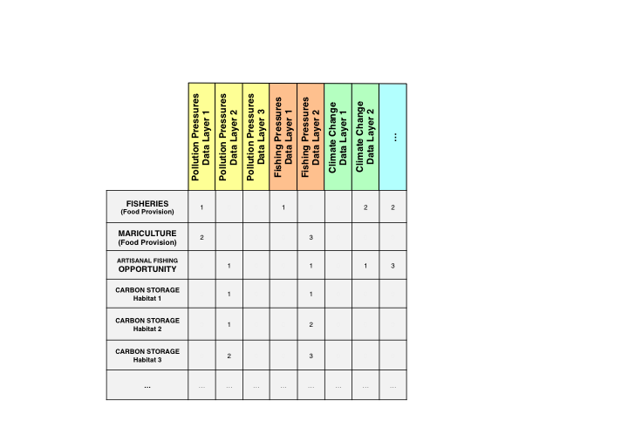

Scores from 1-3 are given to rank the importance of each pressure. Only values of 2 or 3 require that a resilience layer be activated when calculating the goal scores.

While pressures and resilience are usually displayed as two-dimensional matrices, they are actually three-dimensional matrices: each stressor should have data for each region in the study area, which is the third dimension of the matrix, as shown in the figure. The Toolbox will combine the data with the rank weights to calculate the pressures scores. Therefore, pressure weights should not be applied to the regions, but only to the goals. The Toolbox will multiply the stressor score for each region by the weight (1, 2, 3) assigned to that pressure for a specific goal and subgoal, and then it will combined that score within its appropriate pressure category as previously discussed.

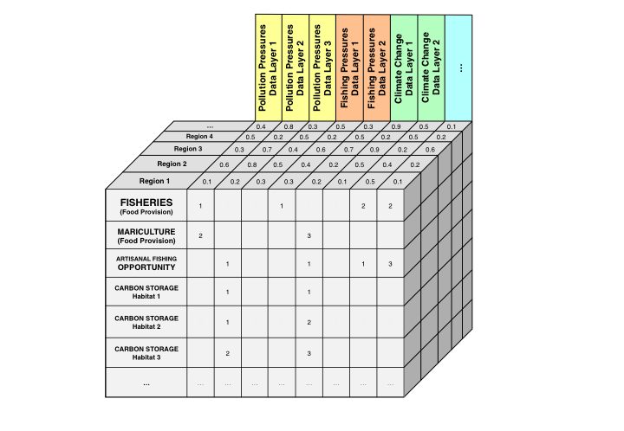

The pressures matrix is three-dimensional: each pressure layer has data per region, which is multiplied by the ranking weights of the pressures matrix.

Each pressure with a rank weight of 2 or 3 should have a corresponding resilience measure, which is meant to 'balance' the pressures since these have the greatest effect on ocean health. The Ocean Health Index considers resilience in two categories: **ecological resilience** to address ecological pressures, and **social resilience**, which may not be strictly marine-related, but they can help estimate how a region may be able to respond to or prevent new environmental challenges. Additionally, **goal-specific regulations** are intended to address ecological pressures, and are measured as laws, regulations, and other institutional measures related to a specific goal. Ideally, for any resilience measure, you would have three tiers of information:

* **Existence of regulations**: Are regulations in place to appropriately address the ecological pressure?
* **Implementation and enforcement**: Have these regulations been appropriately implemented and are there enforcement mechanisms in place?
* **Effectiveness and compliance**: How effective have the regulations been at mitigating these pressures and is there compliance with these regulations?

Ideally, information would exist for these three tiers, and you would be able to weight the resilience measure based on the quality of the information as 1 (existence of regulation), 2 (implementation and enforcement), or 3 (effectiveness and compliance). This approach is different from the way ranks are assigned in pressures, which is based on impact. However, in most cases, information is not available for these three tiers: often, the existence of regulations is all that is available, and this does not always vary by region. In some cases, you may want to consider building your own set of indicators to determine **implementation and enforcement** and **effectiveness and compliance.**

### Incorporating local pressures in your assessment

The pressures you will include in your assessment will depend on what is important in your study area and what data are available. If local pressures data are not available, you may default to using data from the global assessment, but this means in most cases that you will not have different information for each region (See **Including pressures from global assessments**). You will determine the weight ranks required in the pressures matrix only after you have identified the data you will include.

The following steps outline the process of how to include pressures in your assessment. The steps are iterative; return to previous steps to ensure you capture all important pressures in your study area:

1. Begin by exploring pressures important to your study area. What are big stressors acting along your coastlines?
2. Are data available to measure these stressors? If not, are other indirect measures or proxies available to represent these stressors?
3. Evaluate the pressures included in the global assessment. For example, if there is no mariculture in your study area, you could remove pressures data layers that only affect this goal (i.e. genetic escapes).
4. Are all of them relevant? Are there local data that can be substituted in the place of global data?
5. Determine the pressure category for any additional stressors in your study area, and add it to the pressures matrix.
6. When all stressors are included in the pressures matrix, determine which goals it affects. Then, determine the weight rankings of all stressors for each goal. Use literature and expert judgement to determine this.
7. Prepare each pressure data layer as described in this manual only after steps 1-6 are completed. In addition to the proper formatting for the Toolbox, pressures data must be rescaled (normalized) on a unitless scale from 0 - 1, where 0 is no stressor at all and 1 is the highest possible value for the stressor, or the value at which the goal achievement is completely impaired. You will have to determine how to rescale the data, whether it is based on the highest value in the data range or other methods.

#### Including pressures from global assessments

If you are not able to find local data for stressors, you may use the data from the global assessments for your country. For most of the stressors, this means that there will not be differences between the regions within your study area. However, several stressors included in the global assessment are based on spatial data at high resolution from previous work by Halpern *et al.* (2008) in *Science:* [A global map of human impact on marine ecosystems](http://www.sciencemag.org/content/319/5865/948.abstract). These data are available at a resolution of 1 km^2 for the entire global ocean, and can be extracted for the regions in your study area. The stressors available at 1km^2 resolution are indicated below with ** ** **.

**Table of pressures layers and descriptions**

|  |  |
| --- | --- |
| layer | name |
| cc_acid** | Ocean acidification |
| cc_slr** | Sea level rise |
| cc_sst** | Sea surface temperature (SST) anomalies |
| cc_uv** | UV radiation |
| fp_art_hb | High bycatch caused by artisanal fishing |
| fp_art_lb | Low bycatch caused by artisanal fishing |
| fp_com_hb | High bycatch caused by commercial fishing |
| fp_com_lb | Low bycatch caused by commercial fishing |
| fp_targetharvest | Targeted harvest of cetaceans and sea turtles |
| hd_intertidal | Coastal population density as a proxy for intertidal habitat destruction |
| hd_subtidal_hb | High bycatch artisanal fishing practices as a proxy for subtidal hard bottom habitat destruction |
| hd_subtidal_sb | High bycatch commercial fishing practices as a proxy for subtidal soft bottom habitat destruction |
| po_chemicals** | Ocean-based chemical pollution |
| po_chemicals_3nm** | Land-based chemical pollution |
| po_nutrients** | Ocean nutrient pollution |
| po_nutrients_3nm** | Coastal nutrient pollution |
| po_pathogens | Access to improved sanitation as a proxy for pathogen pollution |
| po_trash | Trash pollution |
| sp_alien | Alien species |
| sp_genetic | Introduced species as a proxy for genetic escapes |
| ss_wgi | Weakness of governance indicated with the WGI |

Note that chemical and nutrient pollution have both land-based (within 3 nautical miles) and ocean-based (within the entire 200 nautical mile EEZ) elements. This is because how pollution affects different goals will depend on the spatial scale of the goal's activity. Some goals occur far from shore, and nutrient and chemical pollution should be included for all offshore waters: FIS, MAR, ECO, and SPP. However, some goals are really only relevant nearshore, so nutrient and chemical pollution should only be included close to the shoreline (3nm in the global study): AO, CS, CP, TR, ICO, LSP, HAB.

These distinctions won't always apply for smaller-scale assessments. For example, in the US West Coast study (Halpern *et al.* 2014), we did not distinguish between offshore and 3nm and therefore only used the po_nutrients data layer.

## Guide to searching for resilience metrics

### Ideal Approach

Ideally, assessments of social resilience would include national-level and as well as local rules and other relevant institutional mechanisms that are meant to safeguard ocean health. The global focus has been on international treaties and indices, so your region should have more localized information. There would also be information as to their effectiveness and enforcement. of more. Information on social norms and community (and other local-scale) institutions (such as tenure or use rights) that influence resource use and management would be useful too.

#### Practical Considerations

In practical terms, resilience is hard to define and finding data can be difficult. It is often difficult to find regulations and indicators that would directly 'balance' individual stressors, but it is worth the effort to explore what information is available in the local context and how it could be included as resilience measures. You may be able to construct your own set of indicators for resilience (particularly social resilience) using proxy data. Your team may have to get creative to develop appropriate assessment measures here. It can be metrically be defined as presence-versus-absence (value of zero or one), or on a scale (value between zero and one) if the measure is an assessment or score. For instance in the global study, resilience measures that were counted in the socio-economic resilience class of data came from the World Governance Indicators (<http://govindicators.org>). In a regional context, however, a more appropriate data layer might be a local governance index of some kind, preferably developed by a reputable organization using credible methods.

When available, National-level data are preferable to global-level data for your assessment. These include national laws on the environment, or protection of the marine environment or rivers that lead to coastal waters. National laws include things like the Clean Water Act (CWA) and the Endangered Species Act (ESA) in the U.S., or the national implementations of the E.U. Water Framework Directive. National actions can also be broadened beyond just legislation to include administrative procedures such as those involving permits, licenses, court cases, administrative action, and compliance mechanisms. [Cultural items at the national scale, such as holidays, are also applied at this scale]

State or province-level laws provide more regionally-specific information and thus work well for assessments. This would involve looking at the same types of laws and policies that exist on the national level, but specifically incorporating those that have been tailored to fit the needs of a particular sub-national area. This includes things such as California's state-level California Environmental Quality Act (CEQA), or the California Ocean Protection Act (COPA), which have laws designed specifically to protect California's environment. This would tell you more relevant information than using data from a national or international law. Local level regulations will usually provide you with the most accurate information for your assessment in order to tailor it best to the local context.

#### Scoring: Turning Qualitative into Quantitative

There are several ways to turn the qualitative information of regulations and social actions into quantitative metrics for analysis. A robust way is to give credit for different aspects of the resilience measures. In addition to a score for having the law, policy, or action, in place, it is possible to gauge the effectiveness of that activity.

The simplest way is to give credit for having a resilience measure in place. This means assigning a binary score of zero or one for "presence" versus "absence" of the resilience measure. For international conventions, this can be done by assigning a value of 1 for having signed a convention. A more rigorous score can be given for countries that have further *ratified* a convention in addition to signing it; this is one way to further differentiate scores. This can be done by seeing if a country has signed and ratified CITES, for example.

For example, if you were trying to find out if there are regulations in place that guide fishing pressure, you could look see if regulations exist for trawl-fishing limitations, or see if there are regulations for fish size, length, or if there are any seasonal restrictions. Another option would be to see if formal stock assessments exist for commercially-fished species.

A further step is to assess how well those measures are being complied with. This will give you more robust way is to assess how well a resilience mechanism is working to maintain the integrity of the regulation and thereby the ecosystem.

For example, once you have found out whether regulations for fishing pressure exist, you would then try to find values for compliance with these regulations. These could be raw data or calculated statistics such as rate of compliance or proportion of compliance. It should answer the question, "Are there indicators of compliance with fishing pressure guidelines"?

A subsequent, and final, step to creating a robust resilience assessment is to determine whether there are enforcement mechanisms in place to deal with non-compliance of the regulations. This is because a regulation is only as good as its implementation, and having both enforcement and compliance actions in place would reinforce the regulation and make it more effective.

For example, in the case of fishing pressures, a further look into available data could lead you learn whether there are reported values of inspector visits and enforcement coverage of permitted facilities. Or you could look at reported numbers of enforcement actions in response to non-compliance. Further, you could also see if there are fines that have been paid or exist in association with non-compliance.

#### Data sources

Environmental laws and policies offer tangible information on resilience. The most common type of environmental regulations come from administrative law, such as pollution regulation of various kinds. Land-use law is also important to the integration of social and ecosystem issues, so finding zoning laws relevant for coastal areas could be useful, and so could finding whether or not a region requires environmental impact statements before allowing construction for either coastal land or for marine planning. Other kinds of law some countries include court cases settling disputes or requiring reparation of pollution damages, for example.

Resilience also goes beyond just the law, however. Insurance policies present another option, for instance.. Coastal areas are increasingly requiring climate-related insurance in some countries, and so the existence of such markets in a vulnerable area would be an example of a climate change resilience measure. Social initiatives also present another way to tackle resilience. There might be a beach clean-up day, a percentage of the refuse material that is recycled by the population, or some other social factor that reduces trash inputs into the ocean. A local law banning plastic bags is another way that local jurisdictions control plastic trash.

In the Brazil study (2014), the marine trash resilience was calculated by counting up whether localities had one of four garbage management services, including access to beach clean-up services, household garbage collection, household recycling collection, and garbage collection in public streets.

### Incorporating local resilience measures in your assessment

1. Begin by exploring how resilience could be measured in your study area. What laws and regulations are in place that could provide resilience to ocean health?
2. Are there locally-developed indices that capture social or ecological resilience? Is there information about how each region in your study area are implementing or enforcing the laws?
3. Evaluate the resilience measures are included in the global assessment. Are all of them relevant? Are there local data that can be substituted in the place of global data? Are there resilience measures that should be excluded entirely?
4. Assign the resilience measure to the appropriate goal. Since resilience measures are in response to pressures that have a weight rank of 2 or 3 effect on a certain goal, determining which goals ecological and social resilience measures effect follows the same pattern as the pressures matrix. For goal-specific resilience measures, assign the resilience measure to the appropriate goal.
5. Prepare each resilience data layer only after steps 1-6 are completed. In addition to the proper formatting for the Toolbox, resilience data must be rescaled (normalized) on a unitless scale from 0 - 1. You will have to determine how to rescale the data, whether it is based on the highest value in the data range or other methods.

#### Including resilience measures from global assessments

Remember that local measures are far more appropriate than those included in global assessments, which likely do not reflect local management targets. However, international data were used in the global assessments that are available to you if you cannot find better local data:

**Table of resilience layers and descriptions**

|  |  |
| --- | --- |
| layer | name |
| alien_species | Alien species |
| cites | Resilience from commitment to CITES |
| fishing_v1 | CBD survey: coastal fishing v1 |
| fishing_v1_eez | CBD survey: ocean fishing v1 |
| fishing_v2_eez | CBD survey: ocean fishing v2 |
| fishing_v3 | CBD survey: coastal fishing v3 |
| fishing_v3_eez | CBD survey: ocean fishing v3 |
| habitat | CBD survey: habitat |
| habitat_combo | CBD survey: coastal habitat |
| habitat_combo_eez | CBD survey: ocean habitat |
| li_gci | GCI: competitiveness in achieving sustained economic prosperity |
| li_sector_evenness | Sector evenness as a measure of economic diversity |
| mariculture | CBD survey: mariculture |
| msi_gov | MSI sustainability and regulations |
| species_diversity | Ocean ecological integrity |
| species_diversity_3nm | Coastal ecological integrity |
| tourism | CBD survey: tourism |
| water | CBD survey: water |
| wgi_all | Strength of governance indicated with the WGI |

* *CBD = Convention on Biological Diversity; GCI = Global Competitiveness Index; MSI = Mariculture Sustainability Index; WGI = World Governance Indicators*.

# The Ocean Health Index Toolbox

**Section Summary:**

In this section, you will learn the basics of how to use the OHI Toolbox to conduct your assessment. You will be introduced to files the Toolbox requires, how you will modify them, and how they interact to calculate the final output scores.

**The OHI Toolbox** is an ecosystem of small files and scripts that are the tools needed to calculate OHI scores. These files and scripts are stored in two '*repositories*': folders that are synchronized with collaborators. The first folder is your **assessment repository** that has a three-letter code, such as *esp* for Spain or *ecu* for Ecuador. You will edit this repository with your data, goal models, and updated pressures and resilience matrix tables. The second repository is called **ohicore** and it contains core functions for combining your data and goal models to calculate OHI scores. You will not edit ohicore, but you are able to explore it to understand the calculations.

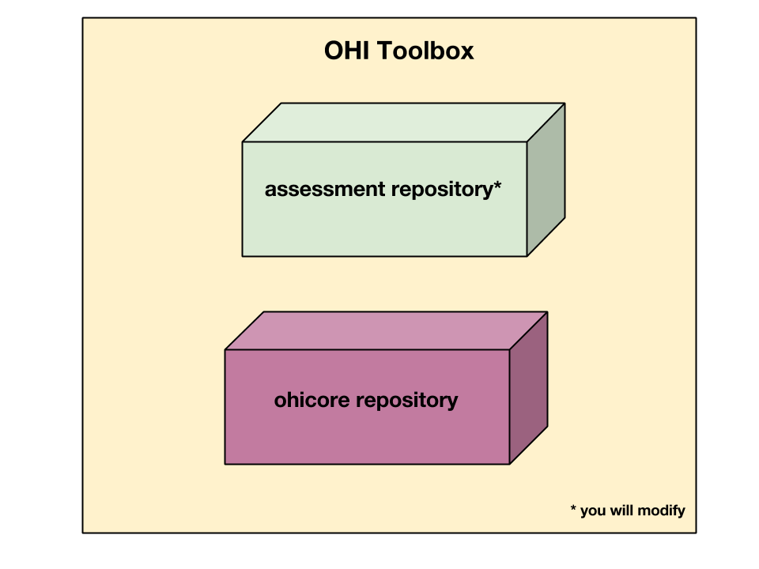

Toolbox = your repo + ohicore

Your **assessment repository** contains data input layers, configuration files, and scripts. These files are organized in the same way within a *scenario folder* called subcountry2014, with data layers, goal model equations, and configuration files from the global 2014 assessment. Files within the scenario folder are comma-separated-value (*.csv*) files and scripts written in the programming language *R*.

**Each OHI+ assessment repository has inputs and goal models based on the 2014 global assessment**. This means that each assessment repository isolates the information used for each region in the global assessment and stores it in a separate OHI+ assessment repository. Therefore, it can be an easy way to explore the inputs used in the global assessment for one specific place. When conducting an assessment, you will replace and modify as much of this information with local information that better represents your study area, since information reported at a national scale cannot always be attributed to its subcountry regions, as has been done in most cases in each OHI+ assessment repository. See more details in the discussion of the **layers folder**.

The Toolbox is open-source and can be downloaded and installed for free. You are able to navigate through these files both at www.github.com/OHI-Science and on your own computer once you have cloned the repository to your computer. GitHub is an online platform used by the OHI that facilitates collaboration and archives past versions of all files with the author indicated. It can be accessed remotely by all members of your team and enables team members to synchronize their work remotely. Because all versions are saved, you can return to previous work and also compare different points in history to track how changes you make affect the output scores. Instruction on how to access your assessment repository is in the Installing the Toolbox section.

The following sections will describe the files included in the Toolbox. You will then learn what is required for data layers for your assessment and how to change goal models.

## Assessment repositories: file system organization

This section is an orientation to the files within your assessment repository. The file system organization is the same for all assessment repositories, and can be viewed at github.com/OHI-Science or on your computer. While reading this section it is helpful to explore a repository at the same time to become familiar with its contents and structure. The following uses the assessment repository for Ecuador (*ecu*) as an example, available at www.github.com/OHI-Science/ecu.

### Assessment repositories

**Assessment repositories** are identified by a three-letter code; Ecuador's assessment repository is called '*ecu*'. Assessment repositories contain several things:

* The **scenario folder** is the most important folder within the repository; by default it is named subcountry2014. It contains all of the inputs needed to calculate OHI scores, and you will modify these inputs when conducting your assessment. The scenario folder is explained in detail in this section.
* All other files in the assessment repository are accessory files. Files with names beginning with a ‘.’ are required for versioning capabilities by GitHub and do not appear when the assessment repository is viewed on your computer.

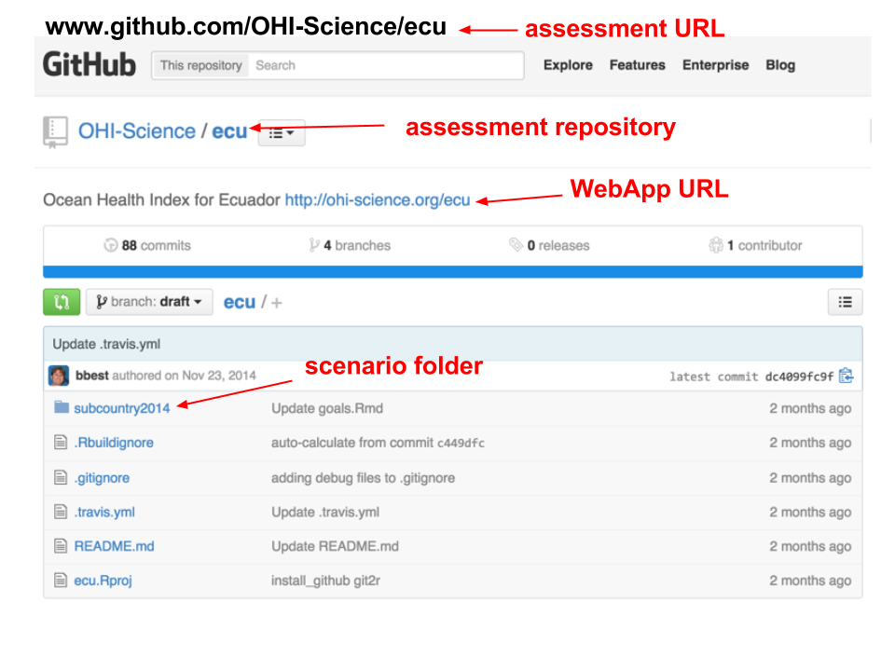

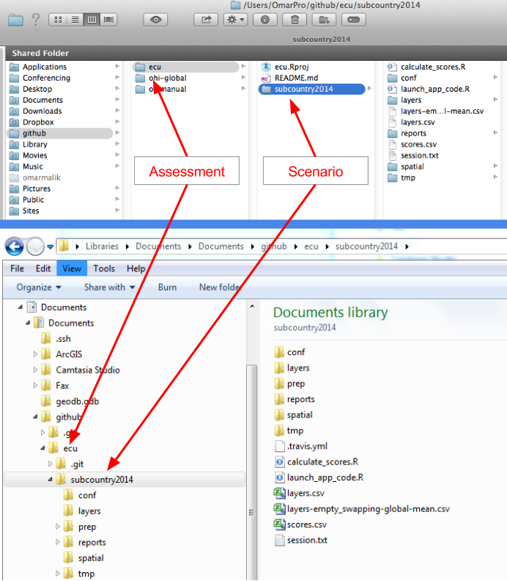

Navigating the assessment repository. The figure shows Mac folder navigation above and Windows navigation below.

### Scenario folders

#### Background

Scenario folders contain all files and scripts necessary to calculate OHI scores. There are two file types:

* ** *.csv* files** contain data inputs or configuration information.
* ** *.R* scripts** are written in the programming language R and use data inputs processing and calculations.

There is one scenario folder in your assessment repository and it is called subcountry2014 to indicate that the assessment is conducted at the subcountry scale (province, state, district, etc.), based on data input layers and goal models used in the 2014 global assessment. When conducting your assessment, you can rename your scenario folder to reflect the subcountry regions in your study area and year the assessment was completed. For example, province2015 would indicate the assessment was conducted for coastal provinces in the year 2015.

Once you complete your assessment with the subcountry2014 (or equivalent) scenario, further assessments can be done simply by copying the subcountry2014 folder and renaming it. This can be done for future assessments, for example subcountry2016 or subcountry2018, which eventually would enable you to track changes in ocean health over time. You can also copy scenario folders to explore different policy and management scenarios, for example subcountry2014_policy1.

### subcountry2014 contents

This figure illustrates the files contained within the subcountry2014 scenario folder.

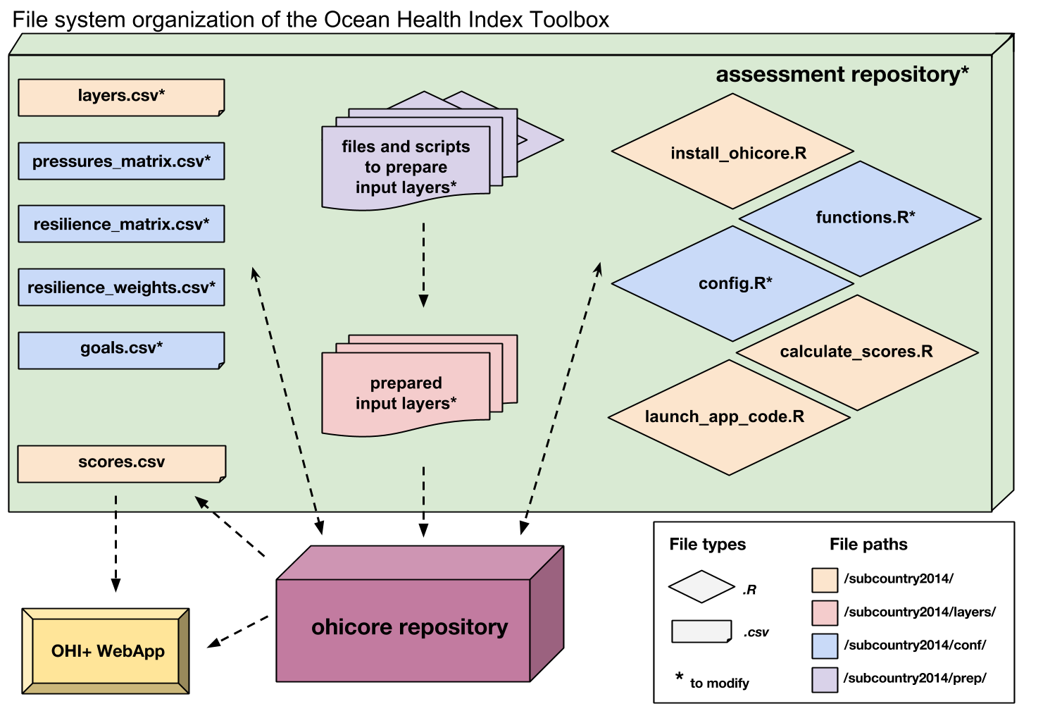

File system organization of the Ocean Health Index Toolbox

These files fall into different categories: some are *.csv* files and some are R scripts, and some are configuration files. Some files you will modify, and some will you leave intact, such as install_ohicore.R which is created and maintained by the OHI+ development team to ensure that your calculations run successfully while the software gets developed. The main place you will spend time will be in **preparing the input data layers** for all of your goal models, pressures, and resiliences. This has partially been indicated for you by the default prep folders in your repository. You will then prepare the **registration of the information in the necessarily places**, and at the same time develop the goal models and code. It will be a back-and-forth process, but generally speaking you will prepare your files first and then run the code in order to produce the calculated scores.

#### *layers.csv*

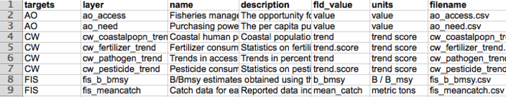

TIP: Keep layers.csv handy. It's a very useful reference throughout the assessment process.

The layers.csv file is the registry that manages all data required for you assessment. All relevant data are prepared as data layers and then registered in this file. The Toolbox will rely on information from this file to use the data layers and display information on the WebApp. You will update some of the layers in layers.csv, and some of them will be auto-generated by the Toolbox code when it's running.

When you open layers.csv, you will see that each row of information represents a specific data layer that has been prepared for the Toolbox. The first columns contain information that will be updated by your team as you incorporate your own data and edits; all other columns are generated later by the Toolbox as it confirms data formatting and content. The columns you should most pay attention to are: *targets, layer, name, description, fld_value, units, filename*.

**The most important columns to pay attention to are**:

* **targets** indicates which goal or dimension uses the data layer. Goals are indicated with two-letter codes and sub-goals are indicated with three-letter codes, with pressures, resilience, and spatial layers indicated separately.
* **layer** is the identifying name of the data layer, which will be used in R scripts like functions.R and *.csv* files like pressures_matrix.csv and resilience_matrix.csv. This is also displayed on the WebApp under the drop-down menu when the variable type is ‘input layer’.
* **name** is a longer title of the data layer; this is displayed on the WebApp under the drop-down menu when the variable type is ‘input layer’.
* **description** is further description of the data layer; this is also displayed on the WebApp under the drop-down menu when the variable type is ‘input layer’.
* **fld_value** the units as determined by the column headers in the source file.
* **units** unit of measure in which the data are reported, to be displayed on outputs later.
* **filename** is the *.csv* filename that holds the data layer information, and is located in the folder subcountry2014/layers.

|  |
| --- |
| Goal (CODE) |
| Food Provision (FP): Fisheries (FIS) and Mariculture (MAR) |
| Artisanal Fishing Opportunity (AO) |
| Natural Products (NP) |
| Coastal Protection (CP) |
| Carbon Storage (CS) |
| Livelihoods and Economies (LE): Livelihoods (LIV) and Economies (ECO) |
| Tourism and Recreation (TR) |
| Sense of Place: Lasting Special Places (LSP) and Iconic Species (ICO) |
| Clean Waters (CW) |
| Biodiversity (BD): Habitats (HAB) and Species (SPP) |

### *install_ohicore.R*

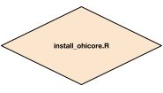

Icon of install_ohicore.R

This script will install ohicore, the engine behind all Toolbox calculations. You will need to run this script only once when using the Toolbox. You will need to run it in oder to run goal functions or calculate scores.

### *launch_app_code.R*

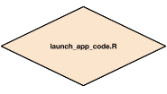

Icon of launch_app_code.R

The Toolbox can be launched on your computer so that you can visualize any edits you make while you are offline. To do this, you will run the code in launch_app_code.R. Make sure you are in the subcountry2014 directory at that time: setwd(~/github/ecu/subcountry2014)

### Your layers folder

The layers folder contains every data layer as an individual *.csv* file. The names of the *.csv* files within the layers folder correspond to those listed in the *filename* column of the layers.csv file described above. All *.csv* files can be read with text editors or with Microsoft Excel or similar software.

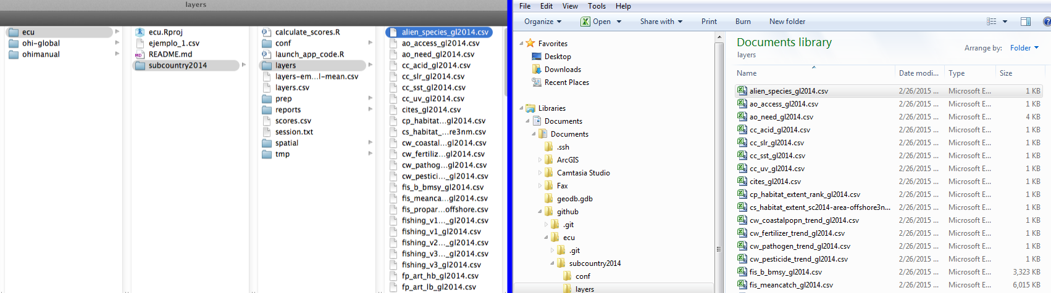

The layers folder contains every data layer as an individual *.csv* file. Mac navigation is shown on the left and Windows navigation is shown on the right.

Note that each *.csv* file within the layers folder has been formatted consistently. The Toolbox expects all data layers to be in the correct 'long format' and in separate files. See **Using the Toolbox** for more.

Now, open the layers/alien_species.csv file: note the unique region identifier (*rgn_id*) with a single associated *score* or *value*, and that the data are presented in long format with minimal columns. See the section on *Formatting Data for the Toolbox* for further details and instructions. Scores can be viewed through the WebApp using the ‘Input Layer’ pulldown menu on the App page.

TIP: You can check your region identifiers (*rgn_id*) in the rgn_labels.csv file in the layers folder.

### Your conf folder

The conf (configuration) folder includes R functions (config.R and functions.R) and *.csv* files containing information that will be accessed by the R functions (goals.csv, pressures_matrix.csv, resilience_matrix.csv, and resilience_weights.csv).

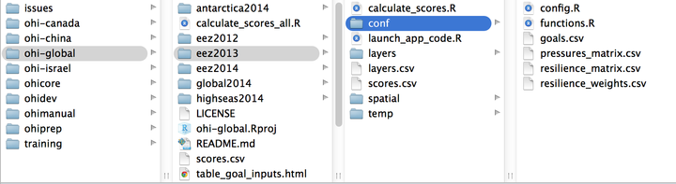

The conf folder contains important R functions and *.csv* files. Mac navigation is shown on the left and Windows is shown on the right.

#### *config.R*

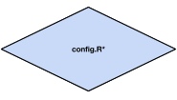

Icon of config.R

The config.R is an R script that configures labeling and constants appropriately.

#### *functions.R*

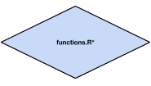

Icon of functions.R

functions.R contains the equations for each goal and sub-goal model, which are stored as R functions. These functions calculate the status and trend using data layers identified as ‘layers’ in layers.csv. When you modify or develop new goal models, you will modify functions.R; you should also be sure to check which other files, such as pressures_matrix.csv

TIP: It's useful to skip to different sections of functions.R to see how key calculations are being done. See section, **Update Functions.R**.

#### *goals.csv*

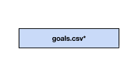

Icon of goals.csv

goals.csv is a list of goals and sub-goals and their weights used to calculate the final score for each goal. Other information includes the goal description that is also presented in the WebApp. goals.csv also indicates the arguments passed to functions.R. These are indicated by two columns: *preindex_function* (functions for all goals that do not have sub-goals, and functions for all sub-goals) and *postindex_function* (functions for goals with sub-goals).

TIP: It's important to check the weightings and preindex functions if you're planning to change the goal or sub-goal models.

#### *pressures_matrix.csv*

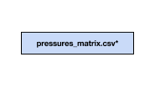

Icon of pressures_matrix.csv

pressures_matrix.csv defines the different types of ocean pressures and the goals they affect.

Each column in the pressures matrix identifies a data layer that is also registered in layers.csv: and has a prefix (for example: po_ for the pollution category). The pressure data layers are also required to have a value for every region in the study area, with the region scores ranging from 0-1.

#### *resilience_matrix.csv*

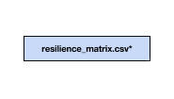

Icon of resilience_matrix.csv

resilience_matrix.csv defines the different types of resilience with the goals that they affect.

Like the pressures matrix, the resilience matrix also has weights depending on the level of protection. However, these weights are in a separate file: resilience_weights.csv.

Each column in the resilience matrix is a data layer that is also registered in layers.csv. Resilience layers, like the pressure layers, are also required to have a value for every region in the study area. Resilience layers each have a score between 0-1.

#### *resilience_weights.csv*

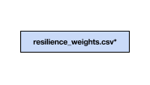

Icon of resilience_weights.csv

resilience_weights.csv describes the weight of various resilience layers, which in Halpern *et al*. 2012 (*Nature*) were determined based on scientific literature and expert opinion.

### *calculate_scores.R*

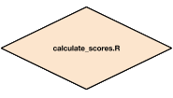

Icon of calculate_scores.R

calculate_scores.R is a script that tells the Toolbox to calculate scores using the *.csv* files in the layers folder that are registered in layers.csv and the configurations identified in config.R. Scores will be saved in scores.csv.

### *scores.csv*

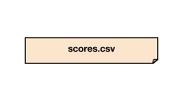

Icon of scores.csv

scores.csv contains the calculated scores for the assessment. Currently, these scores were calculated using data for your country from the global 2014 assessment. Scores are reported for each dimension (future, pressures, resilience, score, status, trend) for each region in the study area (with region identifier), and are presented in ‘long’ format. Scores can be viewed through the WebApp using the ‘Output Score’ pulldown menu on the 'App' page.

### Your *spatial* folder

The spatial folder contains a single file, regions_gcs.js. This is a spatial file in the JSON format; it spatially identifies the study area and regions for the assessment. If you plan to modify your study area or regions, you will need to upload a *.js* file with appropriate offshore boundaries.

You will need a GIS or **Spatial Analyst** to do this: see <http://ohi-science.org/pages/create_regions.html> for some instruction.

#### *layers-empty_swapping-global-mean.csv*

This file contains a list of data layers that were used in the Global Assessment that were note used for your country after you have run calculate_scores.R. Without these data for your country, global averages are included in your subcountry2014 scenario folder so the Toolbox can calculate scores until you replace these data with appropriate data for your study area. This file is not used anywhere by the Toolbox but is a registry of data layers that should prioritized to be replaced with your own local data layers.

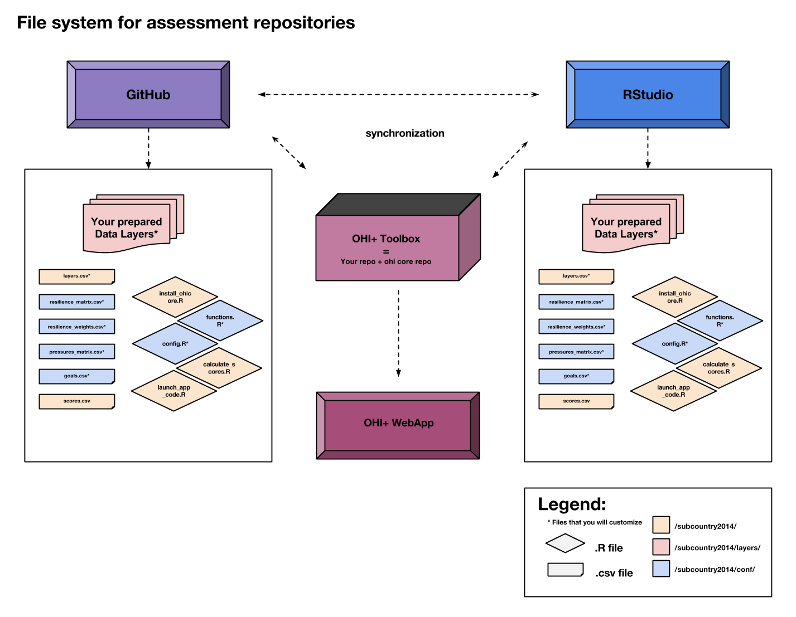

The file system you will use will be available both on your computer and on the Web.

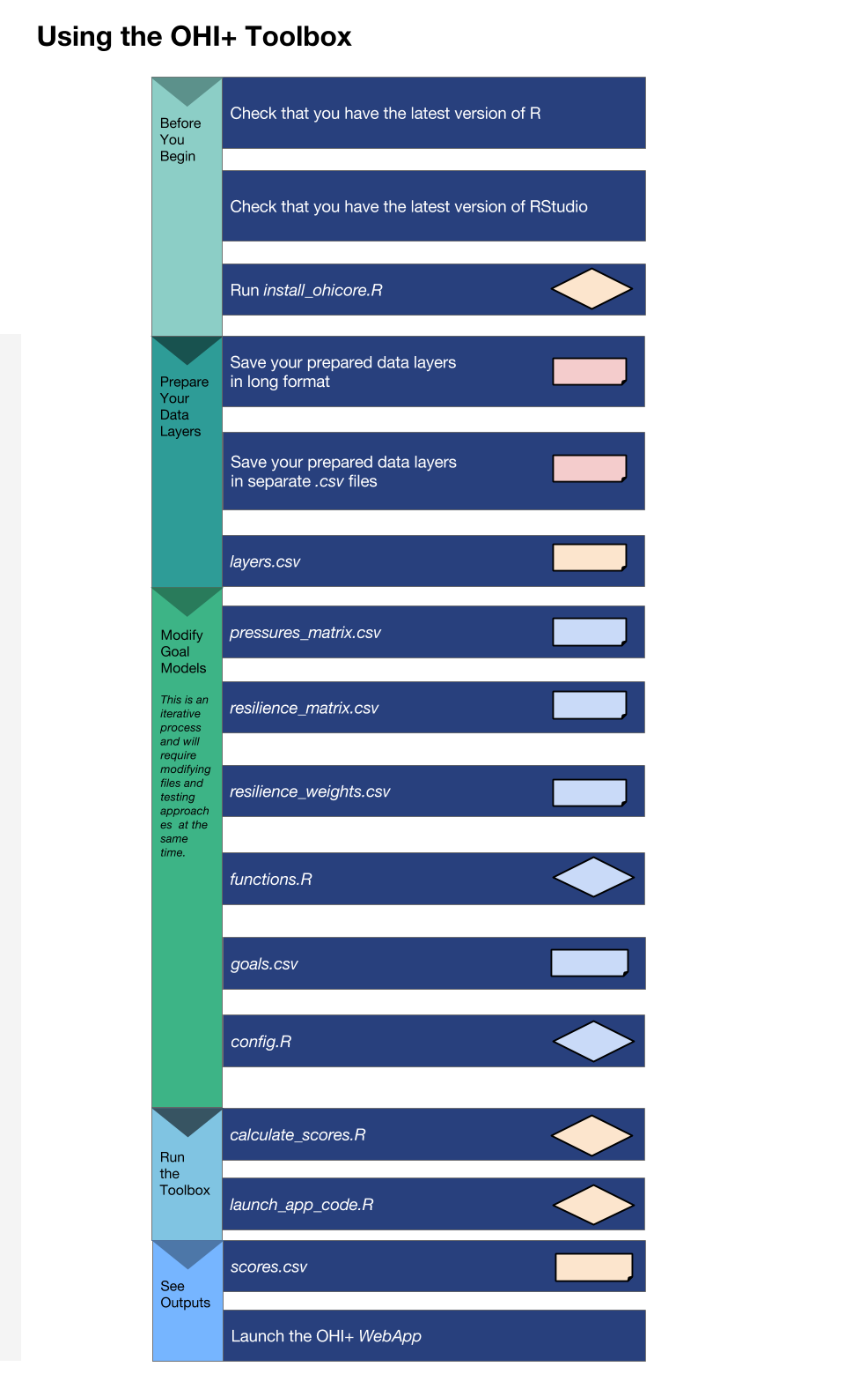

Recommended steps in which to engage with files in the OHI Toolbox.

## Formatting Data for the Toolbox

### Introduction

The OHI Toolbox is designed to work in the programming language **R** using input data stored in text-based *.csv* files (*csv* stands for 'comma-separated value'; these files can be opened as a spreadsheet using Microsoft Excel or similar programs). Each data layer (data input) has its own *.csv* file, which is combined with others within the Toolbox for the model calculations. These data layers are used for calculating goal scores, meaning that they are inputs for status, trend, pressures, and resilience. The global analysis included over 100 data layer files, and there will probably be as many in your own assessments. This section describes and provides examples of how to format the data layers for the Toolbox.

OHI goal scores are calculated at the scale of the reporting unit, which is called a ‘**region**’ and then combined using an area-weighted average to produce the score for the overall area assessed, called a ‘**study area**’. The OHI Toolbox expects each data file to be in a specific format, with data available for every region within the study area, with data layers organized in 'long' format (as few columns as possible), and with a unique region identifier (*rgn_id*) associated with a single *score* or *value*. In order to calculate trend, input data must be available as a time series for at least 5 recent years (and the longer the time series the better, as this can be used in setting temporal reference points).

The example below shows information for a study area with 4 regions. There are two different (and separate) data layer files: tourism count (tr_total.csv) and natural products harvested, in metric tonnes (np_harvest_tonnes.csv). Each file has data for four regions (1-4) in different years, and the second has an additional 'categories' column for the different types of natural products that were harvested. In this example, the two data layers are appropriate for status calculations with the Toolbox because:

1. At least five years of data are available,
2. There are no data gaps
3. Data are presented in 'long' or 'narrow' format (not 'wide' format -- see "**Long Formatting**"" section).

**Example of data in the appropriate format:**

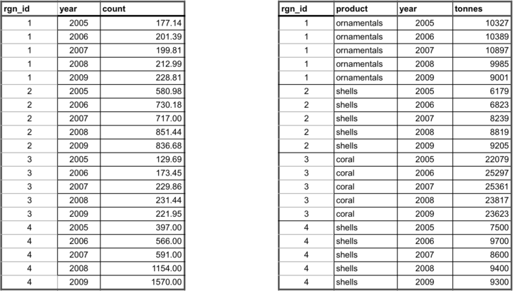

### Gapfilling

It is important that data prepared for the Toolbox have no missing values or 'gaps'. Data gaps can occur in two main ways: 1) **temporal gaps**: when several years in a time series in a single region have missing data, and 2) **spatial gaps**: when all years for a region have missing data (and therefore the whole region is 'missing' for that data layer).

How these gaps are filled will depend on the data and regions themselves, and requires thoughtful, logical decisions to most reasonably fill gaps. Each data layer can be gapfilled using different approaches. Some data layers will require both temporal and spatial gapfilling. The examples below highlight some example of temporal and spatial gapfilling.

All decisions of gapfilling should be documented to ensure transparency and reproducibility. The examples below are in Excel, but programming these changes in software like R is preferred because it promotes easy transparency and reproducibility.

#### Temporal gapfilling

Temporal gaps occur when a region is missing data for some years. The Toolbox requires data for each year for every region. It is important to make an informed decision about how to temporally gapfill data.

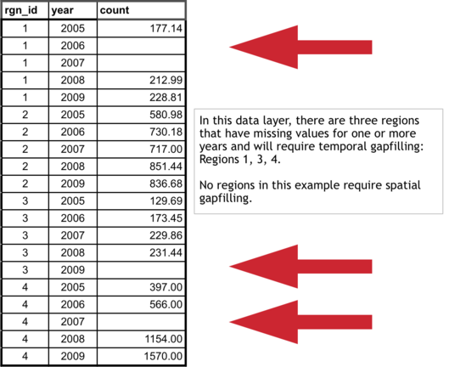

Often, regression models are the best way to estimate data and fill temporal gaps. Here we give an example that assumes a linear relationship between the year and value variables within a region. If data do not fit a linear framework, other models may be fit to help with gapfilling. Here we give an example assuming linearity.

Using a linear model can be done in most programming languages using specific functions, but here we show this step-by-step using functions in Excel for Region 1.

**Temporal gapfilling example (assumes linearity: able to be represented by a straight line on a graph)):**

There are four steps to temporally gapfill with a linear model, illustrated in the figures with four columns.

**1. Calculate the slope for each region**

The first step is to calculate the slope of the line that is fitted through the available data points. This can be done in Excel using the **SLOPE(known_y's,known_x's)** function as highlighted in the figure below. In this case, the x-axis is *years* (2005, 2006, etc...), the y-axis is *count*, and the Excel function automatically plots and fits a line through the known values (177.14 in 2005, 212.99 in 2008, and 228.81 in 2009), and subsequently calculates the slope (12.69).

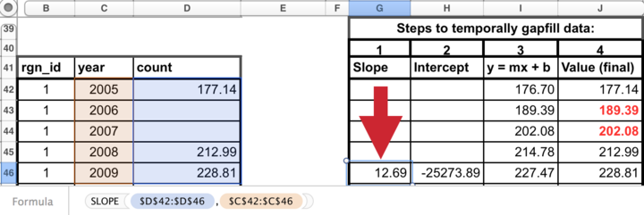

**2. Calculate the y-intercept for each region**

The next step is to calculate the intercept of the line that is fitted through the available data points. This can be done in Excel similarly as for the slope calculation, using the the **INTERCEPT(known_y's,known_x's)** function that calculates the y-intercept (-25273.89) of the fitted line.

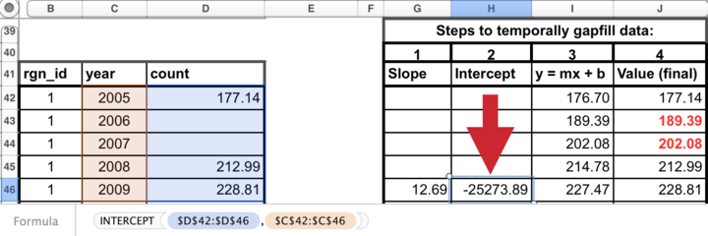

**3. Calculate y for all years**

The slope and y-intercept that were calculated in steps 1 and 2 can then be used along with the year (independent variable) to calculate the unknown 'y-values'. To do so, simply replace the known three values into the **y = mx + b** equation (m=slope, x=year, b=intercept), to calculate the unknown 'count' for a given year (189.39 in 2006, and 202.08 in 2007).

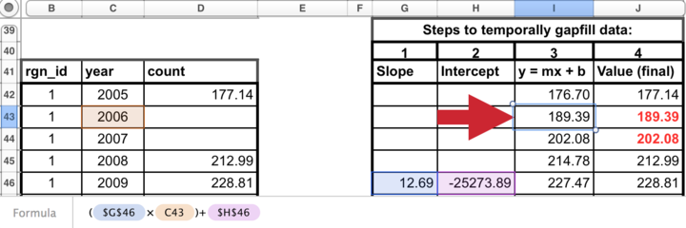

**4. Replace modeled values into original data where gaps had occurred**

Substitute these modeled values that were previously gaps in the timeseriew. *The data layer is now ready for the Toolbox, gapfilled and in the appropriate format.*

#### Spatial gapfilling

Spatial gaps are when no data are available for a particular region. The Toolbox requires data for each region. It is important to make an informed decision about how to spatially gapfilling data.

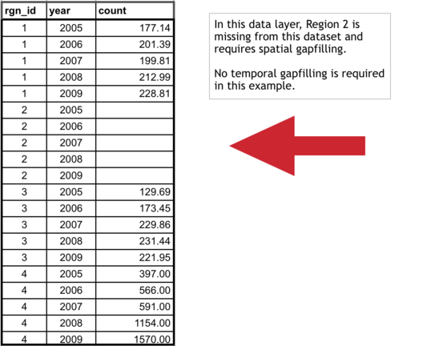

To fill gaps spatially, you must assume that one region is like another, and data from another region is adequate to be substituted in place of the missing data. This will depend on the type of data and the properties of the regions requiring gapfilling. For example, if a region is missing data but has similar properties to a different region that does have data, the missing data could be 'borrowed' from the region with information. Each data layer can be gapfilled using a different approach when necessary.

**Characteristics of regions requiring gapfilling that can help determine which type of spatial gapfilling to use:**

1. proximity: can it be assumed that nearby regions have similar properties?
2. study area: are data reported for the study area, and can those data be used for subcountry regions?
3. demographic information: can it be assumed a region with a similar population size has similar data?

**Spatial gapfilling example:**

For a certain data layer, suppose the second region (*rgn_id 2*) has no data reported, as illustrated in the figure above. How to spatially gapfill *rgn_id 2* requires thinking about the properties and characteristics of the region and the data, in this case, tourist count.

Here are properties that can be important for decision making:

*rgn_id 2*:

* is located between *rgn_id 1* and 3
* is larger than *rgn_id 1*
* has similar population size/demographics to *rgn_id 3*
* has not been growing as quickly as *rgn_id 4*

There is no absolute answer of how to best gapfill *rgn_id 2*. Here are a few reasonable possibilities:

Assign *rgn_id 2* values from:

* *rgn_id 1* because it is in close proximity to *rgn_id 2*
* *rgn_id 3* because it is in close proximity to *rgn_id 2* and has similar population size/demographics
* *rgn_id 1* and 3 averaged since they are in close proximity to *rgn_id 2*

Suppose the decision was made to gapfill *rgn_id 2* using the mean of *rgn_id 1* and *3* since this would use a combination of both of those regions. Again, other possibilities could be equally correct. But some form of spatial gapfilling is required so a decision must be made. The image below illustrates this in Excel.

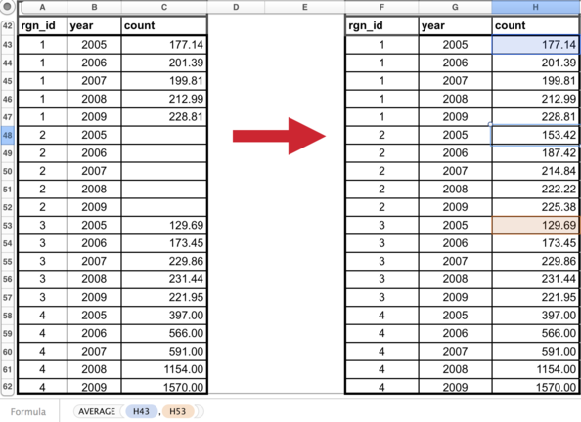

The data layer is now ready for the Toolbox, gapfilled and in the appropriate format.

### Long formatting

The Toolbox expects data to be in 'long' or 'narrow' format. Below are examples of correct and incorrect formatting, and tips on how to transform data into the appropriate format.

**Example of data in an incorrect format:**

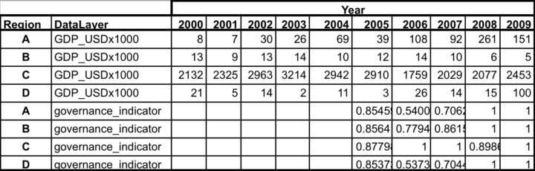

With 'wide' format, data layers are more difficult to combine with others and more difficult to read and to analyze.

**Transforming data into 'narrow' format:**

Data are easily transformed in a programming language such as R.

In R, the reshape package has the melt command, which will melt the data from a wide format into a narrow format. It also can cast the data back into a wide format if desired. R documentation:

* <http://cran.r-project.org/web/packages/reshape2/reshape2.pdf>
* <http://www.slideshare.net/jeffreybreen/reshaping-data-in-r>
* <http://tgmstat.wordpress.com/2013/10/31/reshape-and-aggregate-data-with-the-r-package-reshape2/>

Example code using the *melt* command in the *reshape2* library. Assume the data above is in a variable called *data_wide*:

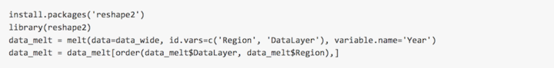

This will melt everything except any identified columns (*Region* and *DataLayer*), and put all other column headers into a new column named *Year*. Data values will then be found in a new column called *value*.

The final step is optional: ordering the data will make it easier for humans to read (R and the Toolbox can read these data without this final step):

**Example of data in the appropriate (long) format:**

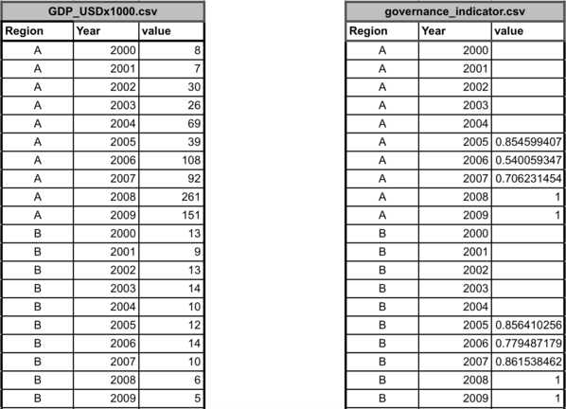

### Rescaling your data

An important consideration is how to rescale your data when preparing it for use in the Toolbox. Rescaling involves turning a distribution of data into a value from zero to one. This is based on finding a highest observed or theoretical point in the distribution of the data, and from there, the relative value of the data can be calculated.

#### Example: Global Data Approach

You should base your decision on whether your consider it more appropriate to decide the reference point based on the data distribution of all data points, be they observed or interpolated, or whether we think we should only consider the observed data. If the interpolation covers large areas, and these get assigned values that aren't very frequent in the observed data, then the two distributions will be very different, and what value is in the 99.99th percentile is different too.

In theory, one would favor deciding the reference point based on as many observations as possible (i.e., interpolate first, then obtain the percentile). In practice, if we think that large interpolated areas are very unreliable, we might prefer to use real observations only (i.e., percentile first, then interpolate).

# Installing the Toolbox

**Section Summary:**

In this section, you will learn how to successfully download, install, and use the software required to conduct an assessment. You will create a GitHub account and install R, RStudio, git, and the Github desktop app. OHI assessments are conducted through open-source platforms that allow you to make real-time changes with collaborators, and to track progress so that errors can be corrected and new insights can be shared in the future.

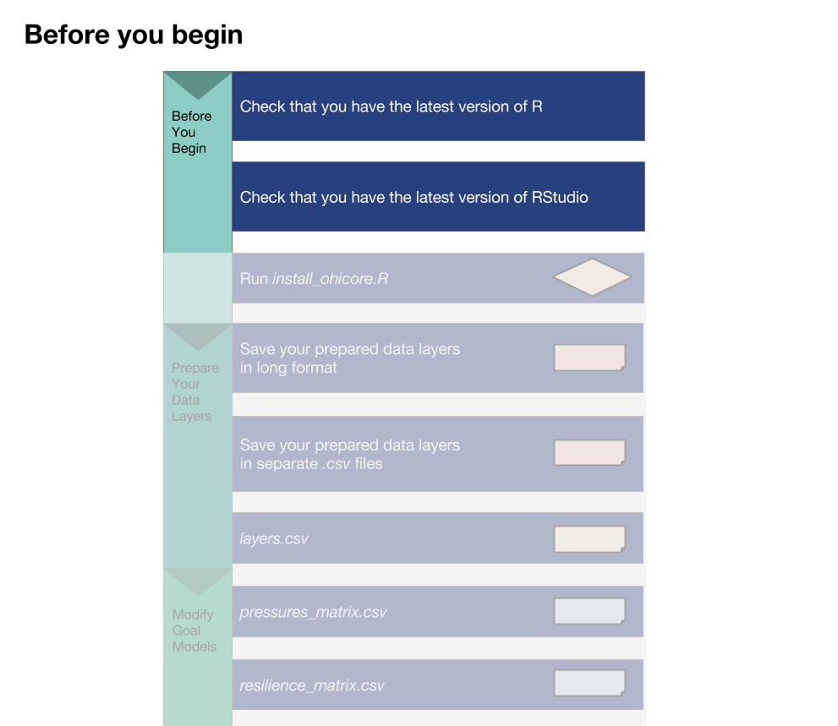

Before you begin using the Toolbox, you should download and install all necessary software.

## Overview

The **OHI Toolbox** is essentially several folders containing all the files required for an OHI assessment. These folders are stored online on www.github.com, and are called **GitHub repositories**. At this point, you should already be familiar with your assessment’s repository, and all of the files it contains (if not, read the section, "**File System for Assessment Repositories**").

Conducting an OHI assessment using GitHub enables collaboration and transparency, and will provide access to the latest developments in the Toolbox software, allowing the OHI team to provide support remotely if necessary.

This section explains the GitHub workflow and how to access and setup required software. Then, it explains how to after modifying files on your own computer, you can use GitHub to upload any modifications you make so that you can work collaboratively with your team.

**Required software:**

1. **Github App**
2. ** *git* **
3. **R**
4. **RStudio**

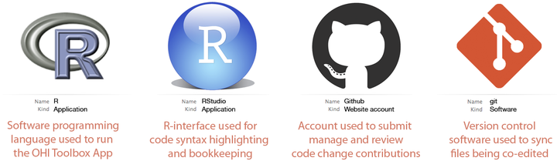

## GitHub

**GitHub** is an open-source development platform that enables easy collaboration and versioning, which means that all saved versions are archived and attributed to each user. It is possible to revert back to any previous version, which is incredibly useful to not only to document what work has been done, but how it differs from work done in the past, and who is responsible for the changes.

**GitHub Vocabulary:**

* **clone** ~ download to your computer from online version with synching capabilities enabled
* **commit** ~ message associated with your changes at a point in time
* **pull** ~ sync a repo on your computer with online version
* **push** ~ sync the online repo with your version, only possible after committing

**sync = pull + commit + push**

### Learning GitHub

The following section describes how to use GitHub to access and sync your assessment repository. There are also many great resources available online with more in-depth information:

* [**Git and GitHub**](http://r-pkgs.had.co.nz/git.html) by Hadley Wickham: <http://r-pkgs.had.co.nz/git.html>
* [**Collaboration and Time Travel: Version Control with Git, GitHub and RStudio**](http://www.rstudio.com/resources/webinars/) video tutorial by Hadley Wickham: www.rstudio.com/resources/webinars
* [**Good Resources for Learning Git and GitHub**](https://help.github.com/articles/good-resources-for-learning-git-and-github/) by GitHub: <https://help.github.com/articles/good-resources-for-learning-git-and-github/>

## Accessing GitHub Repositories

GitHub has an online interface and a desktop application for the version-control software called ** *git*. ** In addition to cloning your GitHub repository to your computer, you will need to download and install *git* software and the GitHub App (application), both of which are freely available.

### Create a GitHub account

Create a GitHub account at <http://github.com>. Choose a username and password. You will use this username and password when you install and set up *git* on your computer.

### Install *git* software

How you install *git* will depend on whether you are working on a Windows or Mac computer. It will also depend on your operating system version. If you have problems following these instructions, it is likely because your operating system requires a previous version of *git*. Previous versions are available from <http://www.wandisco.com/git/download> (you will need to provide your email address).

**For Windows:**

* Download *git* at <http://git-scm.com/downloads> and follow the install instructions.
* When running the Windows installer, use all default options except "Adjusting your PATH environment": instead, select "***Run Git from the Windows Command Prompt***". This will allow later compatibility with RStudio.

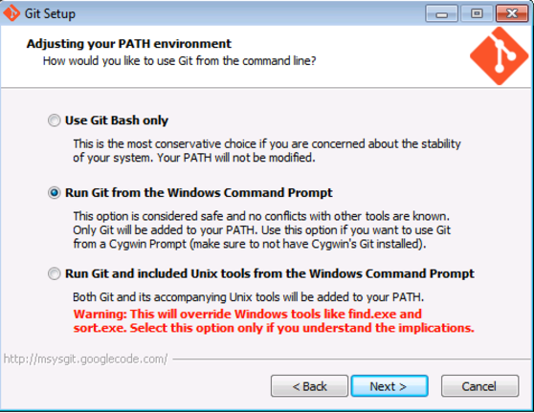

**For Mac:**

* Download *git* at <http://git-scm.com/downloads> and follow the install instructions.
* Apple's [Xcode](https://developer.apple.com/xcode/) has a command line tools option during install which can override the preferred *git* command line tools. To ensure you are using the latest preferred version of *git*, you will need to launch Terminal and type the following few lines of code:
* Access Terminal from the Applications folder: **Applications > Utilities > Terminal**. When you launch Terminal a window will appear with your computer’s name followed by a $. When you type, your commands will appear after the $.

Add access your 'bash profile' by typing:

pico ~/.bash_profile

You are now able to edit your ‘bash profile’. Type:

export PATH=/usr/local/git/bin:$PATH

Exit pico by typing:

control-X  
y  
return/enter

Exit Terminal by typing:

exit

Finally, quit Terminal.

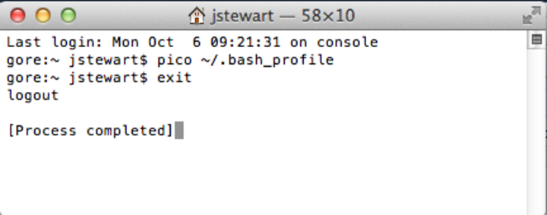

### Set up your Git Identity

After downloading and installing *git*, you will need to set up your **Git Identity**, which identifies you with your work. *Note*: if you have any problems with the following instructions, it is likely because of incompatibility between the version of your operating system and the version of git you downloaded in the previous section. In this case, find and download a compatible version at <www.wandisco.com/git/download> and then follow the instructions below.

You will set up your GitHub identity using the command line specific to Windows or Mac:

* **Windows**: Start > Run > cmd
* **Mac**: Applications > Utilities > Terminal

In the window, you will see a cursor where you are able to type. Type the following and press return (or enter) at each step. Make sure all spaces and symbols are identical to the example below, including all spaces ( ) and dashes (-).

Substitute your GitHub username instead of jdoe:

git config --global user.name jdoe

and then: substitute the email address you used to create your GitHub account:

git config --global user.email johndoe@example.com

You can check settings with the following:

git config --list

Quit the Terminal after typing:

exit

### Install the GitHub application

There are several options to clone your repository to your local machine. When getting started, we recommend using the GitHub application. This is freely available for download. Follow the default instructions for downloading and installing from the following:

* **Windows**: <https://windows.github.com/>.
* **Mac**: <https://mac.github.com/>.

### Create a folder called *github* on your computer

Because you will use GitHub to collaborate with your team or request support from the OHI team, it is important you save files in places where the file path that is universal and not specific to your computer. When team members save files in different places, this will create a lot of problems when collaborating, particularly between Macs and Windows machines.

**Please create a folder called github in your root directory**. The file path for this folder will be:

* **Windows**: Users\[User]\Documents\github\
* **Mac**: Users/[User]/github/

This folder can be identified by any computer as ~/github/.

TIP: You can check the location of your github folder by right-clicking the folder icon and selecting 'Get Info' on a Mac or 'Properties' on Windows.

### Clone your repository to your computer

Clone a repository by clicking the 'Clone in Desktop' button on your online repository's homepage (<https://github.com/OHI-Science/[assessment]>):

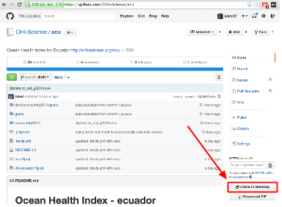

You will be asked where to save this repository: save it into the github folder you created. The file path for your assessment will therefore be:

* Windows: C: \Users\[User]\Documents\github\[assessment] (example: C:\Users\johndoe\Documents\github\ecu)
* on a Mac: /Users/[User]/github/[assessment] (example: /Users/johndoe/github/ecu)

The assessment can be identified by any computer as ~/github/[assessment].

The entire folder will now be saved on your computer.

### Update permissions

You need to **email your username to [ohi-science@nceas.ucsb.edu*](mailto:ohi-science@nceas.ucsb.edu*)* for permission to upload modifications to your GitHub repository (you only need to do this once). Only team members who will be modifying files will need to do this; all other members can view online and download the repository without these permissions.

### Work locally

You will then work locally on your own computer, modifying the files in the repository to reflect the desired modifications your team has identified for your assessment. Multiple users can work on the same repository at the same time, so there are steps involved to 'check in' your modifications so they can merge with the work of others without problems. GitHub has specific words for each of these steps. You have already successfully **cloned** an online repository to your local machine. After making modifications, you will **commit** these changes with a description before being able to sync back to the online repository. **Synching** involves both **pulling** any updates from the online repository before **pushing** committed changes back to the server.

TIP: While you can edit files in the online GitHub repository, we do not recommend this. It is good practice to track changes through commits and syncing.

The example below illustrates GitHub's collaborative workflow with the ohi-israel repo owned by OHI-Science:

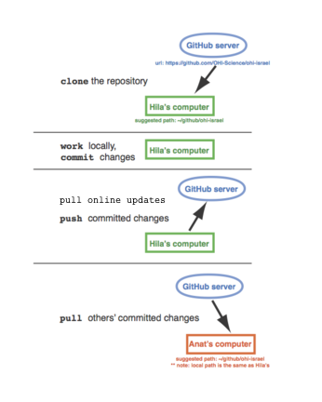

**All changes within your local repository will be tracked by GitHub regardless of the software you use to make the changes**. This means that you can delete or paste files in the Mac Finder or Windows Explorer and edit *.csv* files in Excel or a text editor, and still sync these changes with the online repository. We recommend doing as much data manipulation as possible in a programming language like R, to maximize transparency and reproducibility. When modifying R scripts such as functions.R, you will need to work in R.

We recommend syncing with either the GitHub App or with RStudio. Both methods require you to commit your changes, before pulling any updates and pushing your modifications. The GitHub App combines the pulling and pushing into one step, called syncing. The following sections show you how to synchronize the repository on your computer with the repository online.

### Syncing

When you work on your computer, any edits you make to any files in your repo, using any program, will be tracked by *git*. You can use any of the above to commit and sync your changes back to GitHub. There are many options you can use to sync your edits on a repo with the online version.

* **GitHub App** [for Mac](https://mac.github.com/) and [for Windows](https://windows.github.com/)
* [**RStudio**](www.rstudio.com)
* **Command line**

If you are just modifying data *.csv* files, you probably only need to use the GitHub App. RStudio is convenient if you are working with *.R* files. Also, the command line can be used by those interested, and there are resources available online.

TIP: Once you sync your repository, the updated information will be automatically available to the WebApps.

### Using the GitHub App to synchronize your repository

The GitHub App will track your modifications and can be used to commit and sync any changes made locally to your repository. Once you are done working on the pertinent files and wish to commit and sync the changes to the online server on the Github server, open the GitHub App. The following example is with the ecu repository:

1. Make sure you select the correct repository, located on the left column of the GitHub App window (Step 1 in the figure).
2. Select the different files to which changes have been made (2a), and preview those changes on the right column of the GitHub App window (2b).
3. Once all the changes have been reviewed, write a summary/description in the respective message bars in the GitHub App window (3), then click on 'Commit' (3a) and then 'Sync' (3b) located on the top-right corner of the GitHub App window (Note: If a Commit button appears instead of Commit & Sync, you can either click Commit and then click the Sync in this way, or you can alternatively select *Edit* > *Automatically Sync After Committing* which will then allow you to click on 'Commit and Sync')

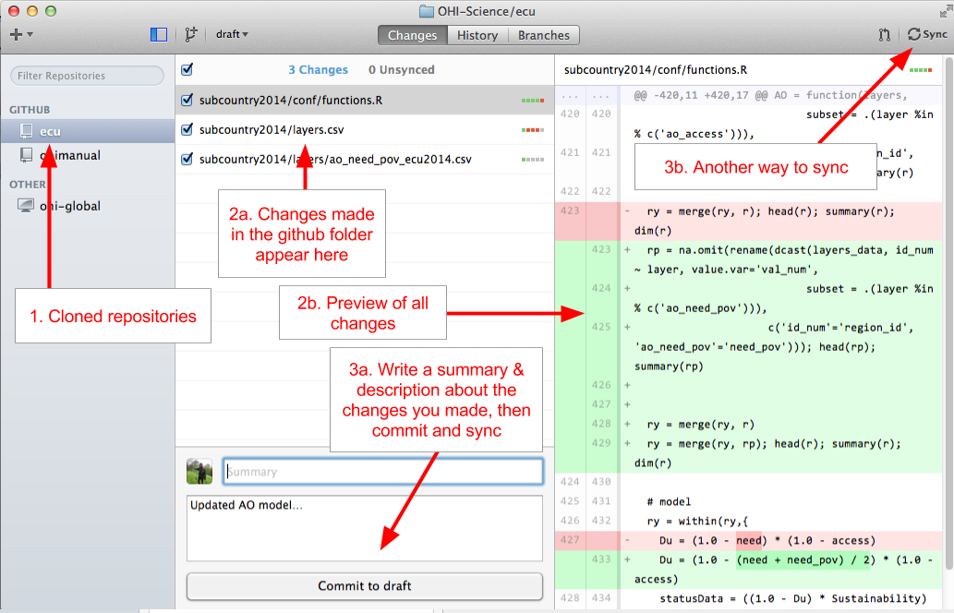

Figure showing the layout of the GitHub App when syncing. Click on 'Commit' and then 'Sync' to push changes to your repository.

Go online and check that your changes are now visible on GitHub online.

### Working with R and RStudio

**RStudio** is a program that can be used to synchronize any modifications you make to files in your assessment’s repository, and if you are working in R, it is convenient since you do not need to open the GitHub App. If you do not already have this installed, install the latest version of R and RStudio (and if you do have these installed, check for updates: there are frequent updates to the R software, and the current version is identified on the website). Both R and RStudio are freely available to download.

**R**: Download the current version of R appropriate for your operating system at <http://cran.r-project.org/> and follow the instructions to install it on your computer. If updating, compare the available version on their website with what you already have on your computer by typing sessionInfo() into your R console.

**RStudio**: Download the current version of RStudio software at www.rstudio.com. RStudio is not updated as often as R, but it is good to check for updates regularly. Note that in this case, you should follow the default install instructions.

If you are working on a Mac, you will need to tell RStudio to use the proper version of Git by doing the updating the preferences for 'Git executable':

**RStudio > Preferences... > Git/SVN > Git executable: /usr/local/git/bin/git**

### Using RStudio to synchronize your repository

RStudio can sync files with GitHub directly, and can be used instead of the GitHub App. Like the GitHub App, it will capture the changes made to any files within the repository, no matter which software was used to modify them. The advantage for using RStudio to sync instead of the GitHub App is if you are working with R scripts already. In RStudio, you sync by first pulling and then pushing (separately); in the GitHub App these two functions are done together.

Launch your project in RStudio by double-clicking the .Rproj file in the assessment folder on your local hard drive.

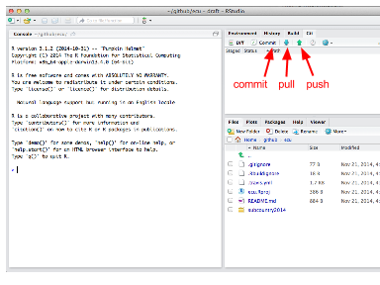

When you modify or add a file, the file will appear in the 'Git' window once it has been saved. In the example below, the file test.R was created.

1. Clicking the 'Staged' box and the 'Commit' button opens a new window where you can review changes.
2. Type a commit message that is informative to the changes you've made.

* Note 1: there will often be multiple files 'staged' at the same time, and so the same commit message will be associated with all of the updated files. It is best to commit changes often with informative commit messages.
* Note 2: clicking on a staged file will identify additions and deletions within that file for your review

1. Click 'Commit' to commit the changes and the commit message
2. Pull any changes that have been made to the online repository. This is important to ensure there are no conflicts with updating the online repository.
3. Push your committed changes to the online repository. Your changes are now visible online.

TIP: If you aren't seeing your changes in the 'Git' window, try saving the file again.

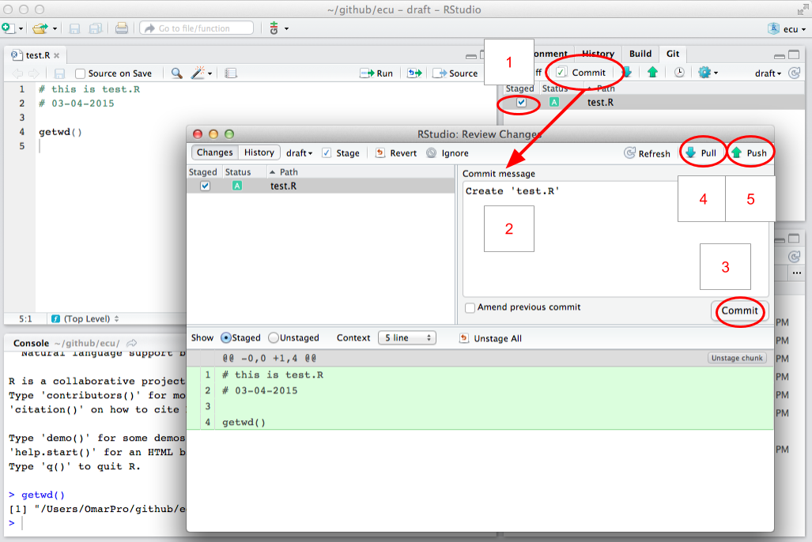

Figure showing RStudio when sycing. After first staging your changes, click the 'commit' button to open a new window where you can enter a 'commit message' and then pull and push new changes.

TIP: Another way to sync and open the project is to click on 'New Project' in the upper-right-hand corner of Rstudio, then choose 'Version Control', and then you can paste the URL of the desired repository. This URL can be found on on your online repository's homepage.

### Install the latest version of R and RStudio

Make sure you have the most current version of R and RStudio. Download **R** at <http://cran.r-project.org/> and install on your computer. If you already have R installed, check the website for updates. There are frequent updates to the R software, and the current version is identified on the website. Compare what is available from their website with what you already have on your computer by typing sessionInfo() into your R console. (This will also identify packages you have installed).

While not required, we highly recommend working with **RStudio**, which is an interface that makes working with R much easier, and it also interfaces with GitHub so you are able to synchronize without using the GitHub App. RStudio does not get updated as often as R does, but it is good to check for updates regularly.

## GitHub repository architecture

GitHub stores all data files and scripts for your assessment in a repository (a folder). Different copies or complements to these folders, called *branches* can also exist, which aid with versioning and drafting. Your repository has four branches, two of which are displayed on your website (e.g., ohi-science.org/ecu):

1. **draft** branch is for editing. This is the default branch and the main working area where existing scenario data files can be edited and new scenarios added.
2. **published** branch is a vetted copy of the draft branch, not for direct editing. This branch is only updated by automatic calculation of scores if:
   1. no errors occur during the calculation of scores in the draft branch, and
   2. publishing is turned on. During the draft editing and testing phases of development, it is typically desirable to turn this off.
3. **gh-pages** branch is this website. The results sections of the site (regions, layers, goals, scores per branch/scenario) are overwritten into this repository after automatic calculation of scores. The rest of the site can be manually altered.
4. **app** branch is the interactive layer and map viewer application. The user interface and server-side processing use the [Shiny](http://shiny.rstudio.com/) R package and are deployed online via [ShinyApps.io](https://www.shinyapps.io/) to your website. Once deployed, the WebApp pulls updates from the data branches (draft and published) every time a new connection is initiated (i.e., browser refreshes).

TIP: When looking at files on GitHub, note that the timestamps are associated with the 'commit' time rather than the 'push' time.

# Using the Toolbox

**Section Summary:**

In this section, you will learn about the most common modifications made to repositories. You will be given examples to follow to help with your own assessment. The most common modifications are changing the pressures and resilience matrices, changing or creating data layers, and changing or removing goals models.

TIP: You should have access to your assessment repository and be familiar with the files in the folder.

As your team finalizes which data should be included in the assessment and begins developing goal models, you can incorporate this information into your repository. Data layer files can be created and updated with any software that handles *.csv* files, but goal models must be updated in R. With any modifications you sync to the online repository, the Toolbox will automatically recalculate goal scores. Calculations can also be done locally and offline by running subcountry2014/calculate_scores.R.

This section gives instruction and examples for the most common modifications you will make to your repository:

* **modifying pressures and resilience matrices**
* **modifying and creating data layers for status, trend, pressures and resilience**
* **modifying goal models**
* **removing goals**

The files you will modify are:

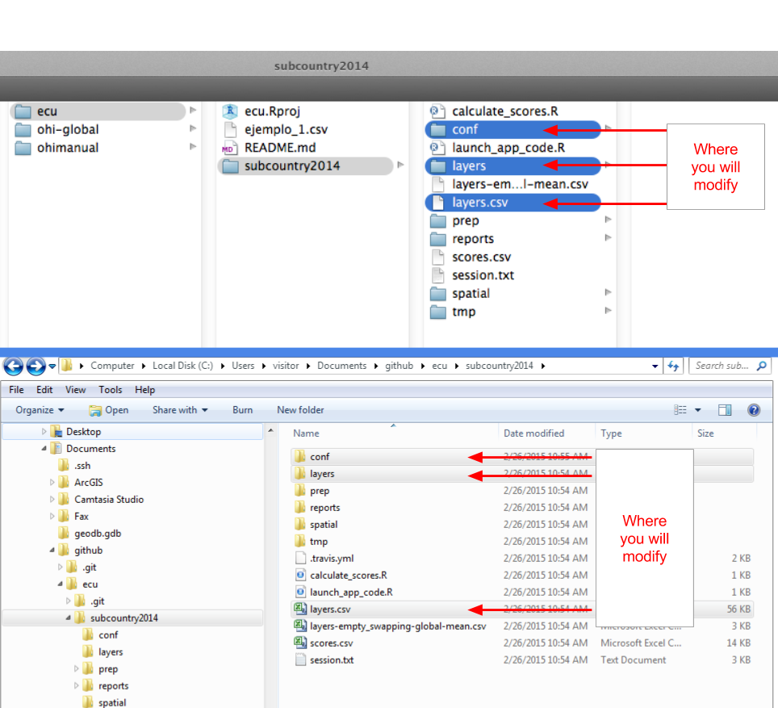

Files you will commonly modify are shown in the figure (Mac navigation is shown above and Windows is shown below). These include the conf folder, layers folder, and layers.csv.

### File Preparation Workflow

It is generally recommended that you construct a useful workflow with your team when updating data layers for the Toolbox. This process is one that can be done by one person, or by several who are working through GitHub to sync the work. There are overall two main steps to preparing to input your layers into the Toolbox, starting with data layer preparation, and then going into data layer registration. The firs step involves placing files into layers folder, and the second is registering those files in layers.csv. This file preparation process can occur in tandem with the model modification process. However, it must occur in order for you to run modified goal code using your new input data.

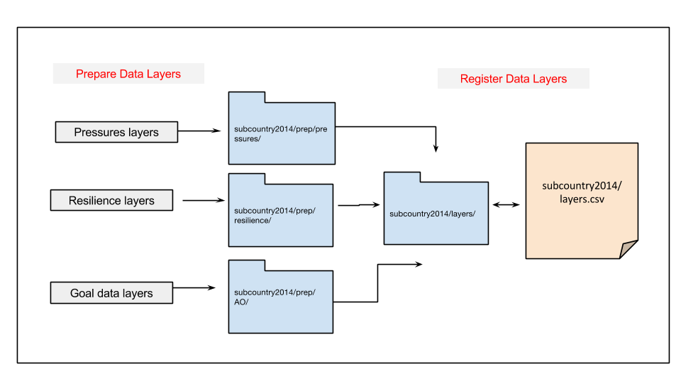

Diagram of OHI Toolbox data preparation workflow. You should start by prepping the files, loading them into the layers folder when they're ready for the Toolbox, and then registering them in layers.csv

## Modifying and creating data layers

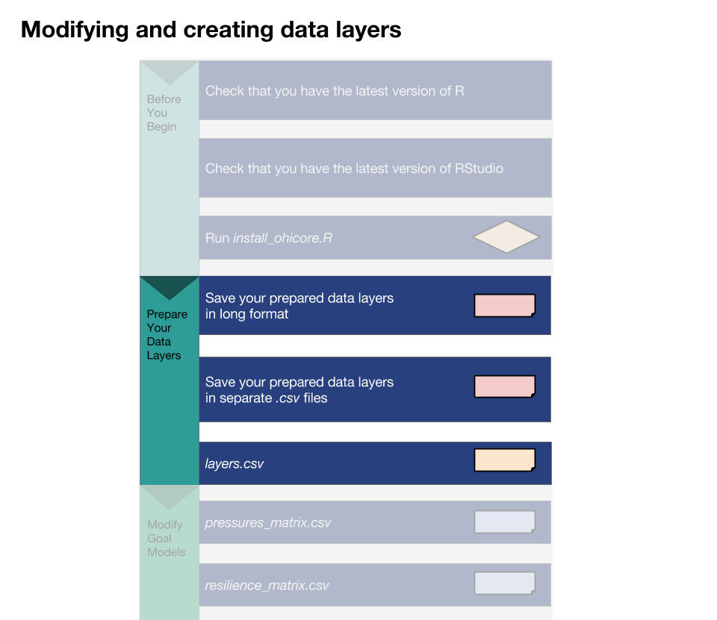

A figure showing key steps in the process of creating and preparing your data layers.

Data layers are *.csv* files and are located in the [assessment]/subcountry2014/layers folder. Remember that all data layers provided in your repository are extracted from the global 2014 assessment.

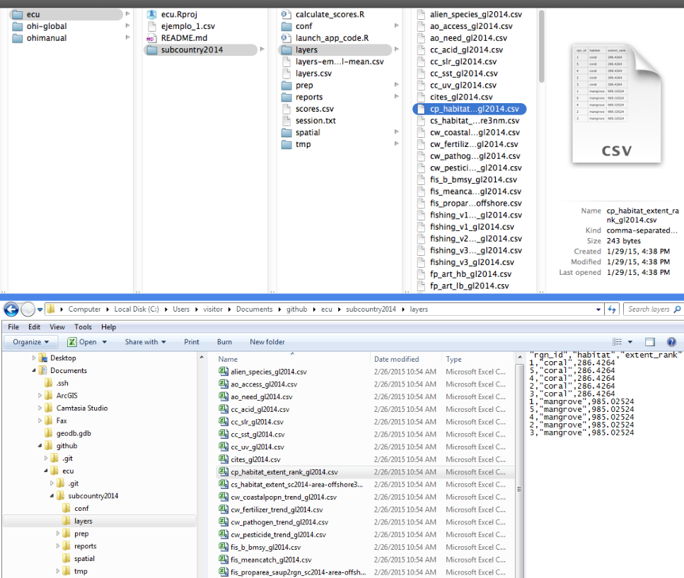

This figure shows the location of your data layers. Mac navigation is shown above and Windows is shown below.

* Layers with the suffix _gl2014.csv (*gl* for *global*) have been exactly copied from the global assessment and applied equally to each region, and therefore the values will be the same across all subcountry regions.
* Layers with the suffix _sc2014.csv (*sc* for *subcountry*) have been spatially-extracted from global data or adjusted with spatially-extracted data so that each region in your assessment has a unique value. For example, gross domestic product (GDP) used in the global assessment was reported at the national (most often country) level. Instead of being applied equally across all subcountry regions (which would incorrectly increase the nation's GDP several times), national GDP was down-weighted by the proportion of coastal population in each region compared with the total coastal population.

Both types of default data layers are of coarse-resolution and should be replaced with local, high-resolution data when possible. The priority should be to replace as much of the _gl2014.csv data as possible.

**There are several steps to follow when working with data layers:**

1. Modify or create data layer with proper formatting
2. Save the layer in the layers folder
3. Register the layer in layers.csv
4. Check (and update when appropriate) pressures_matrix.csv and resilience_matrix.csv (located in: [assessment]/subcountry2014/conf)

### Create data layers with proper formatting

The OHI Toolbox expects each data layer to be in its own *.csv* file and to be in a specific format, with data available for every region within the study area, with data organized in 'long' format (as few columns as possible), and with a unique region identifier (*rgn_id*) associated with a single score or value. See the **'Formatting data for the Toolbox'** section for more information.

### Save data layers in the *layers* folder

When you modify existing or create new data layers, we recommend saving this as a new *.csv* file with a suffix identifying your assessment (example: _sc2014.csv). Modifying the layer name provides an easy way to track which data layers have been updated regionally, and which rely on global data. Then, the original layers (_gl2014.csv and _sc2014.csv) can be deleted.

* Note: filenames should not have any spaces: use an underscore (‘_’) instead. This will reduce problems when R reads the files.

### Register data layers in layers.csv

When there are new filenames associated with each layer, they will need to be registered in [assessment]/subcountry2014/layers.csv. If a layer simply has a new filename, only the *filename* column needs to be updated:

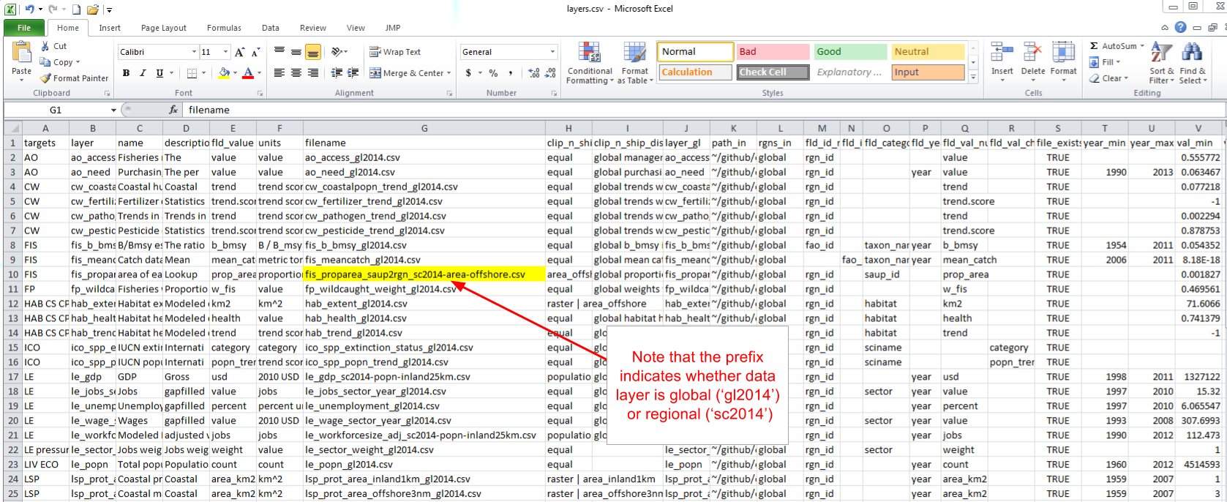

Register new layers in layers.csv. Be sure to note if there is a change in the filename.

TIP: This part is done manually. If you prefer not to manipulate your file by hand, you can generate a script that automates this.

However, if a new layer has been added (for example when a new goal model is developed), you will need to add a new row in the registry for the new data layer and fill in the first eight columns (columns A-H). It is important to check that you have filled you the fields correctly, for instance, if "fld_value" does not match the header of the source data layer, you will see an error message when you try to calculate scores. Other columns are generated later by the Toolbox as it confirms data formatting and content:

* **targets:** Add the goal/dimension that the new data layer relates to. Goals are indicated with two-letter codes and sub-goals are indicated with three-letter codes, with pressures, resilience, and spatial layers indicated separately.
* **layer:** Add an identifying name for the new data layer, which will be used in R scripts like functions.R and *.csv* files like pressures_matrix.csv and resilience_matrix.csv.
* **name:** Add a longer title for the data layer--this will be displayed on your WebApp.
* **description:** Add a longer description of the new data layer--this will be displayed on your WebApp.
* **fld_value:** Add the appropriate units for the new data layer (which will be referenced in subsequent calculations).
* **units:** Add a description about the *units* chosen in the *fld_value* column above.
* **filename:** Add a filename for the new data layer that matches the name of the *.csv* file that was created previously in the layers folder.
* **fld_id_num:** Area designation that applies to the newly created data layer, such as: *rgn_id* and *fao_id*.

TIP: Think about what units you would like to be displayed on the WebApp when filling out "units."

### Check pressures and resilience matrices

If the new or modified layer is a pressures layer, check that pressures_matrix.csv and resilience_matrix.csv have been properly modified to register the new data layers.

## Modifying pressures matrices

Your team will identify if any pressures layers should be added to the pressures matrices, and if so, which goals the pressure affects and what weight they should have. You can transfer this information in pressures_matrix.csv (located in the [assessment]/subcountry2014/conf folder). It is important to note that the matrix identifies the pressures relevant to each goal, and which weight will be applied in the calculation. Each pressure is a data layer, located in the subcountry2014/layers folder. This means that pressure layers need information for each region in the study area, and some layers will need to be updated with local data. In modifying pressures, you will need to consider whether data layers can be updated or added, and whether data layers map onto goals appropriately in the local context.

Adding a new pressure to the pressures matrix requires the following steps:

1. Create new pressure layer(s) and save in the layers folder
2. Register pressure layer(s) in layers.csv
3. Register pressure layer(s) in pressures_matrix.csv
   1. Set the pressure category
   2. Identify the goals affected and set the weighting
   3. Modify the resilience matrix (if necessary)

The following is an example of adding two new pressures layers.

### Create the new pressure layers and save in the layers folder

If you create a new data layer, give it a short but descriptive name that also includes a prefix that signifies the pressure category (for example: *po_* for the pollution category). There are five physical categories and one social category:

* *po_* = pollution
* *hd_* = habitat destruction
* *fp_* = fishing pressure
* *sp_* = species pollution
* *cc_* = climate change
* *ss_* = social pressure

So for example, po_trash is a pollution layer with trash on beaches, and sp_alien is species pollution due to alien (invasive) species.

In the current example, the two new layers created to account for the input and output effects of desalination operations will be called *po_desal_in*, and *po_desal_out*.

These new layers will have scores from 0 to 1, with values for each region in your study area, and will be saved in the layers folder.

### Register the new pressure layers in layers.csv

Add two new rows in layers.csv, and register the new pressure layers by filling out the first eight columns for *po_desal_in*, and *po_desal_out*.

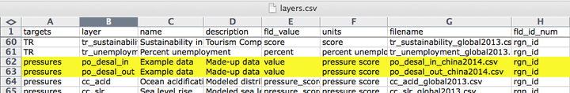

### Register the new layers in pressure_matrix.csv

pressures_matrix.csv identifies the different types of ocean pressures (columns) with the goals that they affect (rows). Adding a new pressures layer to pressures_matrix.csv requires adding a new column with the pressure layer name.

#### Set the pressure category

This step requires transferring previous decisions made by your team into pressures_matrix.csv. Each pressure category is calculated separately before being combined with the others, so it is important to register the new pressure with the appropriate category prefix decided by your regional assessment team.

#### Identify the goals affected and set the weighting

This step also requires transferring prior decisions into pressures_matrix.csv. Mark which goals are affected by this new pressure, and then set the weighting. Pressures weighting by goal should be based on scientific literature and expert opinion (3 = highly influential pressure, 2 = moderately influential pressure, 1 = not very influential pressure). Remember that the rankings in the pressures matrix are separate from the actual data within the pressures data layers. The rankings ensure that within a particular goal (e.g. within a row of the pressures matrix), the stressors that more strongly influence the goal’s delivery have a larger contribution to that goal’s overall pressure score. Therefore, the rankings are assigned independently of the actual pressure scores, and only determine their importance within the calculations.

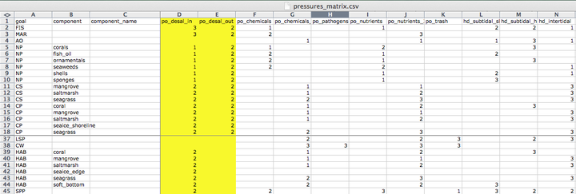

### Modify the resilience matrix (if necessary)

Resilience is included in OHI as the sum of the ecological factors and social initiatives (policies, laws, etc.) that can positively affect goal scores by reducing or eliminating pressures. The addition of new pressure layers may therefore warrant the addition of new resilience layers that were not previously relevant. Similarly, the removal of pressure layers may warrant the removal of now irrelevant resilience layers.

## Modifying resilience matrices

Previous decisions made with your team will identify if any resilience layers should be added to the resilience matrices, and if so, which goals and/or pressures the resilience affects and what weight they should have. You can then transfer this information into resilience_matrix.csv (located in the [assessment]/subcountry2014/conf folder).

resilience_matrix.csv maps the different types of resilience (columns) with the goals that they affect (rows). New resilience layers may be added to resilience_matrix.csv based on finer-scale local information either in response to a new pressures layer, or as a new independent measure. Any added layer must be associated with a pressures layer that has a weight of 2 or 3 in the OHI framework so that resilience measures can mitigate pressures in each region.

Each goal must have a resilience measure associated with it. In the figure below, the Toolbox would give an error because there are no resilience layers indicated for the natural products (NP) goal.

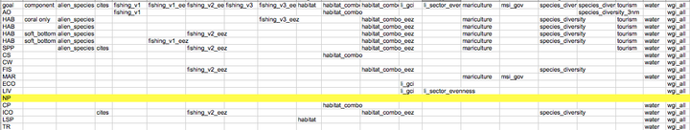

### Updating resilience matrix with local habitat information

In this example we will borrow from the experience of ohi-israel, where they assessed habitats in the Habitats (HAB) sub-goal that were not included in global assessments ohi-global. Therefore, the resilience matrix needed some revision.

The habitats assessed for ohi-israel are:

rocky_reef, sand_dunes, soft_bottom

Updates are required for the following files:

* *layers.csv*
* *resilience_matrix.csv*
* *resilience_weights.csv* (only if adding new resilience layers)

#### Global resilience layers

The first step is to determine which resilience layers from the global assessment are relevant to your assessment, and whether others need to be added. The full list of layers included in the global resilience matrix are:

alien_species, cites, fishing_v1, fishing_v1_eez, fishing_v2_eez, fishing_v3, fishing_v3_eez, habitat, habitat_combo, habitat_combo_eez, li_gci, li_sector_evenness, mariculture, msi_gov, species_diversity, species_diversity_3nm, tourism, water, wgi_all

Some of these layers capture general aspects of governance that apply to the protection of any habitat. These are:

alien_species, cites, msi_gov, water, wgi_all

Two layers only apply to the livelihoods and economies goal (LE), so they should be excluded from HAB resilience:

li_gci, li_sector_evenness

The remaining layers apply to certain habitats, but not others. We focus on these to determine how to adapt the HAB resilience calculation for ohi-israel. They are:

fishing_v1, fishing_v1_eez, fishing_v2_eez, fishing_v3, fishing_v3_eez, habitat, habitat_combo, habitat_combo_eez, mariculture, species_diversity, species_diversity_3nm, tourism

#### Determining how to modify these resilience layers

* To determine whether species_diversity_3nm or species_diversity should be used:
  + sand_dunes should use species_diversity_3nm,
  + soft_bottom should use species_diversity,
  + is rocky_reef mainly coastal? if so it should use tourism and species_diversity_3nm.
* If the habitats can be affected by mariculture plants (e.g. eutrophication and decreased water quality can occur if mariculture plants are close by and have poor wastewater treatment), then the mariculture resilience score should be added.
  + are there any mariculture plants in Israel? If yes, on which habitats do they occur?
* The remaining layers are the fishing_v... and habitat.. layers, which are composite indicators obtained from different combinations of the following indicators:

Mora, Mora_s4, CBD_hab, MPA_coast, MPA_eez,

where:

* Mora is a fisheries governance effectiveness indicator by Mora *et al* (2009)
* Mora_s4 is another indicator from Figure S4 of the supplementary material of the same publication that focuses on regulations of artisanal and recreational fisheries
* CBD_hab is a score assigned based on answers to a questionnaire compiled by countries that committed to Rio's Convention on Biological Diversity (CBD) to establish their progress towards habitat biodiversity protection
* MPA_coast is an indicator obtained as the proportion of coastal (3nm) waters that are in a marine protected area (MPA), with the maximum being 30% of coastal waters
* MPA_eez is an indicator obtained as the proportion of the whole EEZ that is in a marine protected area, with the maximum being 30% of the whole EEZ.

This table shows which indicators are used by each combo layer:

|  |  |  |  |  |  |
| --- | --- | --- | --- | --- | --- |
| Layer | Mora | Mora_s4 | CBD_hab | MPA_coast | MPA_eez |
| fishing_v1 | Mora |  | CBD_hab | MPA_coast |
| fishing_v1_eez | Mora |  | CBD_hab |  | MPA_eez |
| fishing_v2_eez | Mora | Mora_s4 | CBD_hab |  | MPA_eez |
| fishing_v3 |  | Mora_s4 | CBD_hab | MPA_coast |
| fishing_v3_eez |  | Mora_s4 | CBD_hab |  | MPA_eez |
| habitat |  |  | CBD_hab |  |
| habitat_combo |  |  | CBD_hab | MPA_coast |
| habitat_combo_eez |  |  | CBD_hab |  | MPA_eez |

**Questions to consider**:

The first objective is to determine whether the general fishing_v.. or habitat_... categories are relevant to each of the habitats. For example, fisheries regulations do not affect the conservation of sand dunes, so this habitat should not use any of the fisheries combos. If the general resilience categories are relevant to the habitat, the next step is to select one resilience layer within the fishing_v… and habitat... categories that most adequately captures the suite of combined resilience variables that affect the habitat. For example, the sand dune habitat is a strictly coastal habitat, so the most appropriate resilience layer would be the one that uses the MPA_coast (i.e., habitat_combo). The rocky reef and soft bottom, on the other hand, should definitely include fisheries and habitat regulations. So, you'll need to choose a fisheries and a habitat combo for these two habitats. To do so, consider:

1. For which habitats should you use both a fishery and a habitat combo, or just use a habitat combo?

* fisheries regulations do not affect the conservation of sand-dunes, so this habitat should not use any of the fisheries combos. Also, this is a strictly coastal habitat, so choose the habitat layer that uses the MPA_coast instead of the MPA_eez, i.e. habitat_combo (and, as mentioned above, choose the coastal version of biodiversity, i.e. species_diversity_3nm).
* The rocky reef and soft bottom, on the other hand, should definitely include fisheries regulations. So you'll need to choose a fisheries and a habitat combo for these two habitats.

1. Which fisheries and habitat combos for rocky_reef and soft_bottom? The choice depends on two things:

* whether they are coastal habitats (within 3nm of the coast) or EEZ-wide habitats
  + if coastal, use the fisheries and habitat combos with MPA_coast (fishing_v1, fishing_v3, habitat_combo), and the species_diversity_3nm layer
  + if EEZ-wide, use the fisheries and habitat combos with MPA_eez (fishing_v1_eez, fishing_v2_eez, fishing_v3_eez, habitat_combo_eez), and the species_diversity layer
* whether the fisheries occurring on that habitat are mainly artisanal, mainly commercial, or both
  + if only commercial fisheries, use a layer that only uses the Mora data fishing_v1..)
  + if only artisanal/small-scale fisheries, use a layer that only uses the Mora_s4 data (fishing_v3..)
  + if both, use a layer that uses both Mora and Mora_s4 data (fishing_v2..)

1. It may also be that the existing global combo layers are not appropriate for your habitats. For example, if rocky reef is mainly coastal, and it is fished by both commercial and artisanal methods, then we need a new combo that uses Mora, Mora_s4, CBD_hab, and MPA_coast (this is the same as fishing_v2_eez, but we use the MPA_coast layer instead of the MPA_eez). All other combinations are already present.
2. Another issue to consider is whether local data are available to improve the pressure layers (that are based on global data). For example, if there are local data on Marine Protected Areas (MPAs) and any areas with special regulations, this should be used to generate the MPA_coast and MPA_eez layers.You may know that only certain types of protected areas are closed to fisheries, and may want to only include those. Also, local datasets may be more accurate and regularly updated. **NOTE: in the global study, these are the same datasets used to calculate the status of Lasting Special Places (LSP).
3. How to update resilience_matrix.csv?

* write the complete list of layers you want to use for each habitat. Based on the above, for example, soft bottom in Israel matches the combination of layers called *soft bottom, with corals* in the default resilience_matrix.csv. But the rocky_reef and sand_dunes don't seem to match any existing combination, so you'll probably need to delete some of the rows, e.g. the *coral only*, and replace with new ad-hoc rows.

## Modifying goal models

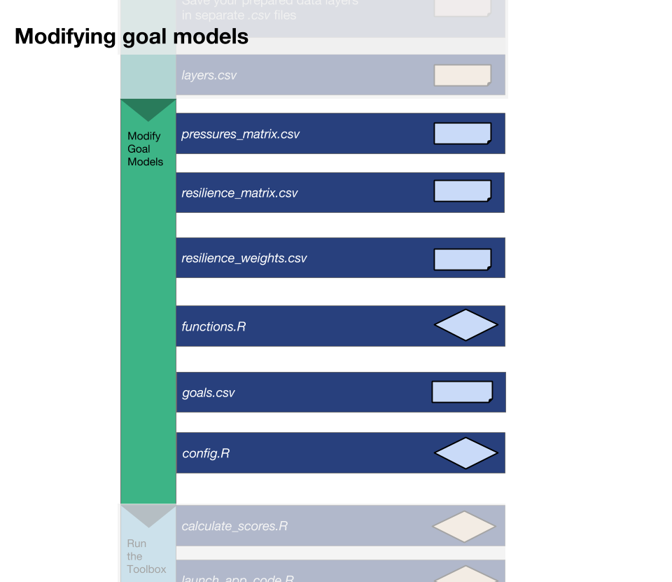

A figure showing the key steps involved in modifying goal models in the Toolbox.

When an existing layer is updated with new data, the Toolbox will automatically incorporate it into the goal calculations after the updated filenames are registered in layers.csv. However, if a new layer has been added to the layers folder and registered in layers.csv, the Toolbox will not use it unless it is called in a goal model. To integrate any new data layers registered in layers.csv you will need to modify the goal model to incorporate the data. Furthermore, in many cases, it will make sense to modify goal models based on data availability and/or local context. For example, the models for regional analyses can often be simplified because of improved data.

**There are some key steps to follow when working with goal models:**

1. Update functions.R
2. Check and possibly update goals.csv
3. Check if you need to update pressures_matrix.csv and resilience_matrix.csv when you change a goal model.

### Update *functions.R*

To incorporate a new data layer into a goal model, open functions.R in RStudio: this script contains all the models for each goal and sub-goal. A member of your team with the ability to write R code will need to translate the updated goal model into the Toolbox format. Follow the structure of existing goal models in order to incorporate the new data layers, noting the use of certain R packages for data manipulation.

The image below shows the navigation pane in RStudio that can be used to easily navigate between goal models.

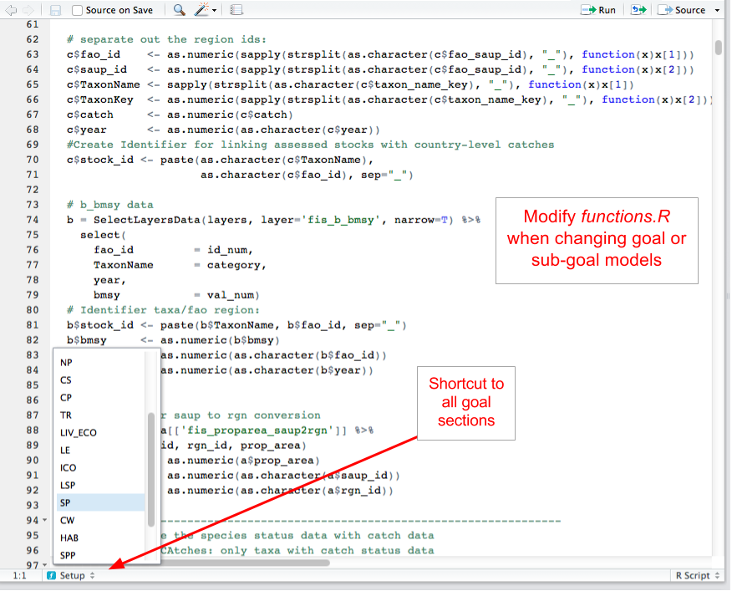

The navigation pane in RStudio can be used to easily navigate between goal models.

### Check and possibly update *goals.csv*

goals.csv provides input information for functions.R, particularly about goal weighting and function calls. It also includes descriptions about goals and sub-goals, which is presented on the WebApp.

Changing goal weights will be done here by editing the value in the *weight* column. Weights do not need to be 0-1 or add up to 10; weights will be scaled as a proportion of the number of goals assessed. goals.csv also indicates the arguments passed to functions.R. These are indicated by two columns: *preindex_function* (functions for all goals that do not have sub-goals, and functions for all sub-goals) and *postindex_function* (functions for goals with sub-goals).

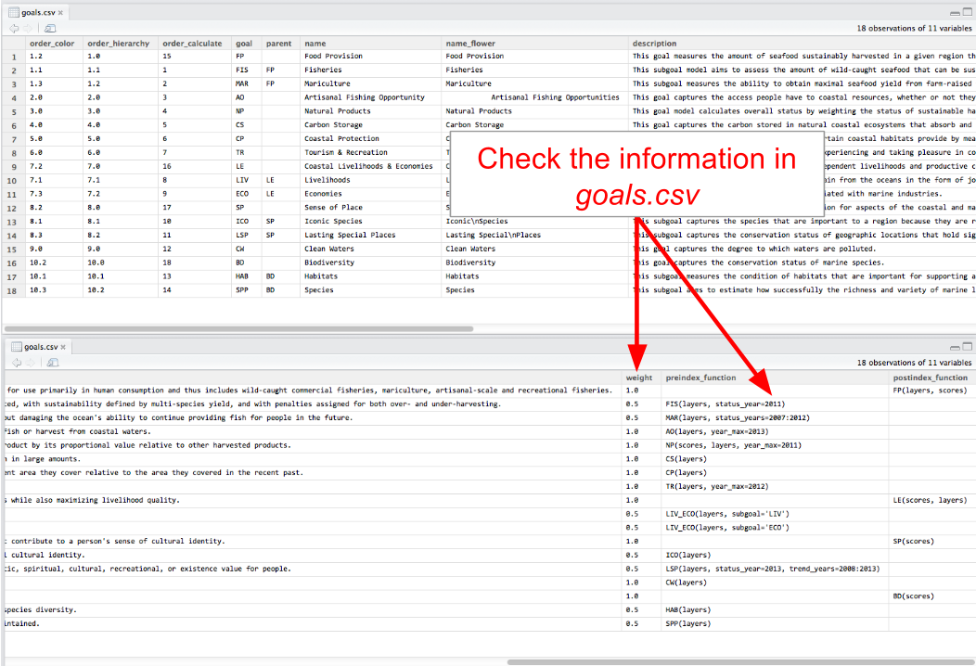

Check the information in goals.csv. It provides input information for functions.R.

**When updating layers or goal models, it is important to ensure that information called from goals.csv is correct**:

TIP: In the 'preindex_function' column, you should see what the year_max, status_year, and trend_year say.

### Example modification:

Suppose your team has decided to add an 'artisanal access' component to the Artisanal Fishing Opportunity goal because of locally available data. Once the data are obtained and properly formatted, the data layer is saved as ao_access_art. To include this new information in the goal model, you will need to do the following:

1. register the layer in layers.csv
2. update the goal model in functions.R
3. update the goal call in goals.csv

Step 1. Register in layers.csv

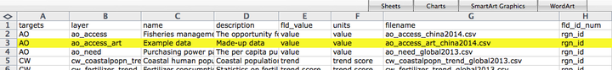

Step 2. Update the goal model

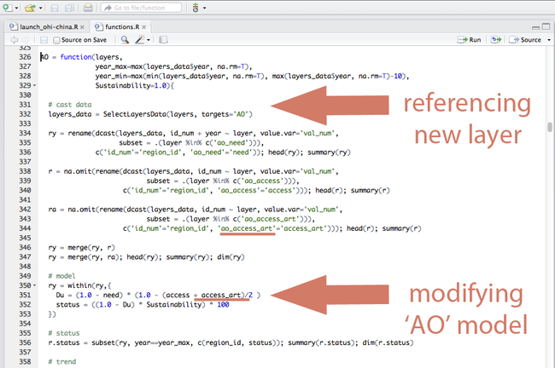

Step 3. Update goal call in goals.csv

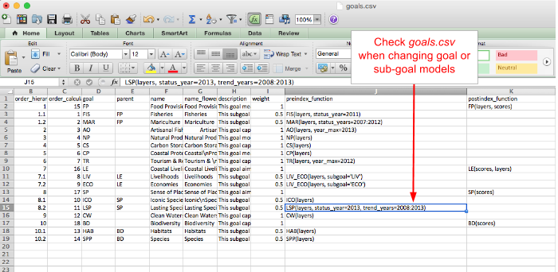

A screenshot of goals.csv, used to modify goal model

### What's the code trying to do?

#### **Natural Products**

You may have already looked at the **NP** section of functions.R. In simple terms, here is what the code is doing:

* It pulls out the appropriate data layers to find out the amount of each product per unit area. It does gap-filling as necessary for the Global data.

It should be noted that in the Global Assessments, the harvested amounts are derived from the information from the Food and Agriculture Organization of the United Nations (FAO), and these are combined with habitat values used elsewhere in the assessment. You should be conscious of this as you go through the model and change it, because you may be able to simplify aspects of the code such as gap-filling.

* It calculates Exposure by finding how intensely each identified product is being harvested (amount of product per km^2), and then transforms this from a scale from 0 to 1.

TIP: The data layer, hab_extent is used here and in other goal models in the default code for the Global Assessment.

* In parallel to this, it finds the Risk of each product based on a scoring system that becomes binary: 0, or 1.
* It then averages the two factors, Exposure and Risk, to reveal where risk and intensity are highest. This value is then inverted to become Sustainability and to reward lower intensity and lower risk.
* The amount of each kind of product, relative to the peak historical yield of that product across all regions assessed, and Sustainability are both used create sustainability-weighted scores for all regions and all years available.
* The latest year value is used in the status, and the past few years' values are used in the trend to produce the final score.

**Figure needed?** Diagram of sustainability calculation, NP; or perhaps a time-series of the available products in country X in order to show where the peak yield would be.]

#### Data Sources

If the case is that corals, sponges, and then you might be able to use FAO data, which is the data source of the Global Assessments. Otherwise, you will have to find comparable data in your area or consult local statistical offices and local fisheries managers to get harvest values similar to landing values and any other kinds of stock assessments. The IUCN offers quantified assessments of risk to species, but that is more appropriate for biodiversity; CITES signatory data may be more appropriate for the trade products. Exposure can be calculated spatially, and for this you should be able to find or produce your own maps if possible. Your maps might have finer resolution than those in global resolution.

#### Gap-filling

TIP: When checking your data, check cases where country-product pair has 0 for sustainability score, but relatively high harvest ratio (curr harvest/peak harvest) – it may be a flag that the sustainability score is off (eg because the habitat area is off)

TIP: Explore simplifying gap-filling: use correlation model of dollar value vs. harvested tonnage, while discarding the part of script using dollar ratio (current dollar value)/(peak dollar value) as a gap-filler for harvest ratio.

TIP: Switch the gap-filling order: using the dollar value correlation model first (in cases where the most recent year has no harvest reported but has dollar value reported, that’s a better estimate than using the harvest from the previous year), then gap-fill any remaining cases of missing harvest for the current year with harvest from the previous year

### Appendix - source materials

#### Global Data Approach (Technical Notes)

**Data Overview**

|  |  |  |  |  |
| --- | --- | --- | --- | --- |
| product | relative tonnes (1) | weighting (2) | Exposure (3) | Risk (4) |
| coral | FAO | FAO | coral habitat | all 1 |
| sponges | FAO | FAO | coral + rocky reef habitat | all 0 |
| ornamentals | FAO | FAO | coral + rocky reef habitat | 1 if blast/cyanide fishing, otherwise 0 |
| fish oil | FAO | FAO | fish score/100 | -- |
| shells | FAO | FAO | coral + rocky reef habitat | all 0 |
| seaweeds | FAO | FAO | rocky reef habitat | -- |

1. relative tonnes: tonnes relative to max tonnes for region with 35% buffer. The maximum corresponds to the year with the highest $ value - but it would probably be better to just base this off tonnes. When we redo these data lets evaluate this approach.
2. weighting: This weights the contribution of each product according to USD at max year for a region. It makes sense to use $, because comparing extraction weight of sponges vs. ornamentals doesn't make sense.
3. Exposure: For fish oil this value is the FIS score (which is a bit different than what is described in the paper because FIS score can have penalties for underfishing). The other values are determined by: log (harvest/habitat area + 1) / log[max(harvest/habitat area) +1].

The habitat area used for seaweeds: rocky reef The habitat area used for coral: coral The habitat area used for shells, ornamentals, sponges: coral plus rocky reef

#### Notes: Preparing the Data

## 

#### Notes: Tech Specs

<!---Note Ecuador's approach to Natural Products:  
Very low data for species, so it has been hard to advance this goal, unknown for each global product. but they did look up FAO data and found 3 products by country  
but they need to be looking for data for things they actually produce, like madera, leña de manglares, sea horses, they do have data for ornamental species in Sta Elena (not sure if they have data (tonnes) of catch of these species) they have good resilience measures, should add these Maybe they should ignore this goal all together? → they can decide to, but first I think they should think about what natural products are actually important to the area: we’ve heard about mangrove wood before--->  
  
<!---SPP status takes into account the IUCN score and the area that the species occupies (although the results are not exactly equivalent to an area weighted average). Specifically, the values are calculated at the spatial scale of the raster cells (which I believe is at 0.5 degree resolution). For each raster cell, the IUCN scores of the species are averaged to get a score. To get status, the raster cell scores within an EEZ are then averaged (after weighting for the area of the raster cell).  
ICO status is calculated by taking the average of the IUCN ratings for all the iconic species in the EEZ. --->  
  
<!---SPECIES he original logic was to represent the species present relative to the proportion of their range within a given EEZ. We may also have wanted to avoid penalizing a region too heavily if only a very small portion of the range came from a very threatened species. I think we were also worried about bad aqua maps data that could misallocate species into a country and having a big effect.  
  
A disadvantage is that rare species (and those with contracting ranges) will have a relatively small influence on the score. Common species will, in most cases, drive the results.  
  
An advantage is (actually a disadvantage of averaging species scores at the EEZ level): "The bigger an area, the more likely you are to find rare at risk species (the classic problem of species-area relationships or SARs) - so bigger countries would have lower diversity scores just as a function of their size but not actual poorer biodiversity. In regards to sampling effort, the number of rare species increases faster than the number of common species, so they would not even each other out."--->  
  
<!---SPECIES. For the global assessment, we started with a list of iconic species, and then found which ones had been assessed, in this case by IUCN. So from that original list of iconic species, we could only include the ones assessed by IUCN. IUCN scores are categorical ('extinct', 'least concern', etc), but Butchart et al. (attached) had done a study where they assigned numeric scores to each IUCN category. So we took the list of iconic species that had IUCN categories and assigned Butchart's numeric scores to each species based on these categories. We found how many species were in each IUCN category, (% or proportion of species in 'least concern' compared to all species with IUCN categories). For each region in the global assessment, we averaged the scores of the species that were there in that region together, giving that region's ICO score. (This averaging assumes that all species are of equal importance). So for an example, let's say there are 10 assessed iconic species: 5 are 'least concern', 4 'vulnerable', and 1 'threatened'. The math would be (5lc + 4v + 1t) / 10. Or, to think about this as percentages, it could be 0.5lc + 0.4v + 0.1t.  
Are you using IUCN categories? If so, you can use Butchart's method. You'll see in the Toolbox that they assign the scores such that we actually have to do (1-Butchart_score) but the logic of what we did is the same.--->

## Removing goals

If a goal is not relevant in your region, it is possible to remove the goal completely from the calculation. There are four places where you will need to remove the reference to this goal. Failing to delete all referenced layers after the goal is deleted will result in errors. To remove goals from your assessment, you will have to do the following:

1. Remove the goal model from functions.R
2. Remove the goal’s row from goals.csv
3. Remove the goal’s row from pressures_matrix.csv
4. Remove the goal’s row from resilience_matrix.csv

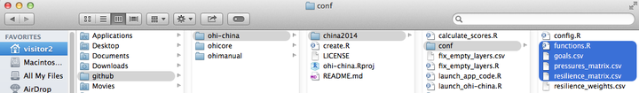

**Example: Removing carbon storage (CS) goal**

To completely remove the carbon storage goal from Index calculations, you will do the following.

1. Remove the carbon storage (CS) goal model from functions.R. Delete the highlighted text in the figure below that references the CS layers and calculates CS goal status, trend, and scores.

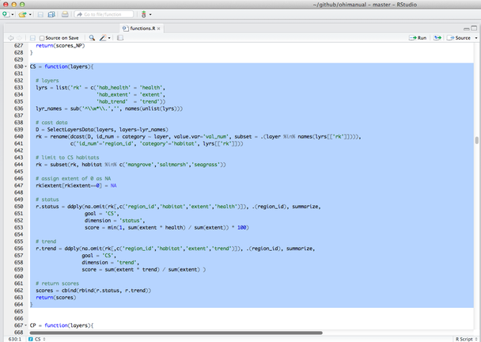

1. Remove the CS row from goals.csv. Delete the highlighted row in the figure below that contains the CS goal.

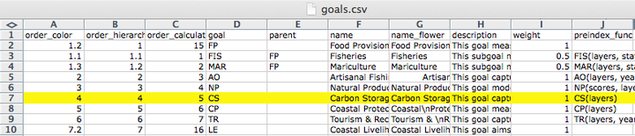

1. Remove all CS rows from pressures_matrix.csv. Delete the highlighted rows in the figure below that contain CS pressures.

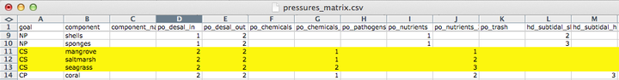

1. Remove all CS rows from resilience_matrix.csv. Delete the highlighted rows in the figure below that contain CS resilience.

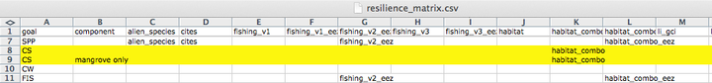

## Modifying the pressures matrix for goals with categories

### Background

The pressures and resilience matrix tables identify which pressures and resilience measures (layers) are relevant to which goals and how they are weighted. But pressures and resilience measures can also affect the components within a goal differently. When that is the case, those components can have individual entries (rows) in the pressures and resilience matrix tables and will have pressures and resilience scores calculated individually for each component.

The Toolbox calls these components of a goal 'categories', and knows to calculate pressures and resilience for category elements separately because they are identified in three places: in pressures_matrix.csv, resilience_matrix.csv, and config.r. These files are all located in the conf folder. To calculate the pressures and resilience scores, the Toolbox uses config.r to identify which categories to expect in the matrix tables, and will give a warning if they do not match. config.r relies upon the data layers identified in the pressures_components and resilience_components variables.

In global assessments, there are several goals that have categories indicated in the matrix tables and config.r file:

|  |  |  |
| --- | --- | --- |
| Goal | Category | layer indicated in config.r |
| NP | product types | np_harvest_product_weight |
| CS | habitat types | cs_habitat_extent |
| CP | habitat types | cp_habitat_extent_rank |
| HAB | habitat types | le_sector_weight |
| LIV | industry sectors | le_sector_weight |
| ECO | industry sectors | hab_presence |

If you have modified any of the category types in the matrix tables of the above goals, or added new category types to any goals, you will likely need to update the layer indicated in config.r. It is also possible to identify individual categories in other goals than those listed above. For example, in the mariculture sub-goal, you could specify the pressures on nearshore mariculture separately from offshore mariculture.

It is important that the file identified in config.r does not contain any NA values.

### Example 1: Pressures

Here is an example of how to modify existing category types for the natural products goal.

In the China OHI+ assessment there are three natural product types (seasalt, sea chemicals, and sea medicine), which differ from those assessed in the global assessments (corals, fish_oil, ornamentals, seaweeds, sponges). After modifying and registering the appropriate data layers and updating the NP function in functions.r, it is time to update the natural product types in pressures_matrix.csv, resilience_matrix.csv, and config.r.

* to update pressures_matrix.csv and resilience_matrix.csv, make sure that each product type has a separate row, with the appropriate pressures identified and weights attributed.
* to update config.r, check that the data layer identified in the pressures_components and resilience_components has the same category types.

When you run calculate_scores.r, the following warning will alert you that there is a mis-match between category types identified in the matrix and config.r:

Calculating Pressures...  
The following components for NP are not in the  
aggregation layer np_harvest_product_weight categories  
(corals, fish_oil, ornamentals, seaweeds, sponges):  
seasalt, sea_chemicals, sea_medicine

This message indicates that the np_harvest_product_weight layer identifies five categories (corals, fish_oil, ornamentals, seaweeds, sponges) but the pressures_matrix.csv indicates three (seasalt, sea_chemicals, sea_medicine).

To ensure that pressures are calculated correctly for the categories in your assessment, you will need to change the layer identified in config.r.

Note that more subtle examples of these mismatch between the categories identified in pressures_matrix.csv and config.r can also occur. For example, after updating the carbon storage layers and goal model in the China OHI+ assessment, the following warning message appeared when running calculate_scores.r:

Calculating Pressures...  
The following components for CS are not in the aggregation layer  
cs_extent categories (saltmarshes, seagrasses, mangroves):  
mangrove, saltmarsh, seagrass

The problem here is that the categories identified in config.r (saltmarshes, seagrasses, mangroves) are plural, whereas the categories identified in the pressures matrix (mangrove, saltmarsh, seagrass) are singular, and the Toolbox needs exact matches. To fix this warning, you need to update the pressures matrix with the plural names.

### Example 2: Resilience

For resilience calculations, the proper categories also need to be identified both in resilience_matrix.csv and config.r. If there is a mismatch, you will see the following message:

Calculating Resilience...  
Note: each goal in resilience_matrix.csv  
must have at least one resilience field  
Based on the following components for NP:  
corals  
fish_oil  
ornamentals  
seaweeds  
shells  
sponges

With resilience, if we update only the resilience_matrix.csv but not config.r, we get the following error message instead of the warning message we saw for pressures above.

Based on the following components for NP:  
 seasalt  
 sea_chemicals  
 sea_medicine  
Error in subset.default(SelectLayersData(layers, layers = lyrs),  
id_num == : object 'id_num' not found  
In addition: Warning messages:  
1: Grouping rowwise data frame strips rowwise nature  
2: In left_join_impl(x, y, by$x, by$y) :  
 joining factors with different levels, coercing to character vector  
 ```  
  
This error can be fixed by updating `config.r` with a layer identifying the appropriate categories.  
  
## Other example modifications  
  
### Preparing the fisheries sub-goal   
  
Here is some background information about how to prepare fisheries data layers for the Toolbox.  
  
**Data layers used by the Toolbox:**  
  
* `fis_b_bmsy`  
* `fis_meancatch`  
* `fis_proparea_saup2rgn`  
* `fp_wildcaught_weight`  
  
#### Description of data layers  
  
`fis_b_bmsy`  
  
* *for species*: B/Bmsy estimate (either from formal stock assessment, or from a data-poor method such as CMSY)   
* *for genus/family/broader taxa*: the toolbox will use median B/Bmsy from species in that region + a penalty for not reporting at species level. In order for the code to assign the correct penalty, the taxa need to include a numerical code of 6 digits, where the first digit behaves like an ISSCAAP code (the standardized species codes used by FAO): 6 means species, 5 means genus, 4 to 1 are increasingly broad taxonomic groups   
* *data source (for CMSY)*: catch time-series (at least 10 years of catch >0), species resilience (if available)   
  
**Example data:**  
  
|fao_id |taxon_name |year |b_bmsy |  
|:------|:--------------|:----|:--------|  
|51 |Ablennes hians |1985 |1.112412 |  
|51 |Ablennes hians |1986 |1.222996 |  
|51 |Ablennes hians |1987 |1.371058 |  
  
  
NOTE: if a species that is caught in different sub-regions belongs to the same population, you don't want to split the catch among sub-regions, instead, you want to sum catch across all sub-regions, so you can calculate B/Bmsy for the whole population. For the global analysis we grouped all species catch by FAO major fishing area (www.fao.org/fishery/area/search/en), indicated in the column *fao_id*, assuming that all species caught within the same FAO area belonged to the same stock, while we assumed that the same species, if caught in a different fishing area, belonged to a separate stock.   
Use *fao_id* as an identifier that separates different fisheries 'stocks' belonging to the same species.   
If you don't have multiple stocks in your study area, set all *fao_id* = 1.   
  
`fis_meancatch`:  
  
* average catch across all years, per species, per region   
* *data source*: catch time-series (at least 10 years of catch >0), with a unique identifier for each population that you want to assess separately   
   
**Example data:**  
  
|fao_saup_id |taxon_name_key |year |mean_catch |  
|:-----------|:--------------------------|:----|:-----------|  
|37_8 |Aristeus antennatus_690051 |2014 |14.24398116 |  
|37_8 |Atherinidae_400218 |2014 |27.30120156 |  
|37_8 |Balistes capriscus_607327 |2014 |3.247883895 |  
  
The *taxon_name_key* column indicates the name of the species (e.g. Aristeus antennatus) and its 'taxonkey'. The taxonkey is a 6 digit numeric code used by the Sea Around Us Project, modified from FAO codes. The important element of this code is the first digit, because it reflects the taxonomic level (6=species, 5=genus, 4=family, etc.) of the reported catch.The toolbox uses this first digit to assign a score to all catch that was not reported at species level, taking the median of the B/Bmsy of assessed species, and adding a penalty that is increasingly strong for coarser taxa.   
  
`fis_proparea_saup2rgn`:   
  
* a conversion file that, for each region for which catch is reported, tells us what proportion of that region falls within each of the final OHI reporting regions.   
  
**Example data:**  
  
| saup_id| rgn_id| prop_area|  
|-------:|------:|---------:|  
| 166| 1| 1.0|  
| 162| 2| 1.0|  
| 574| 3| 0.7|  
| 37| 4| 0.8|  
  
**Specific instances:**  
  
 *only if catch is reported for different regions than the ones used for the OHI assessment:* this should be calculated using spatial analyses of overlap of the spatial units at which catch is reported with the spatial units at which the OHI assessment will be reported. The global data was reported by subregions (*saup_id*) and in some cases multiple subregions were part of the same, larger EEZ. Since for OHI we wanted results by EEZ (*rgn_id*), in those cases we needed to combine results from the subregions to get the final score, based on their size relative to the total EEZ size (*prop_area*).   
 *If catch is reported for the same areas for which OHI is calculated:* then all the *prop_area* are = 1.   
 *If catch is reported for the whole area of the assessment, but you want to calculate a separate OHI score for different sub-regions:* for each OHI reporting region (*rgn_id*) you'll repeat the same region in the *saup_id* column, and *prop_area* will be =1. This effectively means all the reporting regions will get assigned 100% of the catch and will have the same final stastus and trend score for the fisheries goal (but may have different pressures and resilience scores, if those layers are different in each sub-region).   
  
`fp_wildcaught_weight`:   
  
*only needed if there is mariculture*: for each region, this represents the relative proportion of catch coming from wild caught fisheries versus mariculture. The layer is used to weight how much the fisheries score influences the final food provision score, the higher the fisheries catch, the more the food provision score will reflect the fisheries score, and vice-versa if mariculture has a higher catch.   
(NOTE that, before all mariculture harvest from all species gets summed, the mariculture harvest for each species is smoothed and then multiplied by the resilience score).   
  
#### Running CMSY model  
  
**Sample data to run CMSY:**  
  
|id |stock_id |res |ct |yr |  
|:--|:---------------------------|:------|:-----------|:----|  
|6 |Acanthistius brasilianus_41 |Medium |100 |1950 |  
|23 |Acanthurus dussumieri_61 | |0.059250269 |1950 |  
|24 |Acanthurus dussumieri_71 | |0.190749971 |1950 |  
|25 |Acanthurus lineatus_61 |Low |12.74821966 |1950 |  
  
The current CMSY script produces an output that looks something like this (split into 2 tables):   
  
|stock_id |convergence |effective_sample_size |yr |b_bmsy |b_bmsyUpper |  
|:-----------------|:-----------|:---------------------|:----|:--------|:-----------|  
|Ablennes hians_51 |SC |30974 |1985 |1.112412 |1.8 |  
|Ablennes hians_51 |SC |30974 |1986 |1.222996 |1.768895 |  
  
|stock_id |yr |b_bmsyLower |b_bmsyiq25 |b_bmsyiq75 |b_bmsyGM |b_bmsyMed |  
|:-----------------|:----|:-----------|:----------|:----------|:--------|:---------|  
|Ablennes hians_51 |1985 |1 |1 |1 |1.093932 |1 |  
|Ablennes hians_51 |1986 |1.014688 |1.075699 |1.298437 |1.209005 |1.160329 |  
  
where *stock_id* is the unique identifier for each stock that was used in the input file, *convergence* indicates whether the model converged and how strongly ('SC' = strong convergence), *effective_sample_size* reports the number of iterations used, *yr* = year, b_bmsy = B/Bmsy for the corresponding year (based on the median of all the estimated values: reccomended), b_bmsyUpper = B/Bmsy at the upper 95% bootstrapped confidence bound, b_bmsyLower = B/Bmsy at the lower 95% bootstrapped confidence bound, b_bmsyiq25 = B/Bmsy at the first quartile, b_bmsyiq75 = B/Bmsy at the third quartile, b_bmsyGM = B/Bmsy based on the geometric mean of estimates, b_bmsyMed = B/Bmsy based on the median of estimates.  
  
**How to:**   
  
**1. Include resilience in the CMSY code:**  
  
In the CMSY R script, in the PARAMETERS section, replace the following:  
  
> ![](./fig/include_resilience.png)  
  
**2. Make assumptions about fisheries regulations:**  
  
If you assume that fisheries are depleted and there isn't very much fisheries regulation, and you are using the CMSY method to assess B/Bmsy, the original model may work well. If, however, the catch of a species declined because fisheries regulations have closed or limited the fishery, or if a fishery was abandoned for economic reasons (e.g., change in consumer prefereces, market price dynamics, etc.), the model may be too pessimistic and understimate B/Bmsy. In that case it may be best to use a version with a uniform prior on final biomass, instead of the constrained prior.   
The original constrained prior on final biomass is set by this line within the code:

finalbio <- if(ct[nyr]/max(ct) > 0.5) {c(0.3,0.7)} else {c(0.01,0.4)}

The model uses a uniform prior if that line is replaced with:

finalbio <- c(0.01,0.7) ```

**3. Use data at a different spatial resolution than the final assessment:**

See notes above for fis_proparea_saup2rgn

**4. Calculate B, or Bmsy:**

The CMSY model calculates B/Bmsy as a ratio, it does not estimate the two variables separately.

**5. Use catch per unit of effort (CPUE):**

The CMSY model requires total biomass removed by fisheries, and uses catch as a proxy for that. It cannot use CPUE. Other more sophisticated stock assessment models use CPUE and may be employed. We do not provide documentation for the use of these other models.

**6. Use other life-history characteristics, in addition to resilience:**

The CMSY model does not use more detailed information. Other more sophisticated stock assessment models use other life-history traits such as fecundity, larval dispersal, r, K, Lmax, etc., and may be employed. We do not provide documentation for the use of these other models.

**7. Create a 'taxonkey' to assign to each species:**

When replacing the SAUP_FAO data with your own data, assign a key of 600000 to all species. For all catch that is reported at genus or coarser taxonomic level, you will have to choose an appropriate taxonkey. You can create your own key, from 100000 to 500000, based on your own judgment of how many species may be reported under that same denomination, and how different they may be (all that matters for the toolbox code is whether the number starts with a 1,2,3,4,5 or 6 with 1 being the coarsest, such as 'miscellaneous marine animals', or 'crustaceans nei').

#### Resources

Martell, S & Froese, R (2013) "A simple method for estimating MSY from catch and resilience". *Fish and Fisheries*, DOI: 10.1111/j.1467-2979.2012.00485.x. [Downloadable here](http://www.google.com/url?sa=t&rct=j&q=&esrc=s&source=web&cd=2&ved=0CCkQFjAB&url=http%3A%2F%2Fwww.iotc.org%2Fsites%2Fdefault%2Ffiles%2Fdocuments%2F2013%2F06%2FIOTC-2013-WPNT03-INF01%2520-%2520Martell%2520%2526%2520Froese%25202012.pdf&ei=PXryU6TtGY3goATglYHoDA&usg=AFQjCNE-S0T1B7B_l7rUYaNNLxsUDguDaQ&bvm=bv.73231344,d.cGU)

Rosenberg, A.A., Fogarty, M.J., Cooper, A.B., Dickey-Collas, M., Fulton, E.A., Gutiérrez, N.L., Hyde, K.J.W., Kleisner, K.M., Kristiansen, T., Longo, C., Minte-Vera, C., Minto, C., Mosqueira, I., Chato Osio, G., Ovando, D., Selig, E.R., Thorson, J.T. & Ye, Y. (2014) Developing new approaches to global stock status assessment and fishery production potential of the seas. *FAO Fisheries and Aquaculture Circular No. 1086*. Rome, FAO. 175 pp. [Downloadable here](http://www.fao.org/docrep/019/i3491e/i3491e.pdf)

## Notes about R

The Toolbox is written in R, and relies heavily on a few R packages created to faciliate data handling and manipulation. The primary R package used is called dplyr by Hadley Wickham. The dplyr package allows for 'chaining' between functions, which is represented with a %>%. See: <https://github.com/hadley/dplyr#dplyr> for documentation.

# Frequently Asked Questions (FAQs)

This document provides answers to some frequently asked questions about conducting regional assessments using the Ocean Health Index. A few questions are related to general concepts in the Ocean Health Index, but mostly those topics are covered at <http://www.oceanhealthindex.org/About/FAQ/>. Here, the FAQ are primarily technical questions regarding regional assessments and using the OHI Toolbox. This document will be updated continually as we have more questions. Questions are arranged by theme, and have the format Q: (question) and A: (answer).

## Overall

## Conceptual

**Q: Are regional assessment scores comparable with global assessment scores?**

A: Regional Index scores cannot be directly compared to global Index scores, or to other regional Index scores calculated through separate efforts. This is because data and indicators (both what they measure and their quality), reference points (set using local knowledge and priorities), and specific goal models are often different for the areas being compared.

However, because scores for each goal are scaled to a reference point, qualitative comparisons can be made. For example, a score of 71 in the US West Coast compared to 66 in Brazil says that the US West coast is closer to fully meeting its sustainable goals (i.e., meeting regional reference points). Furthermore, use of the same Ocean Health Index framework across regional assessments permits fruitful discussion and general comparisons even if data inputs differ. Ocean Health Index assessments at any scale always work within a standardized definition of ocean health, using information to capture the philosophy of the ten goals that have been identified (and undergone scientific peer-review) prior to compiling relevant data. Use of the ten-goal framework is important both to ensure that all aspects of ocean health are captured and to allow better comparison across regional assessments than would be possible if the different regions used different methods.

**Q: How does the Index account for ecosystem benefits?**

A: The OHI is not an index of ecosystem services. The Index prefers to describe benefits from a healthy ocean and emphasize their relevance, but the ideas are closely related. The ten goals roughly fall into areas of ecosystem services such as food provisioning (**Food Provision**), regulatory services (**Carbon Storage**), cultural services (**Tourism and Recreation**,**Special Places**), supporting services (**Clean Waters**, **Biodiversity**), and other values (**Livelhoods and Economies**).

*(Source: OHI Baltic workshop)*

**Q: Where is climate change measured in the Index?**

A: Four different aspects of climate change -- increases in sea surface temperature (SST), sea level rise (SLR), ultraviolet radiation (UV), and ocean acidification (OA) -- are included as pressures to many goals in the Index, including Natural Products, Carbon Storage, Coastal Protection, Sense of Place, Livelihoods & Economies and Biodiversity. Mitigation of climate change through carbon storage is one of the ten goals.

**Q: Why are food provision and artisanal fishing opportunities goals separated?**

A: These goals measure different aspects of how people relate to fishing. The catch of fish made by artisanal (=small-scale, subsistence type) fisheries is captured in the food provision goal. Jobs, wages and income from both the food provision and artisanal fishing goals are captured in the livelihoods & economies goal. The purpose of the artisanal fishing opportunity goal is to evaluate the opportunity for people to pursue this fishing in relation to their need to do so.

## Timing and Resources

**Q: How much does it cost to produce a regional assessment?**

A: Regional assessments can be completed at(varying costs depending on the local context.(Funds are needed for a management and scientific team, workshops and meetings (including travel), communications, policy engagement, and operating costs. Therefore, securing funding is an important component to satisfactorily complete the assessment. We encourage the development of a local proposal or strategic action plan that details a timeline of activities and the resources needed to accomplish them.

**Q: How many people are required in a team?**

A: rather than a specific number of individuals, what is required are specific skillsets. For example, if the scientific analysts were capable of effectively conducting the R analysis, then a dedicated R analyst would not be required. In current assessments, teams range between 2 and 8 people.

**Q: How long does it take to calculate OHI at a regional scale?**

A: The duration of an OHI assessment depends on a number of factors, such as the budget and number of people involved, the scale of the study area and whether new regions will need to be created, how easily data can be acquired, how much local data can be incorporated, how many goal models need to be changed. Additionally, decisions about setting reference points require input from experts. For independent assessments (OHI+), we have found that the average time has ranged from 1.5 to 3 years (See **Task Timeline** in the **Conceptual Guide**).

**Q: How much time will modifications by an R analyst take?**

A: This will depend on if you are changing any models, and potentially data layers--but a lot of changing data layers just requires registering them properly in layers.csv (and maybe pressures_matrix.csv and resilience_matrix.csv if they are pressures or resilience files) and having the functions.R file call those layers. That is more 'bookkeeping' than actual R programming.

**Q: How much time will modifications by a GIS analyst take?**

A: this will depend on how many layers you are processing: you are clipping spatial data? That will take some time because there are quite a few files, but maybe not too long since it is pretty small scale and once there is a clipping mask created I think you apply it to other files.

**Q: Which goals require a GIS analyst?**

A: All goals using spatial data could potentially require a GIS analyst. These goals are commonly: habitat-based goals and sub-goals: (Coastal Protection, Carbon Storage, Habitats—a sub-goal of Biodiversity), Food Provision, Sense of Place, Species—a sub-goal of Biodiversity, Clean Waters

## Structure

**Q: Can we remove or add goals to the OHI?**

A: A lot of deliberation went into defining the ten goals, and they seem to do a pretty good job of covering many if not most ocean uses, so additional goals may not be necessary. But it could be that they eclipse or replace an existing goal.

## Reference points

**Q: Can planning targets can be used as the reference points?**

A: Yes, planning targets can be used as reference points. This won't be appropriate for every goal, but there are cases where this seemed best (example: iconic species sub-goal in the global assessment, mariculture sub-goal in the US West Coast assessment).

**Q: What is sector evenness?**

A: Sector evenness (also called a diversity index) is an economic concept that is included in OHI to enable comparison across many different sectors included in the Livelihoods & Economies goal. This goal evaluates jobs, wages and revenues for nine marine employment sectors. The distribution of employment across these nine sectors is an effective indicator of resilience. If total employment within a community is primarily based in one or two sectors, the overall economic system will be excessively vulnerable to downturns in those sectors. Conversely, if employment is spread relatively evenly throughout all nine sectors, the overall system will be more robust and resistant to such disturbances. Overall revenue within the community will remain more stable during such downturns, and workers displaced by a downturn in their sector may be able to find employment in another sector without leaving the community.

## Appropriate data layers

**Q: Shipping and port activity are hardly affected by the health of the ecosystem. Why are these included in the Index?**

A: Shipping and port activity are included as pressures only

**Q: Can oil spills be included in OHI?**

A: Yes, oil spills could be included as a pressure and in the Clean Waters goal.

**Q: Is seasonal (non-permanent) sea ice included in OHI habitats?**

A: No, sea ice only includes permanent sea ice.

**Q: Can seaweeds be included in the Carbon Storage goal?**

A: Because they store carbon for less than 100 years, seaweeds and corals are not included in the carbon storage goal. While the pelagic oceanic carbon sink (phytoplankton) plays a large role in the sequestration of anthropogenic carbon, the pelagic ocean mechanisms are not amenable to local or regional management intervention. Phytoplankton and contribute to carbon fixation when they die and sink to the sea bottom at sufficient depth, because it is effectively out of circulation. However, if those phytoplankton are eaten, the carbon is cycled back into the system and not sequestered. Something that could potentially be included in the carbon storage goal is mollusc shells, if they are added to a landfill and not recycled in the sea. So if information on mariculture production and waste disposal are available, this could be an interesting addition to carbon storage at a regional scale.

**Q: Is coastal engineering included in Coastal Protection? What if it reduces erosion?**

A: We did not include an assessment of the protection afforded by man-made structures, such as jetties and seawalls, because these structures cannot be preserved without maintenance, may have other negative side effects (e.g. alter sedimentation rates causing erosion in new locations), thus they do not constitute long-term sustainable services. Coastal engineering (jetties, harbours, marina and breakwater) is not natural, and is mostly seen as a pressure. It will also be evident in the status of due to decreased natural habitat. It gets tricky when structures are built to help reduce coastal erosion--they are still manmade and therefore not a natural benefit that the ocean provides. But if available data allow, it might be possible to include tradeoff effects: maybe in areas where natural habitats are degraded and man-made structures have been built to reduce erosion, we could reduce the pressure that would otherwise be applied.

**Q: How is seawater used for cooling on-shore power plants incorporated into OHI?**

A: The use of cooling water for on-shore power plants would be a pressure on the ocean, since it causes entrapment of fishes, larvae, etc, and usually is circulated back into the ocean at higher temperatures (and maybe other chemicals, minerals, etc). Since the energy is coming from land-based activities, there isn't a service that the ocean is providing that 'benefits' people, it is only a pressure from the OHI perspective.

**Q: How is freshwater production through desalination incorporated into OHI?**

A: Desal would be incorporated into OHI in several places. The benefit is that there is freshwater produced, which could be incorporated into the Natural Products goal (or potentially into its own goal). Data required would be the volume of freshwater created based on the volume of seawater involved and spatial extent. Setting the reference point would not be based on how much can be produced, but some other targets perhaps set by government (percentage of the population served). Similar to the mariculture sub-goal and tourism goals, any negative effects caused by desal that affect other goals (example: species) do not influence the ability to obtain desalination targets now and in the future. Therefore, the sustainability coefficient only measures the ability to sustain that goal, but not the impacts on other goals: instead, they are taken into account as pressures when calculating the other goals. Desal should be included as a pressure similar to cooling on-shore power plants since the discharge brine is dense, doesn't plume very well and there are chemicals involved.

**Q: Where do energy activities fit in to OHI?**

It depends. Energy could be part of a **Natural Products** goal, for instance, such as wave energy -- but then the question is, what is the reference point? It is partially accounted for in **Livelihoods & Economies** through sectoral jobs data. The infrastructure is also something to consider. It could also be a pressure or resilience factor if there is a measurable footprint of the activity. You may want to consider for resilience, do you have governance measures that promote more sustainable practices in the energy industry?

## Food Provision

**Q: Could the culture of marine fish in closed pools on-shore be included in the Mariculture sub-goal?**

A: This should not be included because onshore aquaculture does not require a marine environment.

**Q: Can aquaculture farms that receive seawater supply and return seawater back to the sea be included in the food provision goal?**

A: This would be more appropriately included in the Mariculture sub-goal, and with finer-scale data additional pressures due to the intake pipes and the processed brine back into the marine system could be incorporated as well. Natural Products

**Q: If natural products are all produced through on-land aquaculture, should this goal be removed?**

A: In this case you would probably have good reason to exclude the natural product goal due if this was defendable through discussions with experts and any reports/papers on the topic. This would also depend on the origin of these natural products--are they from the region’s waters? Habitat-based goals

**Q: I have fish that are used as feed for other fish (e.g., sprat) in my country. Can I include them in this goal?

A: It would be more appropriate to include them in Natural Products rather than Food Provision. This is because they are not being consumed directly. Fish such as sprat, for example, may be used to feed pigs in addition to other fish, and therefore you would need to know how much (tonnage) is being produced, and where it is going to be able to accurately distinguish these categories to avoid double-counting.

*(Source: OHI Baltic Workshop, February 2015)*

**Q: How is coral health calculated?**

A: Coral health was estimated by compiling point data from multiple studies of percent live coral cover. In other words, estimates of coral cover within transects of certain sites were repeated in time and we used that rate of change in time as an indication of health of the reefs in the whole region. The difficulty lies in 1) having enough different locations sampled that you can say something about the whole region and 2) finding studies that did repeated measures in time, in the same location, over at least 20 years. In the Global 2013 assessment, there were so few datasets that satisfied this condition that we had to pool observations from different locations.

**Q: Is it possible to calculate habitat goals when there is only one year of habitat data?**

A: With only one year of habitat data, it is not possible to calculate the trend (which requires 5 years of data). Instead, it might be best to use the available habitat data to calculate the current status and then to overlay pressures for the last 5 years to calculate trend.

## Livelihoods & Economies

**Q: Benefits gained from Wild-caught fisheries, Mariculture, Tourism & Recreation are included in specific goals. Why are these counted again in Livelihoods & Economies?**

A: The quantity of fish, mariculature, and participation in T&R are considered separately in goals whereas the monetary component is captured in L&E.

**Q: Why are revenue data from shipping, boat building, ports and harbors included as revenue? Do these activities rely on a healthy ocean?**

A: These sectors are included in the Ocean Health Index because the demand for some of those boats (fishing boats, sailboats, yachts) is dependent on a healthy ocean.

**Q: Why isn’t oil and gas industries included in revenue?**

A: The Natural Products goal does not include non-living items such as oil, gas, and mining products, because these practices are not considered to be sustainable. They are also done at such large scales that including them would essentially make OHI an index for oil and mining--and they are not truly an ocean product. Because these products are not included in terms of quantity extracted, it did not seem appropriate to include information regarding jobs, wages or revenue.

## Tourism & Recreation

**Q: How do I calculate the sustainability term for TR?**

A: The best way is to use a local indicator or measure of tourism sustainability or competitiveness, otherwise use the TTCI value from the Global 2013 assessment for the study area (applied evenly across all regions.

## Natural Products

**Q: Where do Natural Products come from?**

A: In the global assessments, Natural Products data come from the UN’s Food and Agriculture Administration (www.fao.org/fishery/statistics/software/fishstatj/en). These data are compiled and reported by product for each country, and available by downloading the FishStatJ software.

## Species

**Q: Can species and iconic species model scores be penalized if there are local flagship species that have not been evaluated?**

Global data are based on IUCN assessments. For these evaluations, IUCN chooses a taxon (e.g. sharks) and a group of world experts assess it comprehensively. Locally identified species identified in a regional assessment may not be in the IUCN database because they do not belong to one of the taxa that have been selected for assessment, or because the experts that did the assessment did not know that information existed. In either case, there is no connection between what IUCN reports and what assessments are done locally. Therefore, it might not be fair to penalize a study area for missing species. For biodiversity, it is unrealistic to expect that all species are assessed, so it seems unfair to penalize for unassessed species. In the fisheries goal, there are penalties for species that are exploited but not assessed, because if there are landings data, it means they are somewhat measurable, and so it is reasonable to expect they should be at least monitored.

It might be reasonable to penalize unassessed iconic species. It is a smaller list of species that are specifically identified as being of interest, for one reason or other. This would work for species that have some form of assessment - unless that information already exists, it might be unrealistic to try to produce the data layer required to develop a new model.

## Sense of Place

**Q: Data are only available for marine protected areas, not terrestrial protected areas. Can we still calculate the Lasting Special Places sub-goal?**

A: Yes, it is possible to calculate only the marine component of this sub-goal: this is not ideal but OHI is flexible to work with the data available.

**Q: Should we calculate each category used in our assessment (e.g., antiquities, MPAs, beaches of special interest) independently, and then give the same weight (e.g., a third of the goal score) to the three categories, or should we instead pool the actual areas of the 3 categories?**

A: Whether you group them together or calculate each category separately depends on reference points. Maybe you want 10% of offshore water to be in MPAs, but only 5% of coastlines to be beaches and 3% Antiquities, for example; in this case, you would calculate them separately and then add them together. But if you want 10% of your country's coast to have any combination of these things, you would keep them together.

*(Source: OHI Israel assessment discussions, 2014-2015)*

## Pressures

**Q: How are single ecological pressures (si in Equation S8) calculated?**

A: Data included in pressures calculations are accessed in the same manner as any other data layer, and rescaled from 0-1 with an appropriate reference point. For further information, see HowTo_GatherAppropriateData and HowTo_CalculatePressures from ohi-science.org.

**Q: Does the pressures matrix need to be changed?**

A: It is likely that the pressures matrix will not need to be changed. The weights assigned in the matrix were set using information from the literature and by experts; the matrix was created by Halpern et al. 2012.

**Q: How is commercial high and low bycatch calculated?**

A: Commercial high and low bycatch are categorical values that were set based on fishing gear type. This began as a list of gear types used, producing a range of potential bycatch frequencies (from local reports when possible), which can be rescaled.

# Toolbox Troubleshooting

The Toolbox prints messages during its processing to help guide error checking and debugging. Here are a few troubleshooting tips. This section will be updated frequently; please share any problems that you encounter.

## General Software Errors

### When RStudio won't push to GitHub

When pushing committed changes within RStudio, would return the error * error: unable to read askpass response from 'rpostback-askpass' * fatal: could not read Username for 'https://github.com': Device not configured 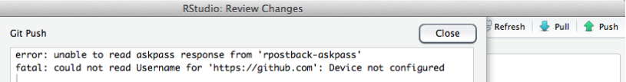

Here's how we fixed it: we updated git.exe to the latest version, 2.2.1, edited the search path to point to the new version, made sure the *git* credential.helper was configured to be able to access the OS X keychain, and pushed a test commit from terminal to store the username and password in the keychain, where it can be accessed from other apps like RStudio. Easy peasy!

1. To check your current version of git.exe, type this at the terminal command line:
   * $ git --version should return something like:
   * git version 2.2.1 (check online to see if this is the latest version)
2. To update, go to <http://git-scm.com/download/mac>, download the latest *git* for OS X, install it.
3. In terminal, type git --version and verify that it reports the new version. If it shows the new version, great! Skip to Step 5.
   * Don't be sad if it doesn't! If you still see the old version, the installer put the new version into a different directory, which has a lower priority in the search path, so now to update the search path. The default Apple *git* seems to install the git.exe into /usr/bin/ directory, this particular updater seems to install into /usr/local/git/bin/ directory. The search path needs to be updated to look for git.exe in the new directory first.
4. To change the search path, open up the paths file in nano editor using sudo:
   * $ sudo nano /etc/paths
   * At the top line of the paths file, add the directory for the updated *git*: ’/usr/local/git/bin’(without the quotes) so it looks like the top line here: 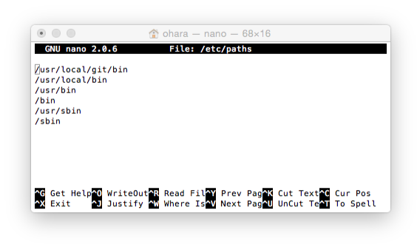
   * Then hit control-X to exit, then Y in response to the save prompt.
5. Make sure your git config is up to date, including credential.helper:
   * $ git config --global -l should return something like:
   * user.name="Casey O'Hara"
   * user.email=ohara@nceas.ucsb.edu
     + see <https://github.com/OHI-Science/ohiprep/wiki/Setup#git_identity> for help on updating user.name and user.email
   * credential.helper=osxkeychain
     + (if you need to configure the credential helper: <https://help.github.com/articles/caching-your-github-password-in-git/>)
6. Now while you are in Terminal, it is important to sync with a repository to establish your security credentials. You must clone a repository and push a 'test' commit, and then once you are prompted for your username and password your information will get stored in the keychain. Here are the steps:
   * Change your working directory to your local github directory: $ cd github
   * (Tip: you can check if you're in the right folder by entering pwd, short for "print working directory"; or you could look at the line of code preceding the "$".)
   * Clone into a repository with a URL *for which you have permissions*. As an example, the following steps use a repository called 'ZAF' but you should use your own URL with a three-letter country code in place of 'ZAF':
   * $ git clone https://github.com/omalik/zaf.git
   * Change your working directory to the folder you just created (here, 'ZAF'): $ cd zaf
   * Push a test commit to repository 'ZAF':
   * $ touch test.md
   * $ git add test.md
   * $ git commit -m "testing"
   * $ git status
   * $ git push
   * Check your status again: $ git status
     + (TIP: You can check your status with $ git status and you can use 'ls' to see if your new changes have registered in this repository.)
7. Now that *git* is updated and your username and password are set, make sure RStudio knows the location of the new git.exe. In RStudio, select **Tools > Global Options…**, select the Git/SVN, and browse to the new Git executable (it should appear as /usr/local/git/bin/git if you updated your *git* version as above). 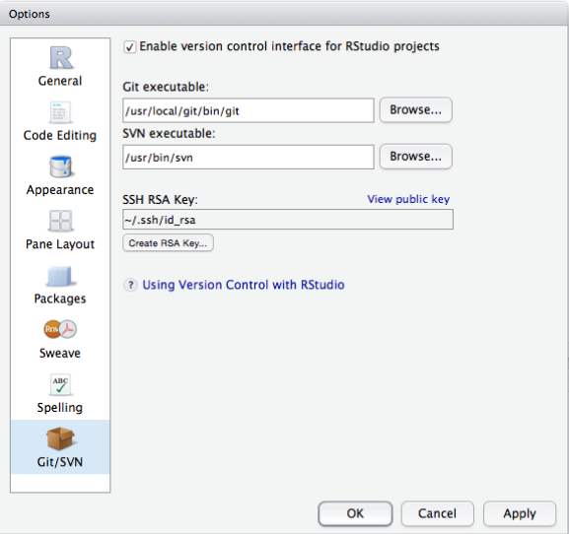

Next time you push a commit from RStudio, it should remember the username and password from your test commit in Step 6, and you should be good to go.

### Loading RWorkspace on Restart

When you restart your R Session (**Session > Restart R** on a Mac), if you see that it is trying to load ohicore, it may give you an error:

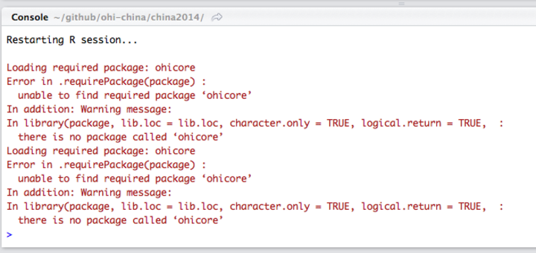

You do not want it to load ohicore or to save anything in your workspace. You will need to change the default setting from you **.Rproj** file. Steps to do this:

1. Go to Project Options, either in the pull-down menu or by double-clicking the .Rproj file:

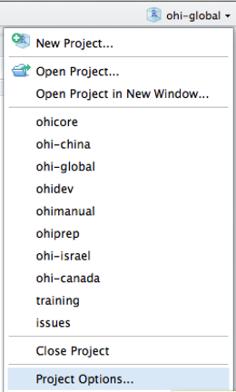

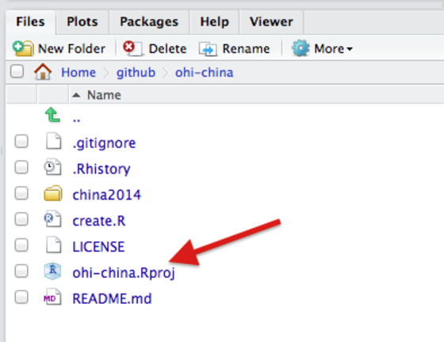

1. Change all options to **No:**

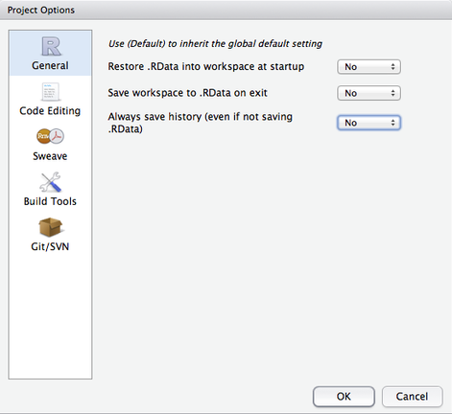

## Errors when Using the Toolbox

### Useful Errors when Calculating Scores

TIP: You can use the *layers* function in calculate_scores.R to error-check whether you have registered your files in layers.csv correctly or not. If you haven't, you will get an error message regarding 'missing files'. 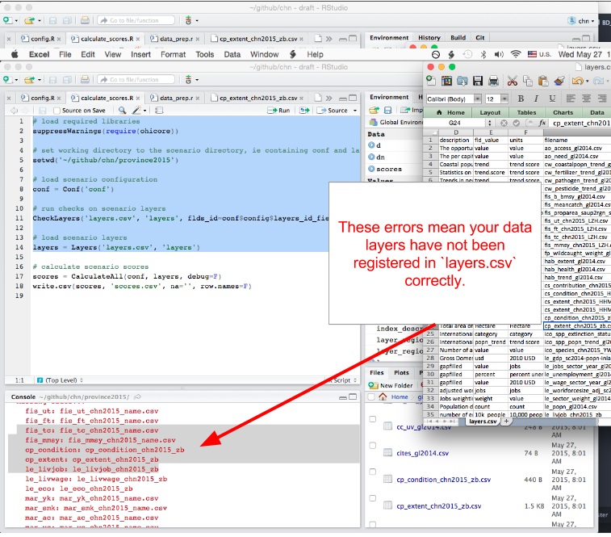

### Calculating Pressures...

#### 'The following components for [goal] are not in the aggregation layer [layer]...'

Example:

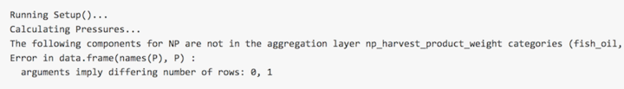

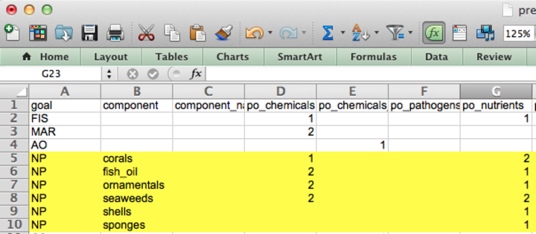

This error means you should update your pressures matrix because it expects there to be components that your region does not have.

#### 'Error in matrix...'

Example: > 

This error means there is an empty column in pressures_matrix.csv, and the Toolbox cannot handle empty columns.

### Calculating Resilience ...

#### 'Error in match(x, table, nomatch = OL) : object id_num not found'

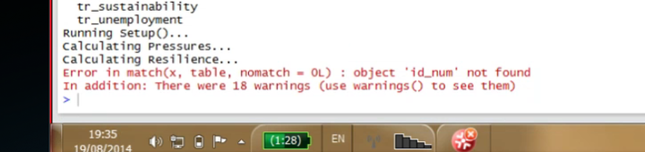

This error means you should check that there is at least one entry for each goal (for each row) in resilience_matrix.csv.